**Press Release**

For Immediate Release: 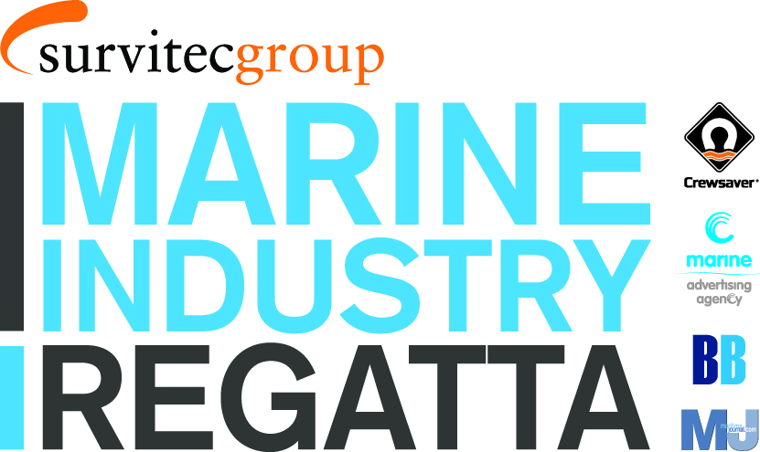

5th April 2016

**Ian Walker announced as guest speaker at the Marine Industry Regatta**

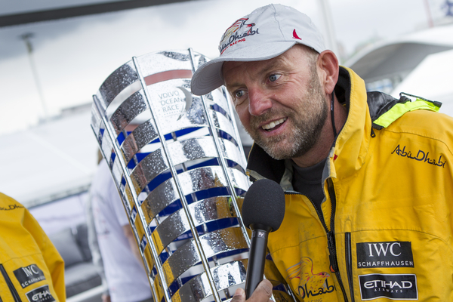The Marine Industry Regatta is excited to announce that Ian Walker will be the guest speaker at this year’s Regatta. Ian will be speaking about both his experience winning the Volvo Ocean Race, as part of the Abu Dhabi Sailing Team, and his most recent triumph, #HellOnHighSeas to raise money for Sport Relief.

*Photo Credit: Ian Roman*

In addition, Ian will be out on the water competing in the event and giving the competitors a real run for their money.

*“With less than 2 months to go, the excitement is building for the 2016 Marine Industry Regatta which will be raising money for the John Merricks Sailing Trust and the Andrew Simpson Sailing Foundation. I’m looking forward to joining the industry for a day’s sailing and guest speaking”* – Ian Walker.

Sailing out of Port Solent, Hampshire, the Marine Industry Regatta takes place on Wednesday 1st June and is a great way to catch up with other marine professionals and to entertain clients and staff.

With only 5 boats remaining for the 2016 Marine Industry Regatta, organisers encourage potential entrants to book their boats now to avoid disappointment.

For more information on the Marine Industry Regatta 2016 and to find out who has already signed up, please call Alex Smith at Sunsail on 02392 222 221 or visit [www.marineindustryregatta.com](http://www.marineindustryregatta.com)

ENDS//

Crewsaver

Hazel Proudlock, Marketing Dept

T +44 (0) 1329 820406

E [hazel.proudlock@survitecgroup.com](mailto:hazel.proudlock@survitecgroup.com)

Or

Alison Willis – Marine Advertising Agency Ltd

T +44 (0) 23 9252 2044

E [Alison@marineadagency.com](mailto:Alison@marineadagency.com)

**Notes to Editors**

**Crewsaver** is a world-leading manufacturer of marine safety equipment and clothing for the commercial and leisure marine industries. Based in Gosport, Hampshire, the company designs and manufactures bespoke safety equipment for several countries’ Special Forces, and the aviation and oil industries. Crewsaver is the only company to hold an exclusive contract to supply lifejackets to the UK government’s Environment Agency and the Royal National Lifeboat Institution (RNLI). They are part of the Survitec Group.

**www.crewsaver.com**

**Survitec Group** holds market-leading positions worldwide in marine, defence and aerospace survival technology. Headquartered in Birkenhead, the company employs 2000 people across 10 manufacturing sites and 50 service centres, operating through a network of a further 550 distributors and agents to bring its best-in-class products and services to a global customer base. With an extensive history spanning over 160 years and a portfolio of some of the most reputable brands in the safety and survival industry, Survitec is committed to product innovation, technological advancement and quality assurance.

Key products within Survitec’s portfolio include marine, defence and aviation Liferafts, world leading submarine escape technology, lifejackets for commercial airlines and the offshore industry as well as pilot flight equipment, including anti-g clothing used for the Eurofighter and JSF programmes. The Group also pioneered marine evacuation technology and today the unique MarinArk system is used on many major cruise ships across the globe.

**www.survitecgroup.com**