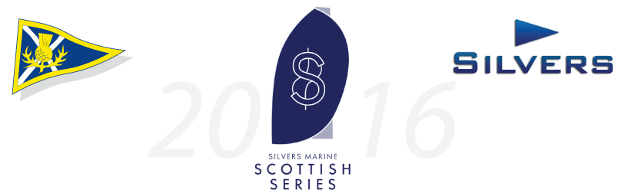**Press Release**

**For Immediate Release:**

**11th April 2016**

***Silvers Marine Scottish Series, May 27th – 30th 2016***

**Crewsaver announces sponsorship with the Silvers Marine Scottish Series 2016 for the second year running.**

Crewsaver is delighted to be sponsoring the Silvers Scottish Series once again. The sponsorship will see the racing areas, including that of the One Design Racing, provided with buoys from Crewsaver’s extensive mark buoy range. The mark buoys will be professionally branded at Crewsaver HQ. Joining the buoys are custom branded wraps in navy which will be used to identify the start marks.

The highly esteemed Scottish Series run by organising authority, Clyde Cruising Club will be running from the 27th to the 30th May 2016.

Scottish Series Event Chairman, David Denholmsays *“Scottish Series is delighted to have the support of Crewsaver again at Tarbert in 2016.  Having a safety manufacturer to the fore is really important in encouraging participants to manage adventurous activities safely”.* David continues *“Crewsaver have stepped behind the One Design Racing. One Design Racing where the boats are evenly matched and the skippers and crew know instantly where they are ranked has great attraction for many.  We already have fleets of Sigma 33s, VX Ones and Hunter 707s.  The announcement that this will be the Sonata Scottish Championship should soon bring the Sonata fleet up to a similar good level.  We anticipate some cracking racing, Crewsaver have been hugely helpful to the organisers with the provision of racing mark buoys”.*

ENDS//

**For media information, hi-res images or product tests please contact:**

Crewsaver

Hazel Proudlock, Marketing Dept

T +44 (0) 1329 820406

E [hazel.proudlock@survitecgroup.com](mailto:hazel.proudlock@survitecgroup.com)

Or

Alison Willis – Marine Advertising Agency Ltd

T +44 (0) 23 9252 2044

E [Alison@marineadagency.com](mailto:Alison@marineadagency.com)

**Notes to Editors**

**Crewsaver** is a world-leading manufacturer of marine safety equipment and clothing for the commercial and leisure marine industries. Based in Gosport, Hampshire, the company designs and manufactures bespoke safety equipment for several countries’ Special Forces, and the aviation and oil industries. Crewsaver is the only company to hold an exclusive contract to supply lifejackets to the UK government’s Environment Agency and the Royal National Lifeboat Institution (RNLI). They are part of the Survitec Group.

**www.crewsaver.com**

**Survitec Group** holds market-leading positions worldwide in marine, defence and aerospace survival technology. Headquartered in Birkenhead, the company employs 2000 people across 10 manufacturing sites and 50 service centres, operating through a network of a further 550 distributors and agents to bring its best-in-class products and services to a global customer base. With an extensive history spanning over 160 years and a portfolio of some of the most reputable brands in the safety and survival industry, Survitec is committed to product innovation, technological advancement and quality assurance.

Key products within Survitec’s portfolio include marine, defence and aviation Liferafts, world leading submarine escape technology, lifejackets for commercial airlines and the offshore industry as well as pilot flight equipment, including anti-g clothing used for the Eurofighter and JSF programmes. The Group also pioneered marine evacuation technology and today the unique MarinArk system is used on many major cruise ships across the globe.

**www.survitecgroup.com**