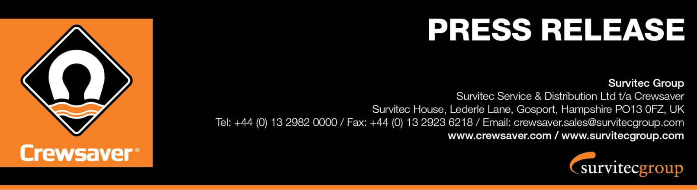
Seawork: Stand PB67

For Immediate Release:
23rd May 2016

Survitec Group introduces the latest addition to the Crewsaver immersion suit range, the Crew Endurance Plus at the 2016 Seawork International Exhibition (14-16 June 2016).
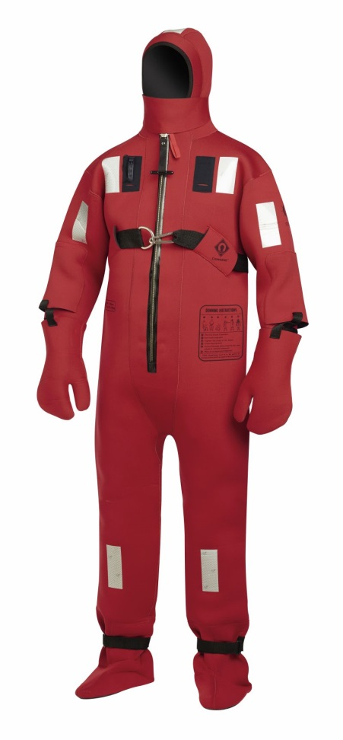
The Crew Endurance Plus joins the successful Crewsaver immersion suit range that Survitec Group supplies to many of the world’s shipping lines and oil and gas enterprises. The suit builds on the success of the classic Crewsaver Immersion Suit and now includes a 40mm nylon lifting strop harness with stainless steel D-ring as standard and at no extra cost to the customer. This strop can simply be removed if not required.

The suit features the popular double layer glove system consisting of latex gloves to aid dexterity and additional neoprene over gloves for increased insulation. The 5mm flame retardant neoprene provides good insulation and resistance to oil, sunlight and seawater and includes many popular features as found throughout the Crewsaver Immersion suit range including, buddy line, protective face flap and MED/SOLAS approved reflective tape.

Regulations for cargo ships and bulk carriers trading outside the parallels 20ºN or 20ºS have stipulated that one fully approved immersion suit or abandonment suit must be carried for each crew member. The Crew Endurance Plus immersion suit meets these requirements and is fully approved to the current MED/SOLAS regulations.

The Crewsaver immersion suit range is designed to keep crew alive in the water after abandoning ship or evacuating an offshore rig in an emergency situation. The Crew Endurance Plus is designed to be worn with an approved lifejacket such as Crewsaver’s Seacrewsader 290N 3D or the Seacrewsader 275N.
Visitors to Seawork, 14th-16th June 2016, will have the opportunity to view the Crew Endurance Plus, which is now available for purchase.

Registered Office: 1-5 Beaufort Road, Birkenhead, Merseyside, CH41 1HQ, United Kingdom Registered in England No. 553893

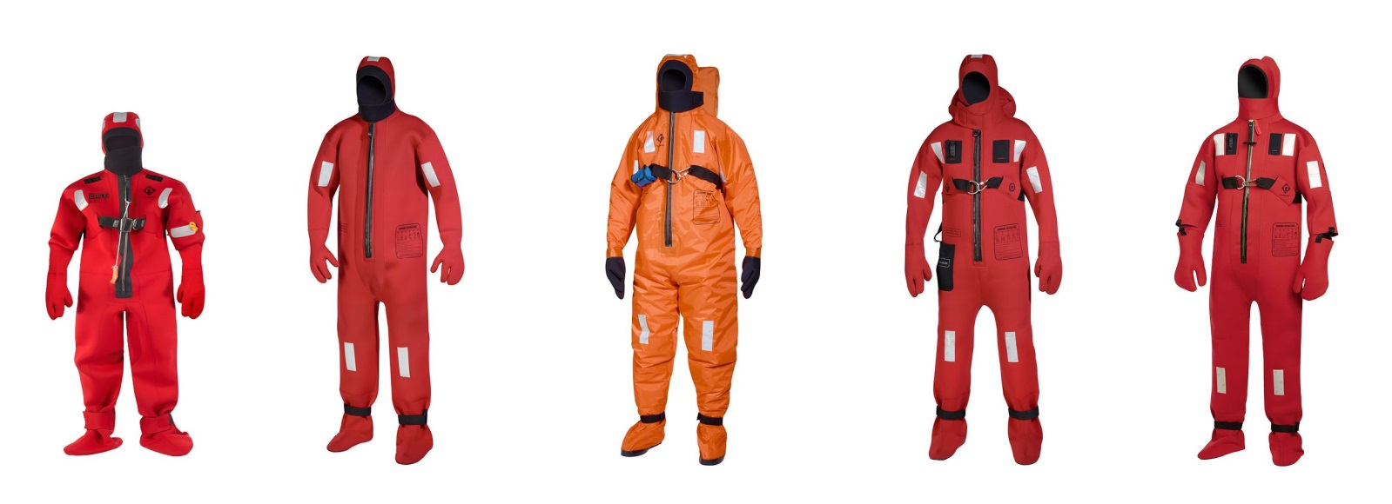

ENDS//

For media information, hi-res images or product tests please contact:

Crewsaver
Hazel Proudlock, Marketing Dept
T +44 (0) 1329 820406
E hazel.proudlock@survitecgroup.com

Or

Alison Willis – Marine Advertising Agency Ltd
T +44 (0) 23 9252 2044
E Alison@marineadagency.com

Notes to Editors

Crewsaver is a world-leading manufacturer of marine safety equipment and clothing for the commercial and leisure marine industries. Based in Gosport, Hampshire, the company designs and manufactures bespoke safety equipment for several countries’ Special Forces, and the aviation and oil industries. Crewsaver is the only company to hold an exclusive contract to supply lifejackets to the UK government’s Environment Agency and the Royal National Lifeboat Institution (RNLI). They are part of the Survitec Group.

www.crewsaver.com

Survitec Group holds market-leading positions worldwide in marine, defence and aerospace survival technology. Headquartered in Birkenhead, the company employs 2000 people across 10 manufacturing sites and 50 service centres, operating through a network of a further 550 distributors and agents to bring its best-in-class products and services to a global customer base. With an extensive history spanning over 160 years and a portfolio of some of the most reputable brands in the safety and survival industry, Survitec is committed to product innovation, technological advancement and quality assurance.
Key products within Survitec’s portfolio include marine, defence and aviation Liferafts, world leading submarine escape technology, lifejackets for commercial airlines and the offshore industry as well as pilot flight equipment, including anti-g clothing used for the Eurofighter and JSF programmes. The Group also pioneered marine evacuation technology and today the unique MarinArk system is used on many major cruise ships across the globe.

www.survitecgroup.com

Registered Office: 1-5 Beaufort Road, Birkenhead, Merseyside, CH41 1HQ, United Kingdom Registered in England No. 553893

