Press Release
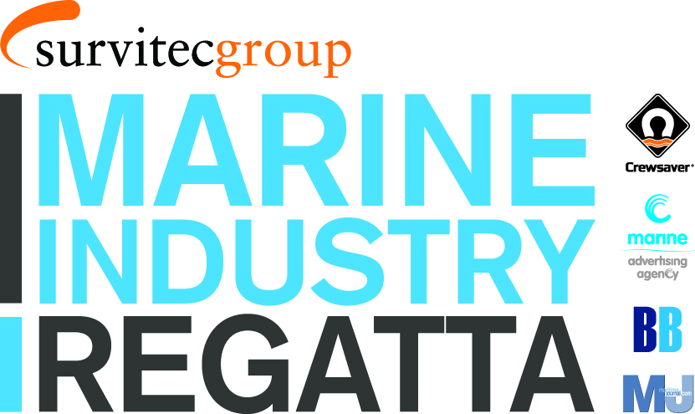
For Immediate Release:
29th April 2016

With only 5 boats remaining for the 2016 Marine Industry Regatta, organisers encourage potential entrants to book their boats now to avoid disappointment.

Marine Industry Regatta organisers are delighted by the swift uptake of entrants for the Solent based 2016 Marine Industry Regatta. The event, running on the 1st June, looks to attract marine professionals from all sectors of the marine industry, making it the perfect opportunity to network and entertain clients and staff.

In addition to the day’s sailing, entrants are invited to the prize giving and an evening of festivities. Additional evening tickets are available for those unable to attend the day’s sailing, but would like to join in for the evening event. The evening’s entertainment includes a well-deserved BBQ, a smooth jazz band and talks by guest speakers including Olympic medallist, Ian Walker who has just completed the #HellOnHighSeas’ challenge for Sport Relief.

The Marine Industry Regatta is also pleased to announce that Sportography will be joining this year’s regatta as the official photography sponsor. This exciting sponsorship creates a great opportunity for participants to access professional images of the day and of their team in action.

The event looks to raise funds for the John Merricks Sailing Trust and the Andrew Simpson Sailing Foundation. Donations to these charities are included in the entry fee.

For the chance to snap up one of the remaining boats or for more information on the Marine Industry Regatta 2016, including who has already signed up please call Alex Smith or Terry Hunt at Sunsail on 02392 222 221 or visit www.marineindustryregatta.com.

ENDS//

Crewsaver
Hazel Proudlock, Marketing Dept
T +44 (0) 1329 820406
E hazel.proudlock@survitecgroup.com

Or

Alison Willis – Marine Advertising Agency Ltd
T +44 (0) 23 9252 2044
E Alison@marineadagency.com

Notes to Editors

Crewsaver is a world-leading manufacturer of marine safety equipment and clothing for the commercial and leisure marine industries. Based in Gosport, Hampshire, the company designs and manufactures bespoke safety equipment for several countries’ Special Forces, and the aviation and oil industries. Crewsaver is the only company to hold an exclusive contract to supply lifejackets to the UK government’s Environment Agency and the Royal National Lifeboat Institution (RNLI). They are part of the Survitec Group.

www.crewsaver.com

Survitec Group holds market-leading positions worldwide in marine, defence and aerospace survival technology. Headquartered in Birkenhead, the company employs 2000 people across 10 manufacturing sites and 50 service centres, operating through a network of a further 550 distributors and agents to bring its best-in-class products and services to a global customer base. With an extensive history spanning over 160 years and a portfolio of some of the most reputable brands in the safety and survival industry, Survitec is committed to product innovation, technological advancement and quality assurance.
Key products within Survitec’s portfolio include marine, defence and aviation Liferafts, world leading submarine escape technology, lifejackets for commercial airlines and the offshore industry as well as pilot flight equipment, including anti-g clothing used for the Eurofighter and JSF programmes. The Group also pioneered marine evacuation technology and today the unique MarinArk system is used on many major cruise ships across the globe.

www.survitecgroup.com

