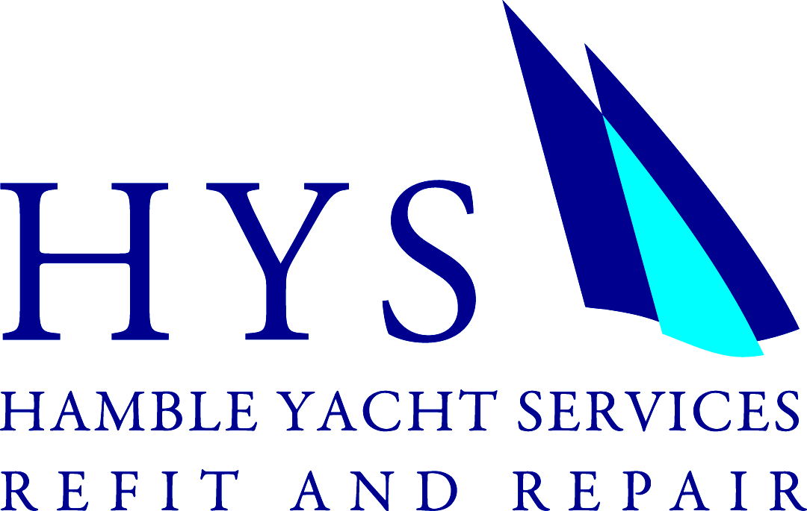 Press Release

HYSRR - Official Lewmar Service Centre.
[For immediate release.]

Hamble Yacht Services Refit & Repair is proud to announce that they have been recognised as an Official Service Center for Lewmar sail and powerboat hardware. Having supplied and installed Lewmar equipment to their clients for many years, it was announced recently that the Hamble based facility is now the recognised Official Service Center in the UK.

Lewmar has transformed beyond recognition from the small company established by Len Lewery and Leslie March in 1946. Yet the spirit of innovation and engineering excellence has remained constant. Today, Lewmar is the premier marine equipment supplier, designing, manufacturing and distributing high-quality control solutions worldwide. Ainslie Hunt (HYSRR Workshop Manager) said “We are proud to fly the Lewmar flag. We are very familiar with the Lewmar product and secure in the knowledge that the equipment we fit on our customers yachts will be best in class”.

Roger Cerrato from Lewmar commented “HYSRR is a long standing customer of ours and we’ve worked closely together on many exciting projects over the years. Their experienced team is ideally positioned to offer a complete supply and fit service for all Lewmar equipment whether it’s a V700 windlass on a 23’ cruiser or a 122 winch on a 120’ Superyacht. We’ve recently used HYSRR’s skills ourselves to assist with installing our new 185 Retractable Thruster into our test boat.”

HYSRR is able to carry out works on-site in Hamble or remotely across the South Coast, the team from Hamble Yacht Services Refit & Repair is looking forward to welcoming more boat owners who are wishing to upgrade or maintain their boats’ deck fittings and control fixtures. Having worked on some of the most renowned yachts located around the globe HYSRR have the experience and resource to deliver projects of any size or scale.

For more information or a quote, contact: info@HYSRR.com
Or call: +44 (0)23 804 54 111

NOTES TO EDITORS:
- Hamble Yacht Services Refit & Repair is a service facility based in Port Hamble, Nr Southampton and is part of the Ancasta Group.
- The Hamble Yacht Services Refit & Repair website is: www.hysrr.com
- Ancasta International Boat Sales is Europe’s Largest Brokerage Network with 14 offices across Europe.
- The Ancasta network features offices in Brighton, Chichester, Port Solent, Cowes, Port Hamble, Swanwick, Lymington, Dartmouth, Falmouth, Mylor, Plymouth, Port Napoleon, Palma de Mallorca and the Algarve Portugal.
- Ancasta International Boat Sales are new boat dealers for Prestige Motor Yachts, Bénéteau sailing and motor yachts, Lagoon Catamarans, CNB Yachts, Fairlie Yachts, McConaghy Yachts.
- The Ancasta website is www.ancasta.com
- The Ancasta Group incorporates Ancasta International Boat Sales & Hamble Yacht Services Refit and Repair and Advanced Rigging.
- Hamble Yacht Services Refit & Repair registered address is: Port Hamble Marina, Hamble, Hampshire, SO31 4NN. Tel:. +44 (0)23 804 54 111 Email: info@hysrr.com

For further information contact: willblair@ancasta.com

