News Release
For immediate release
12th May 2016

Performance Sailing Shop, a brand new technical sailing clothing retailer, launches as www.performancesailingshop.com goes live
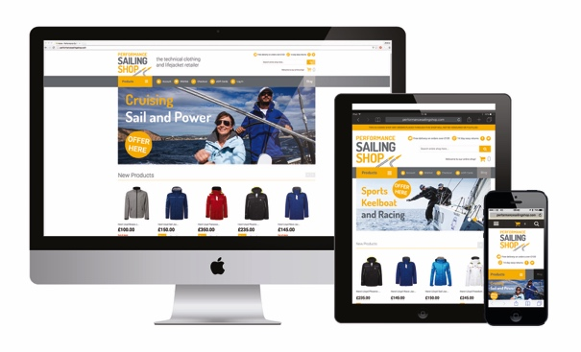
Performance Sailing Shop, a new online retailer selling the very best technical sailing clothing and lifejackets at www.performancesailingshop.com, launches on Friday 13th May 2016 in time for the 2016 sailing season. Performance Sailing Shop stocks technical clothing from Henri Lloyd, Musto, adidas and Rooster as well as lifejackets from Crewsaver. Cruising and racing sailors are catered for, as well as powerboat enthusiasts.

The new website aims to make online shopping for technical sailing clothing straightforward and easy, with clear product information, free delivery on orders over £100 and 14 day returns. ‘Performance Sailing Shop blogs’ guide visitors through the range of technical clothing available and help them to choose the right products, whatever they’re up to on the water. The website is fully responsive working perfectly on all devices from desktops through to tablets and mobile phones.

Performance Sailing Shop is also able to sell eGiftCards that can be redeemed online at www.performancesailingshop.com, making it even easier to treat someone who loves boating – you choose the eGiftCard, they pick the present!

To celebrate the launch, Performance Sailing Shop is entering all those who sign up for its newsletter before 23:59 on 30th June 2016 into a prize draw to win a £100 Performance Sailing Shop eGiftCard. Subscribers to the Performance Sailing Shop newsletter and its Facebook followers will also benefit from being the first to hear about new products, special offers and promotions. Full terms and conditions can be found at www.performancesailingshop.com

With a base in Haslar Marina, Gosport, at the heart of the south coast sailing scene, Performance Sailing Shop will also be open by appointment for those who prefer to try on their kit in its comfortable boutique store.

ENDS//

Notes to editors
Performance Sailing Shop is a trading name of MAA Prepaid Ltd a registered company within the UK. It was founded in 2016 by Mike Shepherd.

Media enquiries
Alison Willis, Marine Advertising Agency, alison@marineadagency.com
Emma Stanbury, Marine Advertising Agency, emma@marineadagency.com

Tel: +44 (0) 23 9252 2044

