For Immediate Release
South West Canoe Show: 14th May 2016

Exciting Yak offers to be had at the 2016 South West Canoe Show

On the 14th May, Yak will be joining AS Watersports in Exeter for the 2016 South West Canoe Show. Visitors to this year’s show will have access to exciting offers* throughout the event including.

- FREE Yak sunglasses with any Yak purchase over £50

- FREE Neoprene Paddle Mitts with any Yak purchase over £100

- FREE Paddle Bag with any Yak purchase over £150

Visit the Yak action station to view the almighty Yak collection where there will also be a member of the friendly Yak team to answer any questions that you may have. Don’t miss out, there is something for everyone no matter what floats your boat.

For more information on Yak visit www.YakAdventureEquipment.com
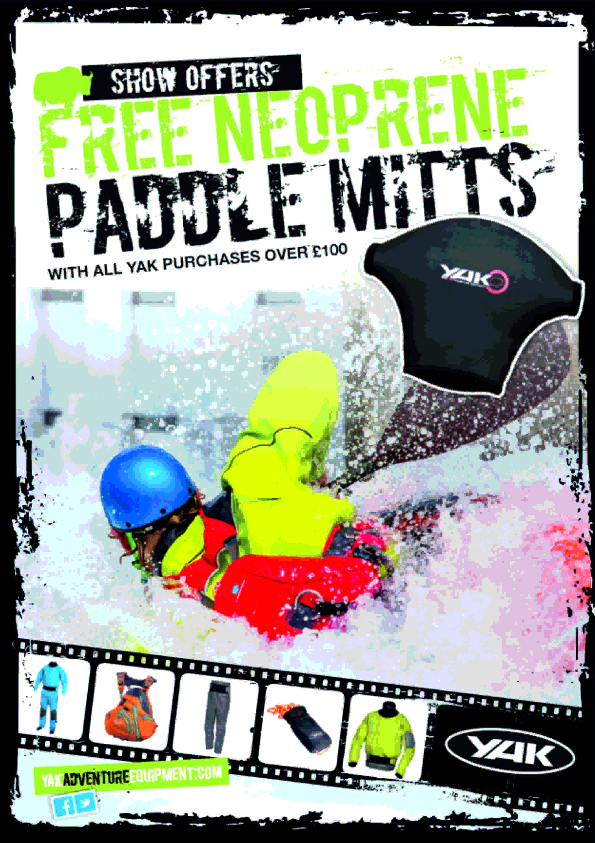
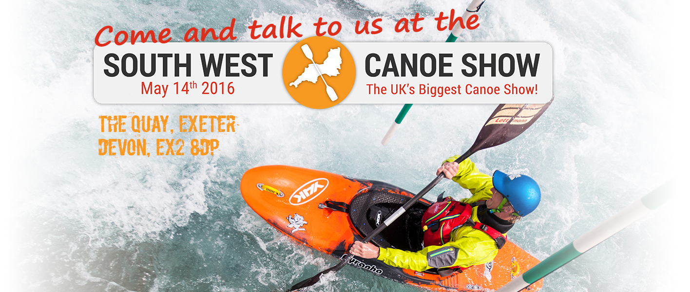

* T&Cs: Max 1 per purchase. Max 2 per customer. E&OE. Terms and conditions apply. Redeemable at location of purchase. Only one offer can be used per purchase. Whilst stock lasts.

ENDS//

For media information, hi-res images or product tests please contact:

Hazel Proudlock, Marketing Dept - Yak Adventure Equipment
T +44 (0) 1329 820406
E hazel.proudlock@survitecgroup.com

Or

Alison Willis – Marine Advertising Agency Ltd
T +44 (0) 23 9252 2044
E Alison@marineadagency.com

Notes to Editors
Part of the Survitec Group which also owns Crewsaver, Yak Adventure Equipment produces and manufactures products that are purposely designed for the whitewater, recreational and touring kayaking and canoe markets. A wide range of products suit all styles and experience, giving paddlers more choice and opportunity to enjoy their sport with total peace of mind. Yak’s products include buoyancy aids, drysuits, cags, trousers, spray decks, gloves, footwear, headwear and buoyancy bags.

Together with Crewsaver, Yak has 50 years of experience manufacturing marine safety products that combine cutting edge technology with high performance and ultimate practicality.
