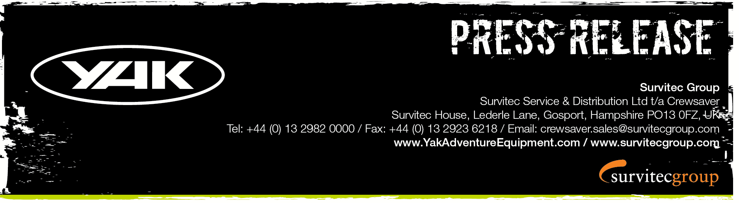
For Immediate Release
13th May 2016

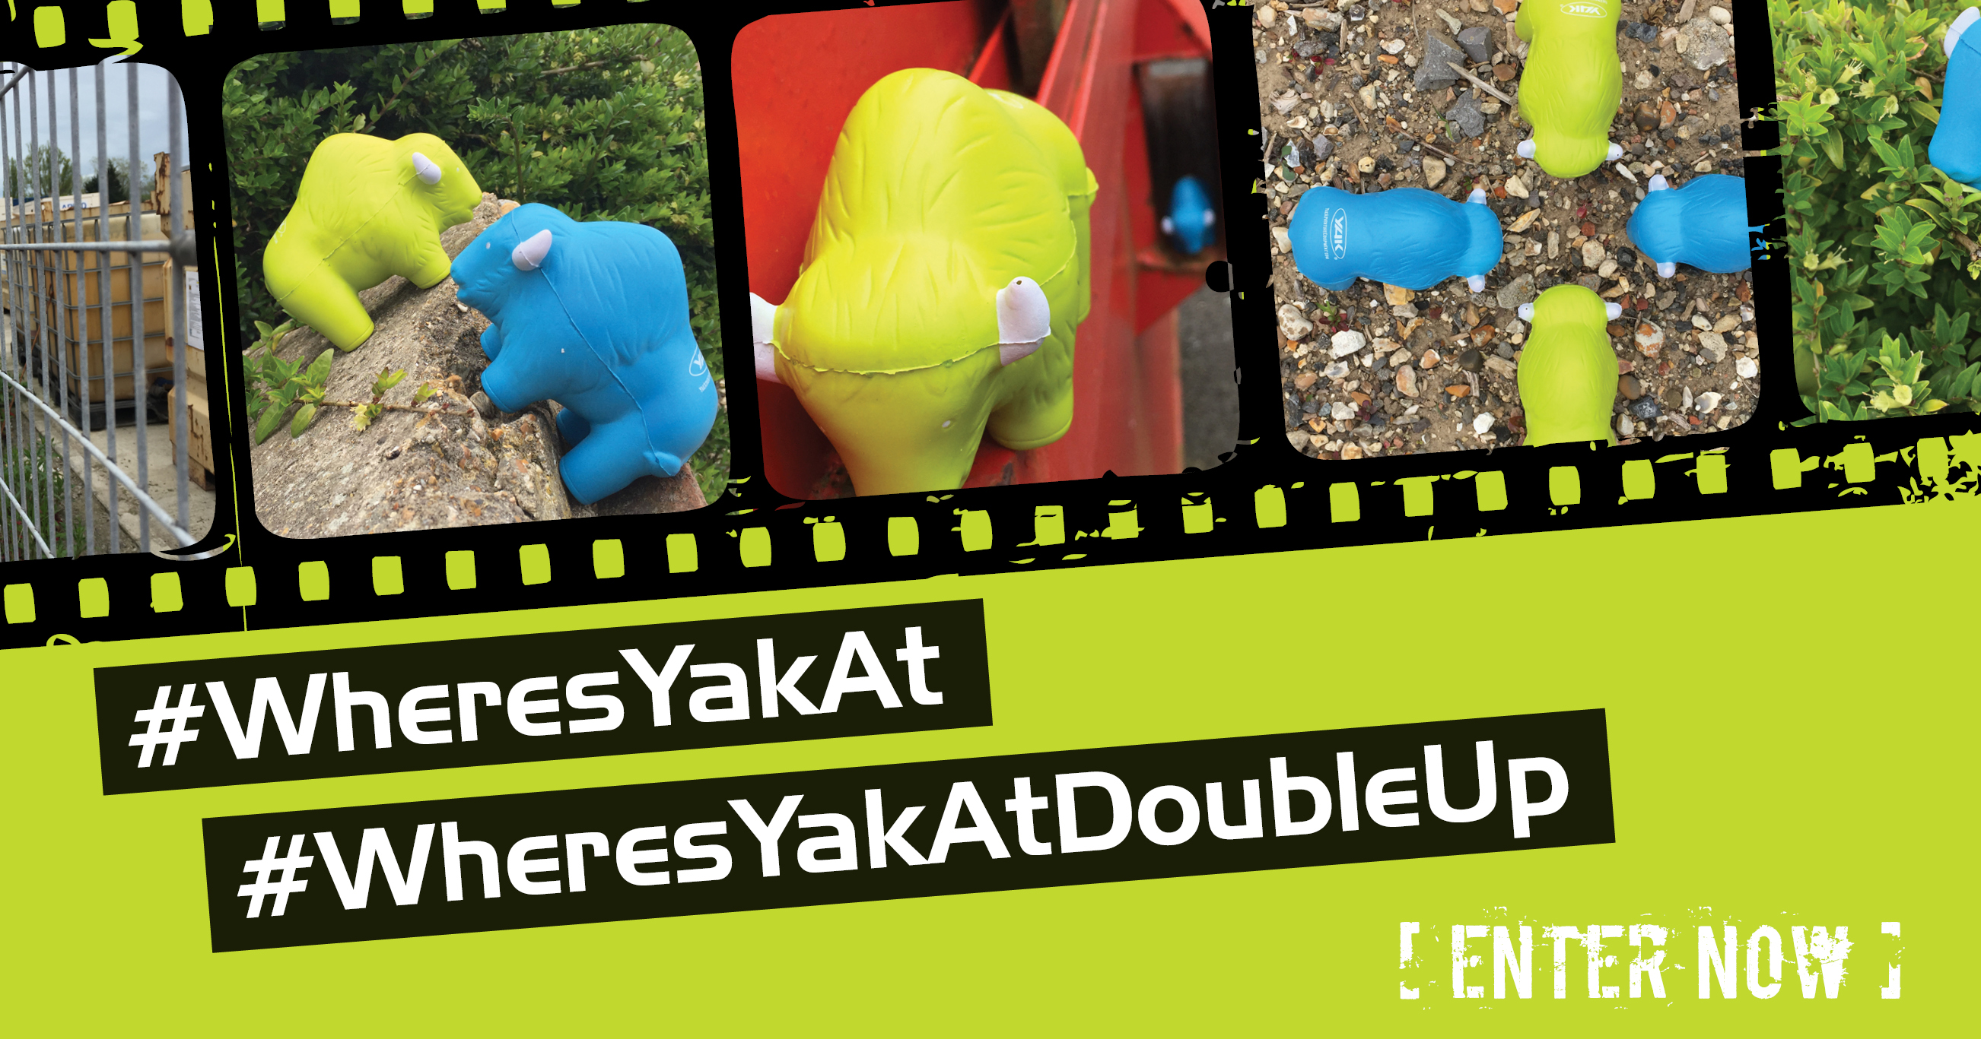
#WheresYakAt is back and this time you decide the winner.
#WheresYakAtDoubleUp exclusive to dedicated Yak fans, enter now!
Yak Adventure Equipment is delighted to announce that following the success of last year’s #WheresYakAt competition, the mischievous Yaks are back and this time you decide the winner. Herds and herds of squishy Yaks in this year’s colour... blue... are descending upon selected Yak retail outlets and Yak sponsored events across the globe and we want to see what they are up to!
#WheresYakAt - Win £500 worth of Yak gear
Get into your local Yak retail outlet or Yak sponsored event where the herds have descended to get hold of your very own squishy Yak! Snap the best pic of your Yak going about its crazy business and post it on the Yak Adventure Equipment Facebook page with #WheresYakAt, to be in with a chance of winning.
In addition, for the dedicated Yak fan, we are delighted to announce the #WheresYakAtDoubleUp, a brand new competition whereby two Yaks are required to enter.
#WheresYakAtDoubleUp - Win £1,000 worth of Yak gear
If you have been dedicated enough to keep your green Yak from last year’s competition and have managed to get your hands on this year’s blue Yak then you can enter the #WheresYakAtDoubleUp competition. Capture what shenanigans the blue and green Yaks get up to when teamed up and post it on the Yak Adventure Equipment Facebook page with #WheresYakAt & #WheresYakAtDoubleUp to be in the chance of winning.
‘We are thrilled to be running #WheresYakAt again, it’s such a great competition that all watersports enthusiasts can get involved in, this year we have some amazing prizes up for grabs so don’t delay and get your entries in today.’ Hannah Burywood, Marketing Manager for Yak.
How to enter
‘Like’ the Yak Adventure Equipment Facebook page and upload your photo to the Yak Facebook page to enter with the #WheresYakAt & #WheresYakAtDoubleUp (if applicable). Make sure you say where it is and make your post public! You can post as many pictures as you like.
How to win
#WheresYakAt – The winner for this will be selected by you, to cast your votes hit ‘like’ on your favourite picture, the picture with the most ‘likes’ wins.
#WheresYakAtDoubleUp – The winner will be selected by the TriSUP Events team, the image chosen will be selected on its creativity, uniqueness and general fun factor.
Winners announced October 10th 2016. T’s & C’s apply, visit our website for details. E&OE.

ENDS//

For media information, hi-res images or product tests please contact:

Hazel Proudlock, Marketing Dept - Yak Adventure Equipment
T +44 (0) 1329 820406
E hazel.proudlock@survitecgroup.com

Or

Alison Willis – Marine Advertising Agency Ltd
T +44 (0) 23 9252 2044
E Alison@marineadagency.com

Notes to Editors
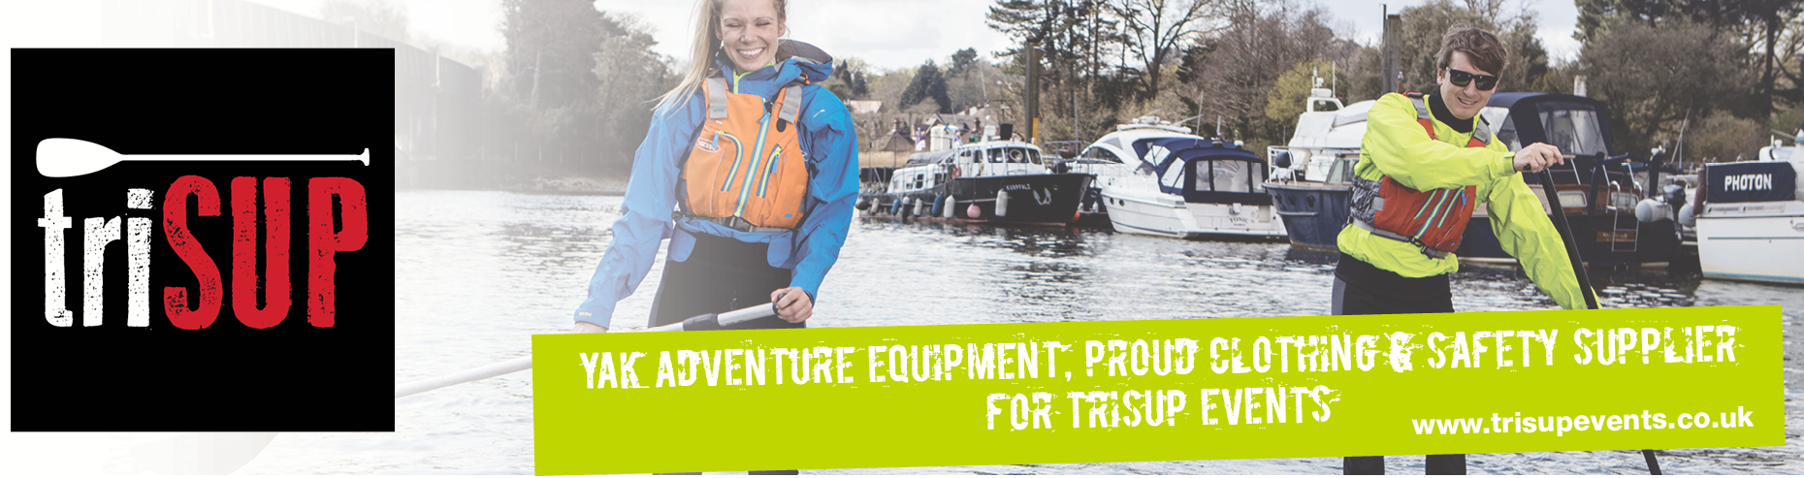
Part of the Survitec Group which also owns Crewsaver and Yak Adventure Equipment produces and manufactures products that are purposely designed for whitewater, recreational and touring kayaking as well as canoeing. A wide range of products suit all styles and experience, giving paddlers more choice and opportunity to enjoy their sport with total peace of mind. Yak’s products include buoyancy aids, drysuits, cags, trousers, spray decks, gloves, footwear, headwear and buoyancy bags. Together with Crewsaver, Yak has 50 years of experience manufacturing marine safety products that combine cutting edge technology with high performance and ultimate practicality.

