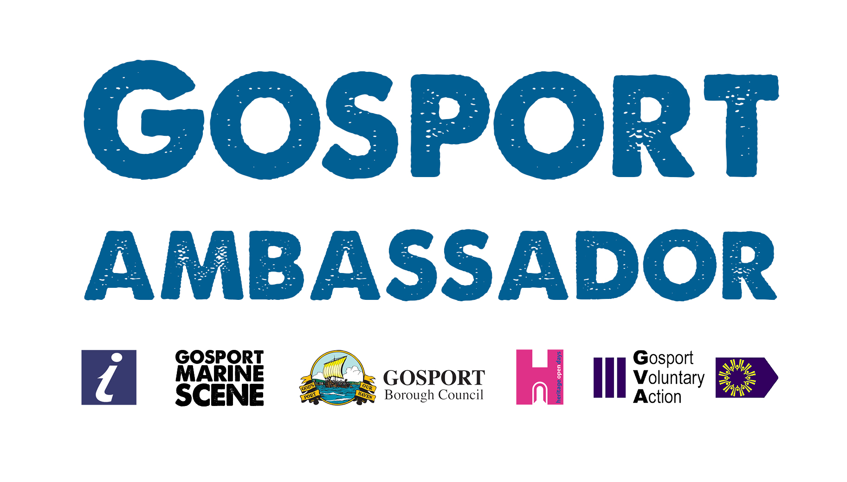

Press Release
For immediate release – 9th June 2016

Gosport Ambassadors offer a warm welcome to the town!

When you arrive in an unfamiliar place there is nothing like a personal welcome to make you feel at home. That’s just what is on offer this summer from teams of Gosport Ambassadors during the big events that will be attracting thousands of visitors and tourists to the town.

Gosport Ambassadors will be at Stokes Bay for the P1 English Grand Prix of the Sea in Stokes Bay over the weekend of 9 and 10 July 2016, at the Gosport Ferry terminal to meet people travelling through Gosport for the America’s Cup World Series weekend on 23 and 24 July 2016, and at various locations across the town for the Heritage Open Days in early September.

The volunteer Ambassadors are chosen for their friendly and outgoing personalities and because they care about our town. Katie Nelson, the Co-ordinator for the Ambassadors and also a volunteer says: ‘I was born here and love Gosport: I want to see it thrive. Our town has a lot of events and attractions to offer visitors and that will be highlighted by the additional welcome from the Ambassadors.’ Katie is supported by her employer, Marina Projects Ltd, also based on the Waterfront.

The task for the Ambassadors is to make people feel they are among friends in Gosport, and to provide information about the things visitors and tourists need to know. Among the frequent questions are where they can eat and drink, where are the cashpoints, how do they get to the other attractions, where they can buy what they need, and – most important – where are the loos!

The idea for the Ambassadors came out of the Waterfront and High Street Economic Plan by the Gosport Coastal Community Team, with input from residents and businesses. The Ambassadors project is being implemented by a partnership of Gosport Borough Council, Gosport Marine Scene, the Tourist Information Centre, Gosport Voluntary Action and the Heritage Open Days.

‘By far our biggest resource is the enthusiasm of the partner bodies and the volunteers’ says Ian Bridges, the Council’s Principal Project Officer. ‘The Gosport Ambassadors programme is a prime example of how the council, local organisations, businesses and residents are coming together to implement initiatives from the Economic Plan.’

More volunteer Ambassadors are being recruited throughout the summer. If you would like to help, email Katie Nelson on events@gosportmarinescene.com

ENDS
More……

Interviews are available
Ian Bridges, Principal Project Officer, Gosport Borough Council, 02392 545 723 ian.bridges@gosport.gov.uk
Peter Cardy, Secretary, Gosport Marine Scene, 07785 393 593 secretary@gosportmarinescene.com

Notes for Editors
Gosport Waterfront and Town Centre Community Team was established in November 2015 as part of a Government initiative to enable local communities to come together and develop a common vision and plans for their area – see http://www.gosport.gov.uk/sections/your-council/council-services/economic-prosperity-tourism-and-culture/gosport-coastal-communities-team/ for more details.
P1 English Grand Prix of the Sea – Gosport is on 9th and 10th July and in addition to power boat and jetski racing includes entertainment on the land too – see http://discovergosport.co.uk/whats-on/maritime-events for more details.
Louis Vuitton America’s Cup World Series Portsmouth is from 22nd to 24th July – see http://discovergosport.co.uk/whats-on/upcoming-events/eventdetail/752/27/louis-vuitton-america-s-cup-world-series for more details.
Gosport Heritage Open Days run from 8th to 11th September – see http://www.gosportheritage.co.uk/ for more details.

