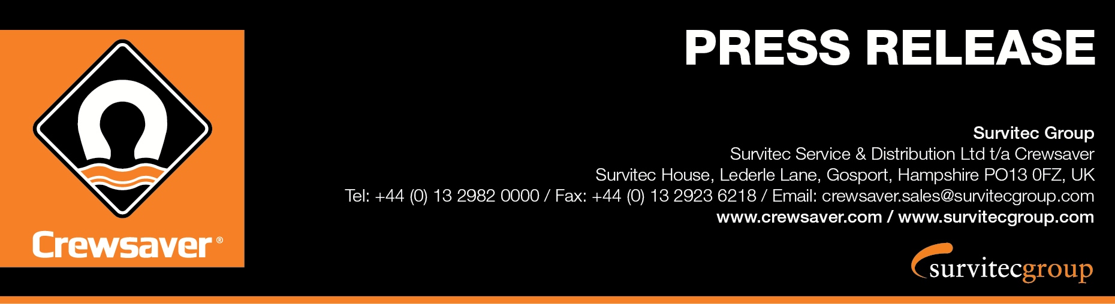
For Immediate Release
08th June 2016

Survitec Group supplies Crewsaver lifejackets to MBNA Thames Clippers

Survitec Group is excited to announce the supply of the Crewfit 165N Sport to MBNA Thames Clippers’ for their 15 catamaran fleet.

All lifejackets include an added custom name badge system for crew members, which has notable benefits for MBNA Thames Clippers. The allocation of the lifejackets with the name badge system will also ensure that each lifejacket is well looked after and allow crew members to treat it as if it were their own. In addition, customers will be able to easily identify staff adding a personal touch to their service.

‘MBNA Thames Clippers offer a fantastic service and we are really pleased to have been able to enhance this with the supply of these lifejackets,’ Paul Callus, Sales Manager – Survitec Group.

The MBNA Thames Clippers’ fleet carries 3.8 million passengers a year along the busy waters of the Thames and safety is paramount. The Crewfit 165N Sport from the popular Crewsaver Fusion 3D lifejacket range joins other Survitec Group products including liferafts, rope and Crewsaver Premier lifejackets procured for emergency use by passengers.

‘We went out to tender for our lifejacket contract in 2015 and we were really impressed by Survitec’s services and quality. The personalisation of lifejackets was important to us as we want our passengers to be able to engage with our crew’ Sean Collins, CEO, MBNA Thames Clippers

ENDS//

For media information, hi-res images or product tests please contact:

Crewsaver
Hazel Proudlock, Marketing Dept
T +44 (0) 1329 820406
E hazel.proudlock@survitecgroup.com

Or

Alison Willis – Marine Advertising Agency Ltd
T +44 (0) 23 9252 2044
E Alison@marineadagency.com

Notes to Editors

Crewsaver is a world-leading manufacturer of marine safety equipment and clothing for the commercial and leisure marine industries. Based in Gosport, Hampshire, the company designs and manufactures bespoke safety equipment for several countries’ Special Forces, and the aviation and oil industries. Crewsaver is the only company to hold an exclusive contract to supply lifejackets to the UK government’s Environment Agency and the Royal National Lifeboat Institution (RNLI). They are part of the Survitec Group.

www.crewsaver.com

Survitec Group holds market-leading positions worldwide in marine, defence and aerospace survival technology. Headquartered in Birkenhead, the company employs 2000 people across 10 manufacturing sites and 50 service centres, operating through a network of a further 550 distributors and agents to bring its best-in-class products and services to a global customer base. With an extensive history spanning over 160 years and a portfolio of some of the most reputable brands in the safety and survival industry, Survitec is committed to product innovation, technological advancement and quality assurance.
Key products within Survitec’s portfolio include marine, defence and aviation Liferafts, world leading submarine escape technology, lifejackets for commercial airlines and the offshore industry as well as pilot flight equipment, including anti-g clothing used for the Eurofighter and JSF programmes. The Group also pioneered marine evacuation technology and today the unique MarinArk system is used on many major cruise ships across the globe.

www.survitecgroup.com

