Press Release
For immediate release
13th June 2016

Mara EFS launches incentive scheme at Seawork (Stand SB26)

Following the development of Mara Buoy, an innovative new mooring buoy for yachts and small commercial vessels, Mara Engineering for the Sea (Mara EFS) is launching a buoy trial incentive scheme at Seawork (Stand SB26) this year.

Test buoys are now available at Portsmouth Harbour, Rhu Marina and Tobermory and Mara EFS is offering a £10 eGiftCard, from MarineGiftcards.com, to anyone who would like to trial the buoy.

All you need to do to receive your eGiftCard is leave a comment on the Mara Buoy Facebook page, along with a picture of your boat moored to the buoy, and the following information:

- Test buoy location
- Comments on using the buoy
- Boat type, size and name, if possible
- Wind and tidal conditions, if possible

On receipt of your feedback, Mara EFS will be in touch and will forward your eGiftCard to you. Your eGiftCard can be redeemed at various retailers including PerformanceSailingShop.com and Henri Lloyd.

Full details, including location co-ordinates, can be found on our website http://www.maraefs.com and on Mara Buoy’s Facebook page
https://www.facebook.com/Mara-Buoy-1681873772028059/

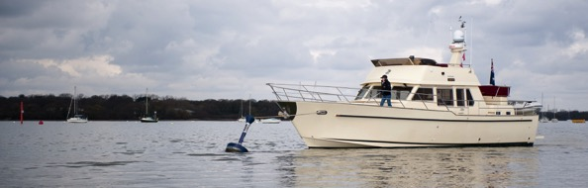

The Mara mooring buoys boast significant areas of improvement in terms of safety, ease of use, reliability, maintenance and night-time visibility. It can even be personalised with your own yacht name, logo or artwork.

The mooring line pick up point is at deck level and the mooring line ‘gives’ upon pick up allowing the deck hand time to make fast. The Mara 15:150D dynamic buoy features a highly reliable, galvanised steel backbone through which the mooring force is transmitted from the mooring line to the mooring chain. Reliability is also increased by the fact that the mooring line runs over radiused surfaces, which reduces chaff. Underwater swivel is eliminated by allowing the line to swivel inside the galvanised steel backbone.

To make maintenance easier, inspection of the mooring line and swivel are carried out through a window in the backbone. Underwater connection is by way of a shackle to the mooring chain, which gives a simple, strong connection and peace of mind. Reflective surfaces help to improve night-time visibility and close quarters navigation.

There is now an additional version of the Mara Buoy; the 15:100D which has all the features of the 15:150D but, at a height of 100cm above water, is suitable for smaller vessels. Two further models are now in development and will be available for trial next month.

Mara Buoy’s are in production and orders are now being taken. Visit www.maraefs.com or email info@marefs.com for further information.

High resolution images are available for download here: http://marineadagency.com/gallery/mara-buoy-on-test-with-rnsa/

ENDS//

Notes to Editors

Mara EFS is a brand name of Jebb Smith Ltd. Jebb Smith Ltd is a family owned business. Mara EFS has over three decades of offshore engineering heritage behind it. Patent Pending – application no. 1506556.8.

Media enquiries via Marine Advertising Agency

Mike Shepherd - mike@marineadagency.com
Emma Stanbury – emma@marineadagency.com
Tel: 023 9252 2044

