NEWS RELEASE
For immediate release
31st August 2016

SUPERYACHT TENDERS AND TOYS NUMBER ONE SUPPLIER OF TENDERS AND TOYS TO NEW BUILD YACHTS
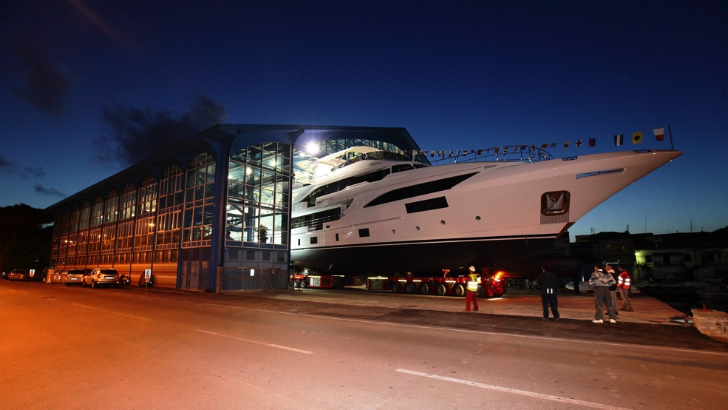
Superyacht Tenders and Toys (SYTT) outfitted two thirds of all new build yachts built in Germany in the first half of 2016 – cementing its position as the go-to supplier for tenders and toys to new builds.

The company offers a complete range of products for new build yachts from jetskis, wetsuits, dive kit and safety equipment to inflatables, towables, Seabobs, performance clothing, watersports toys and tenders. As Superyacht Tenders and Toys aren’t affiliated to any particular brand they are able to offer their clients choice not compromise, using their unrivalled expertise to advise on and source the right products based on requirements, restrictions and budget.

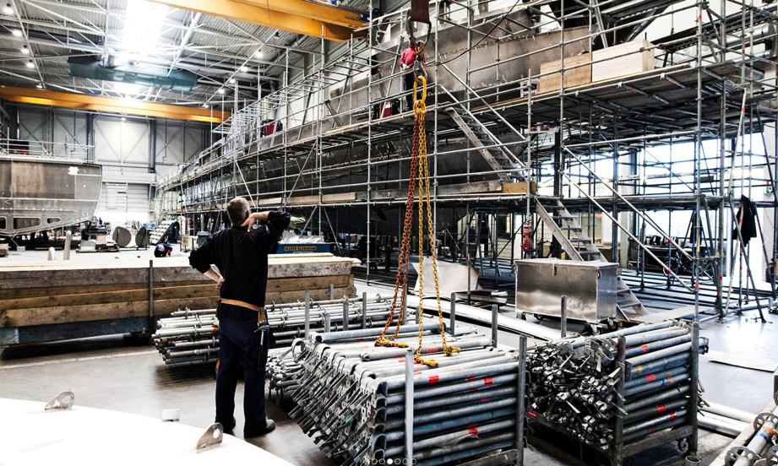
Superyacht Tenders and Toys simplify the process of outfitting new builds; having just one point of contact means savings can be made in terms of efficiency and delivery. Superyacht Tenders and Toys prides itself on its support and after sales service. All items purchased are supported for the lifetime of the goods, at no charge. Product specific training is also available when necessary.

Client satisfaction is key, Tripp Hock of Galactica Fleet says “Josh and his team at Superyacht Tenders and Toys did a fantastic job in a very short time (over the Christmas holidays no less) to totally outfit our latest new build with toys. They are dedicated, knowledgeable, and punctual.”

The company has added a new area to its website that is dedicated to new builds - http://superyachttendersandtoys.com/new-builds/

Josh Richardson, Director of Superyacht Tenders and Toys, said “We are very proud to be able to say that we have outfitted two thirds of new build yachts built in Germany so far this year. This is a fast-growing area of our business and we’re excited about the upcoming new build projects that we’re working on.”

To learn more about Superyacht Tenders and Toys, visit
www.superyachttendersandtoys.com

ENDS

Media enquiries via Marine Advertising Agency:
Alison Willis, alison@marineadagency.com
Emma Stanbury, emma@marineadagency.com
T: 023 9252 2044

For further information:
Download - images for editorial use http://superyachttendersandtoys.com/image-gallery/sytt-supplier-to-new-build-yachts/

