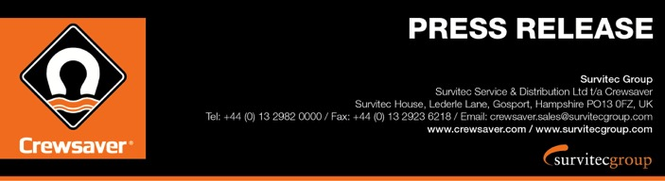
For Immediate Release:
22nd September 2016
Southampton Boat Show 16th – 25th September 2016
Ocean Hall – J250

Crewsaver #LifejacketSafe campaign strikes a chord with visitors to
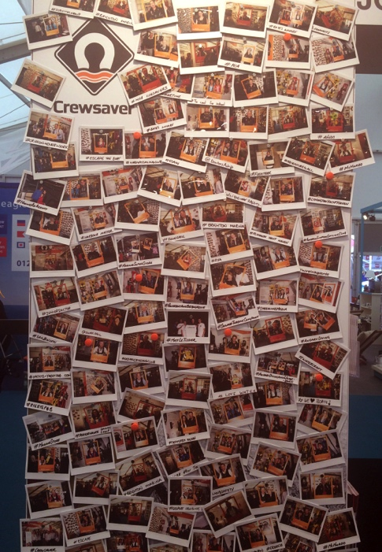
Southampton Boat Show 2016

Crewsaver has had a great response to its #LifejacketSafe campaign from visitors to the 2016 Southampton Boat Show, which started on 16th September and runs through to 25th September 2016. Hannah Burywood, Marketing Manager for Crewsaver, said “I’m delighted that Crewsaver retailers and the public have got behind the #LifejacketSafe campaign. It’s really important to us to get the message out to people about wearing, using and maintaining their lifejackets properly.” So far over 150 people have had their photos taken for Crewsaver’s #LifejacketSafe wall at the show, pledging their support for the campaign.

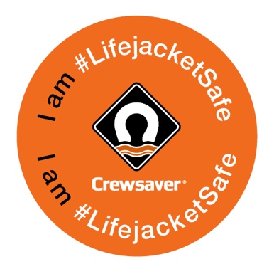
Crewsaver has been giving out advice on lifejacket safety on its stand (J250, Ocean Hall) during the Southampton Boat Show. The lifejacket manufacturer has produced a flier with handy do’s and don’ts and a selection of frequently asked lifejacket safety questions. Hannah Burywood revealed that the most common question the Crewsaver team has been asked so far is about lifejacket servicing. “There seems to be a lot of confusion over lifejacket servicing. Our recommendation would be that your lifejacket is serviced by a professional every year. Crewsaver has a network of approved service stations and a search facility on our website to help find the closest one to you.” she said.
The Crewsaver #LifejacketSafe photo wall at Southampton Boat Show 2016

The new Crewsaver complete children’s lifejacket range was launched at the show and has also attracted a lot of attention from visitors. The new Euro 100N children’s foam lifejacket is available for the first time and the updated Supersafe 150N foam lifejacket is also debuting at the show. In order to help visitors choose the right children’s lifejacket for their activity, Crewsaver has produced a handy guide to children’s lifejackets, which is also available on its stand at the show.
Crewsaver is giving out #LifejacketSafe stickers at Southampton Boat Show to those who have their photo taken to pledge support for the campaign

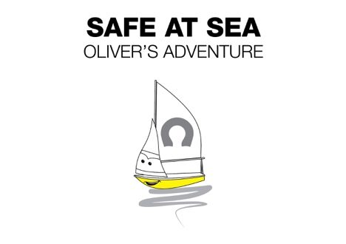
A children’s storybook ‘Safe at Sea – Oliver’s Adventure’ is another tool that Crewsaver is using to educate the next generation and encourage them to be #LifejacketSafe. The story follows the adventures of Oliver, a young sailboat who looks up to Rory the speedboat, who chooses not to wear a lifejacket and inevitably gets into trouble.

Visitors to the show who have their photo taken for the Crewsaver #LifejacketSafe wall will also be entered into a competition to win an Abu Dhabi Ocean Racing lifejacket that was actually worn by a member of the Abu Dhabi Ocean Racing Team, who won the Volvo Ocean Race.
The cover of the Crewsaver children’s storybook ‘Safe at Sea – Oliver’s Adventure’

ENDS//

For media information, hi-res images or product tests please contact:

Crewsaver
Hazel Proudlock, Marketing Dept
T +44 (0) 1329 820406
E hazel.proudlock@survitecgroup.com

Or

Alison Willis – Marine Advertising Agency Ltd
T +44 (0) 23 9252 2044
E Alison@marineadagency.com

Notes to Editors

Crewsaver is a world-leading manufacturer of marine safety equipment and clothing for the commercial and leisure marine industries. Based in Gosport, Hampshire, the company designs and manufactures bespoke safety equipment for several countries’ Special Forces, and the aviation and oil industries. Crewsaver is the only company to hold an exclusive contract to supply lifejackets to the UK government’s Environment Agency and the Royal National Lifeboat Institution (RNLI). They are part of the Survitec Group.

www.crewsaver.com

Survitec Group holds market-leading positions worldwide in marine, defence and aerospace survival technology. Headquartered in Birkenhead, the company employs 2000 people across 10 manufacturing sites and 50 service centres, operating through a network of a further 550 distributors and agents to bring its best-in-class products and services to a global customer base. With an extensive history spanning over 160 years and a portfolio of some of the most reputable brands in the safety and survival industry, Survitec is committed to product innovation, technological advancement and quality assurance.
Key products within Survitec’s portfolio include marine, defence and aviation Liferafts, world leading submarine escape technology, lifejackets for commercial airlines and the offshore industry as well as pilot flight equipment, including anti-g clothing used for the Eurofighter and JSF programmes. The Group also pioneered marine evacuation technology and today the unique MarinArk system is used on many major cruise ships across the globe.

www.survitecgroup.com
