Press Release
For immediate release
15th September 2016

Mara EFS launches Mara Buoy Static

Following on from the success of the Mara Buoy, an innovative new mooring buoy for yachts and small commercial vessels, Mara Engineering for the Sea (Mara EFS) has developed a further version of the buoy called the Mara Buoy Static. The Mara Buoy Static brings a simpler product to the market, at a highly competitive price, whilst retaining the substantial benefits loved by users of Mara Buoy. The original Mara Buoy is now known as the Mara Buoy Dynamic.

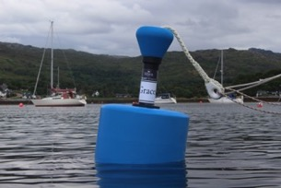
The Mara Buoy Static offers the following features:

- Deck level mooring system
- Customisable graphics
- High structural integrity
- Ease of use
- Designed to be heard-wearing

Mara Buoy Static
The Mara Buoy Static is simple to use; when approaching the buoy, the crew-member simply picks up the Mara Buoy eye, passes their own line through the eye and then brings it back on board. The low friction, smooth surface of the eye itself is designed to be very kind to mooring lines, virtually eliminating short to medium term chaff. A second mooring line, or chain, can easily be rigged as a back up if required.

Both the Mara Buoy Static and the Mara Buoy Dynamic will be exhibited at the Scottish Boat Show 14th – 16th October 2016.

Mara EFS will be undertaking a road-trip in October, showing both the Static and Dynamic Mara Buoys at marinas along the West Coast of Scotland. A further trip is planned for the South Coast of England in either late October or early November. These trips will offer a great opportunity to see the many benefits of these buoys over standard mooring systems.

Full details can be found on our website http://www.maraefs.com and on Mara Buoy’s Facebook page, https://www.facebook.com/Mara-Buoy-1681873772028059/, with a video available shortly.

Mara Buoys are in production and orders are now being taken. Visit www.maraefs.com or email info@marefs.com for further information.

High-resolution images are available for download here: http://marineadagency.com/media-centre/

ENDS//

Notes to Editors

Mara EFS is a brand name of Jebb Smith Ltd. Jebb Smith Ltd is a family owned business with over three decades of offshore engineering heritage behind it. European Registered Design No 003124676.

Media enquiries via Marine Advertising Agency

Mike Shepherd - mike@marineadagency.com
Emma Stanbury – emma@marineadagency.com
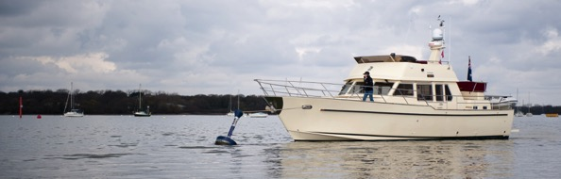
Tel: 023 9252 2044
Mara Buoy Dynamic

