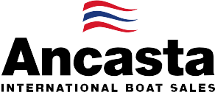

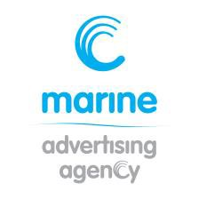
N e w s R e l e a s e
FOR IMMEDIATE RELEASE
19th September 2016

Dame Ellen MacArthur christens new Beneteau Sense 57 at Southampton Boat Show 2016

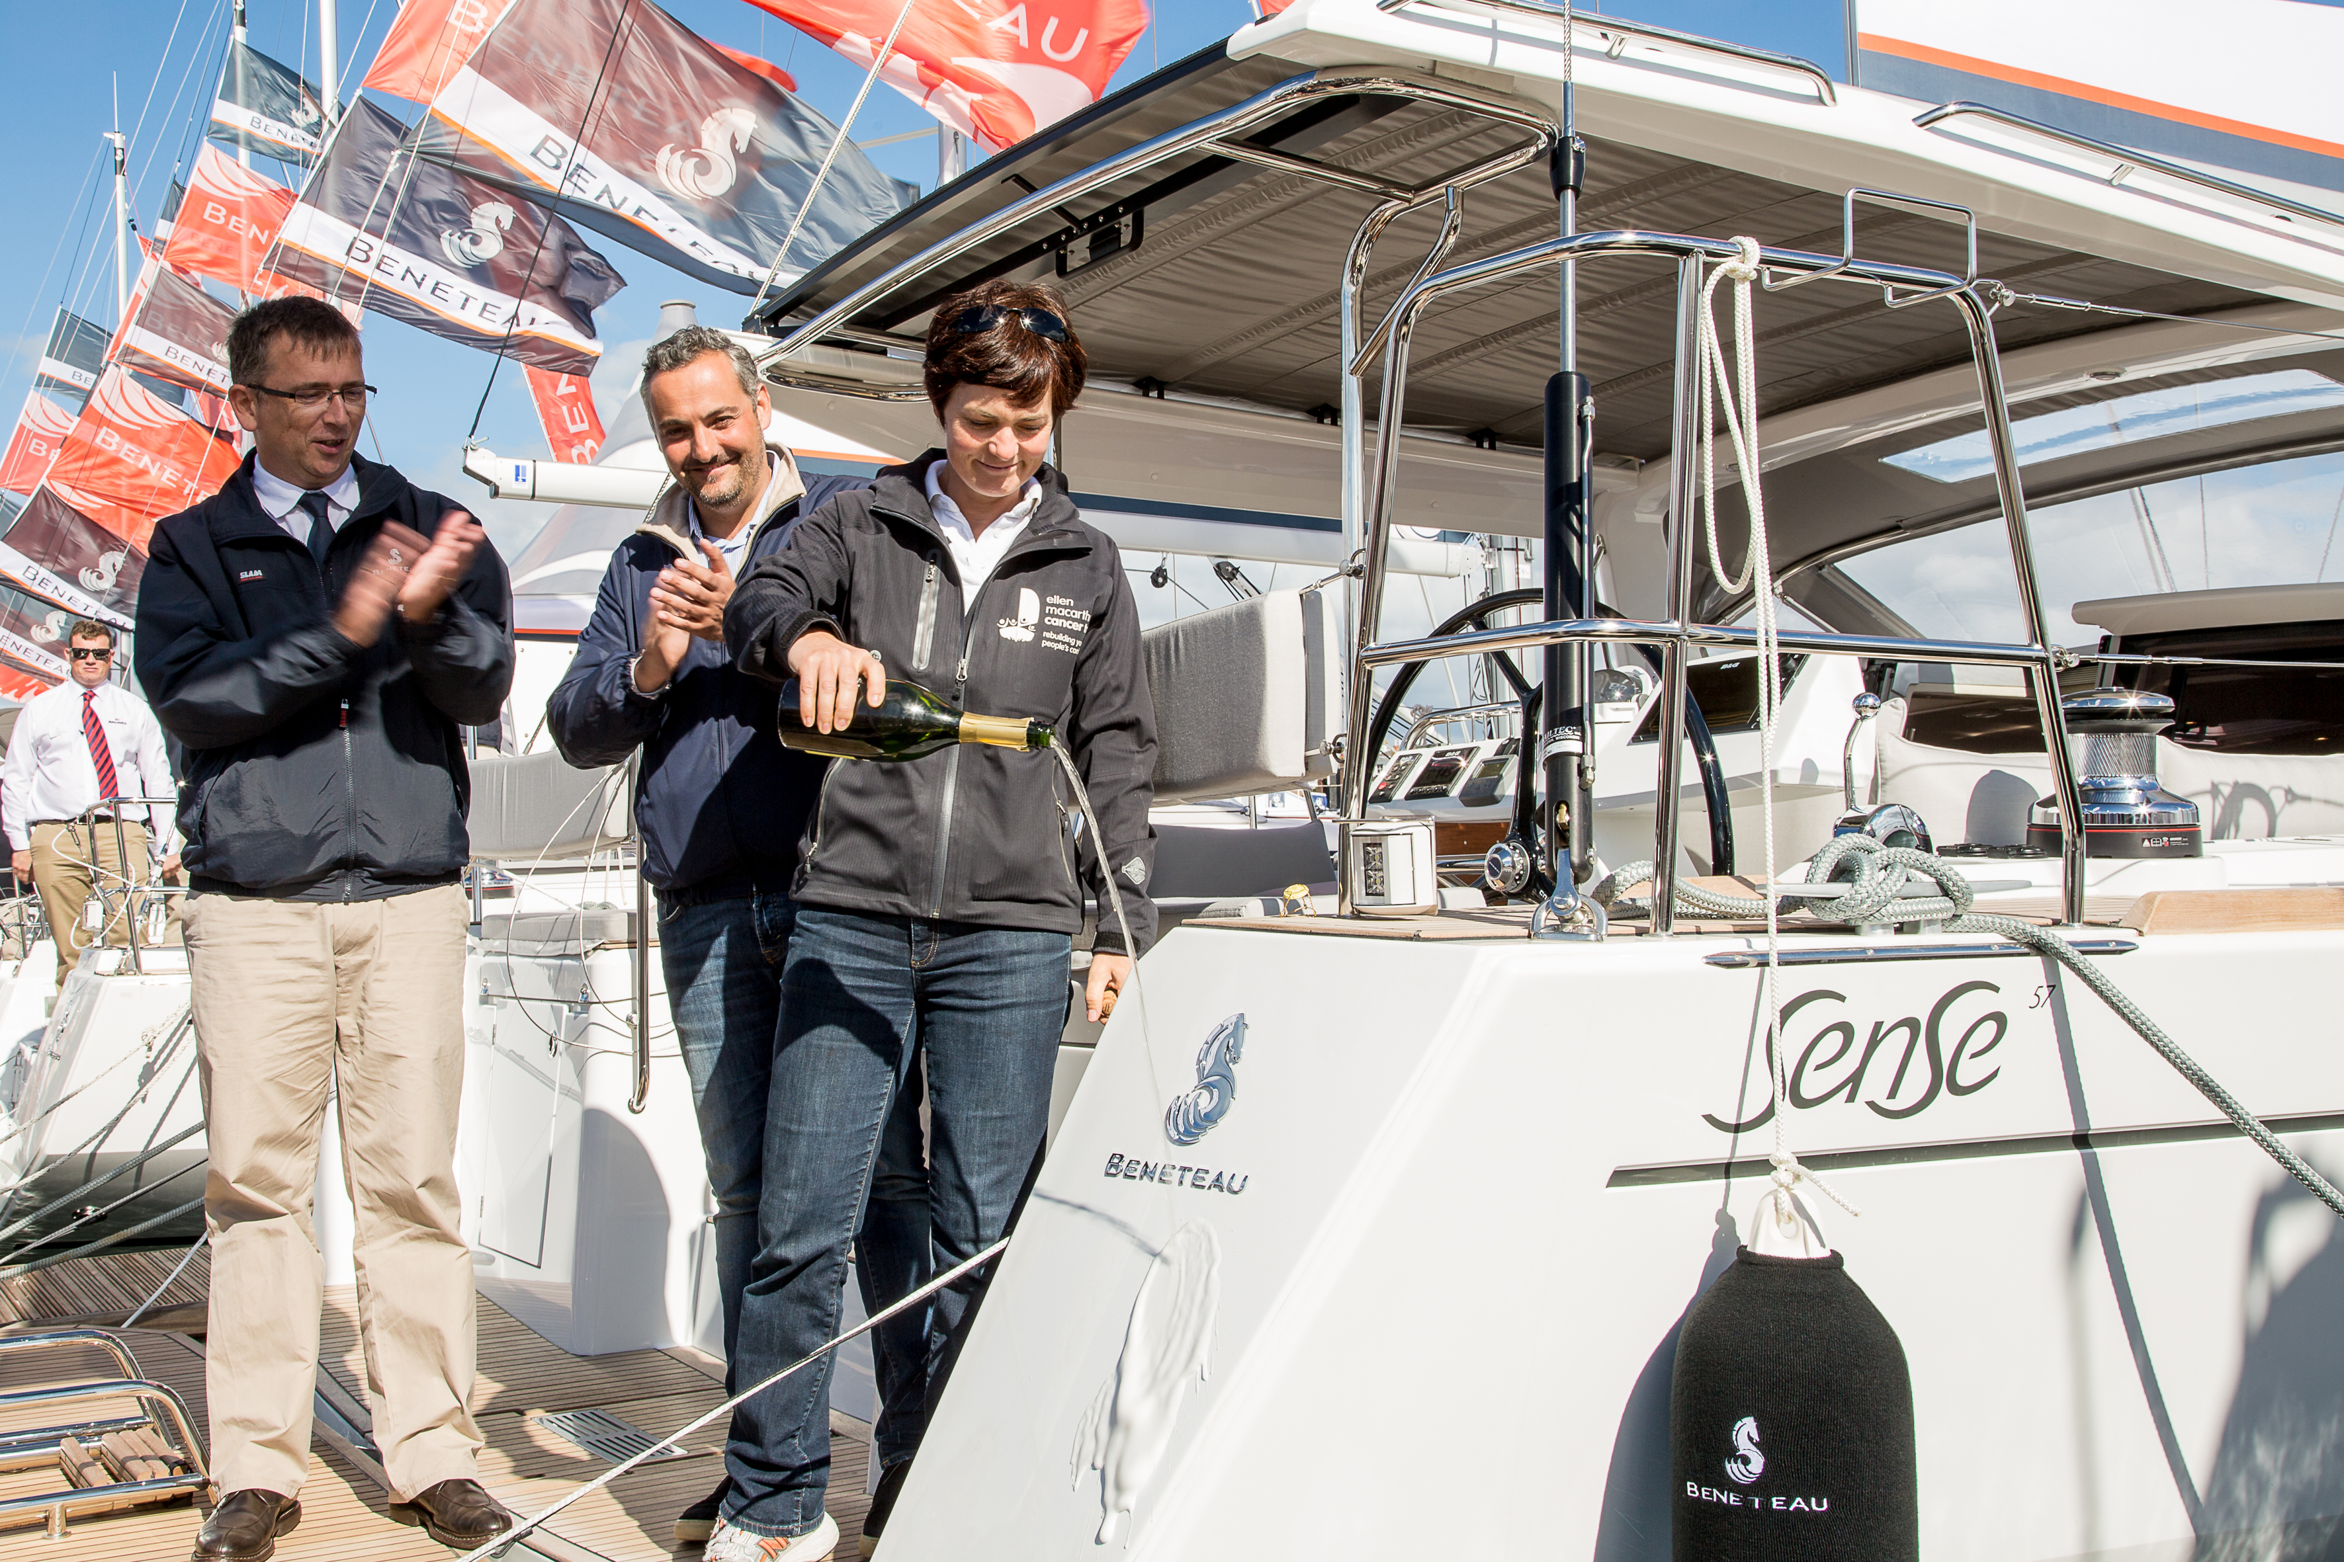
The new Beneteau Sense 57, which makes its UK debut at the 2016 Southampton Boat Show, was christened by Dame Ellen MacArthur, on the opening day of the show, Friday 16th September 2016. Ancasta, the UK’s largest Beneteau Sail dealer, is presenting the Sense 57 at the show.
Commenting on the event, Beneteau tweeted that they “couldn’t wish for a better godmother”. A sailing legend, Dame Ellen was a natural choice to christen the new Sense 57. She is most well known for having held the record as the fastest solo circumnavigator of the globe (which she achieved in 2004) and founding the Ellen MacArthur Cancer Trust, which takes young people in recovery from cancer out sailing to rebuild their confidence. Her other sailing achievements include sailing single-handed around Britain in 1995, coming second to Michel Desjoyeaux in the Vendée Globe in 2001 and winning the Route du Rhum in 2002. Ellen has also been awarded France’s highest decoration, the Legion d’honneur, making her a perfect choice for the French brand as the Sense 57’s ‘godmother’.

The new Sense 57 is the latest in Beneteau’s Sense range. Designed by Berret-Racoupeau and Nauta Yachts, the Sense 57 is supremely comfortable. The unique deck plan has the cabins located to the bow so that the cockpit can be set lower. This means that the Sense 57 sits lower on the water, giving it sleek lines. It is perfectly balanced under sail and remains highly manoeuvrable even with a limited crew, giving cruising comfort that is second to none.

Specification:
Base price £341,826 ex VAT
On the water price £382,879 ex VAT
LOA 17.78m
Hull Length 16.80m
LWL 15.93m
Maximum Beam 4.97m
Cruising Speed 8kn
Dry (Light) Weight 18,780kg
Category of Sailing A, B & C
Standard Sail Area 152m sq
Standard Fuel Capacity 415 L
Standard Water Capacity 640 L

Visitors to Southampton Boat Show, which runs from 16th to 25th September 2016, can view the Sense 57 on berth M121. Call Ancasta on 023 80 450 000 to make an appointment to view.
To find out more about the Sense 57 visit http://www.ancasta.com/boats-for-sale/new-boats/beneteau-sail/sense/57/

ENDS

Notes to editors

About Ancasta
  - Ancasta International Boat Sales has 14 offices across Europe
  - Ancasta is the UK’s largest Prestige Luxury Motor Yachts dealer, the UK’s largest Beneteau Power and the UK’s largest Beneteau Sail dealer
  - Ancasta is exclusive UK dealer for Lagoon Catamarans
  - In addition Ancasta is a new boat dealer for CNB Yacht Builders and McConaghy Yachts
  - The Ancasta Group incorporates Hamble Yacht Services Refit & Repair and Advanced Rigging and Hydraulics, both operating from Port Hamble.
  - For more information on Ancasta visit www.ancasta.com
Media enquiries via Marine Advertising Agency:
Alison Willis - alison@marineadagency.com
Tel: 023 9252 2044

