NEWS RELEASE
For immediate release
10th October 2016

SUPERYACHT TENDERS AND TOYS SUPPLIES 40 MPH ELECTRIC CYCLES TO MY Cloudbreak

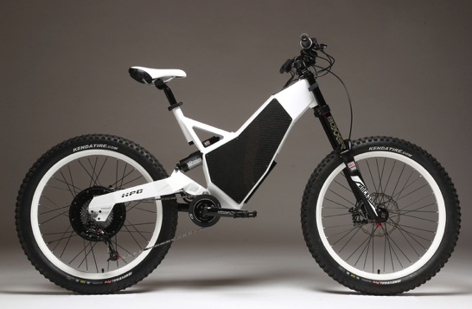
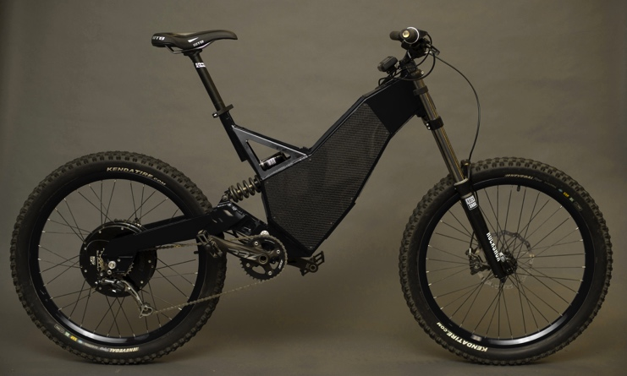
Superyacht Tenders and Toys (SYTT) has supplied three custom black high-performing HPC Revolution electric bikes to exciting new build MY Cloudbreak. The electric bikes, which can hit speeds of over 40mph and have featured on the US version of Top Gear, were designed by aerospace engineers and are hand built in the USA. They are a new addition to SYTT’s portfolio of products that it can supply to its superyacht clients.
The HPC Revolution in black

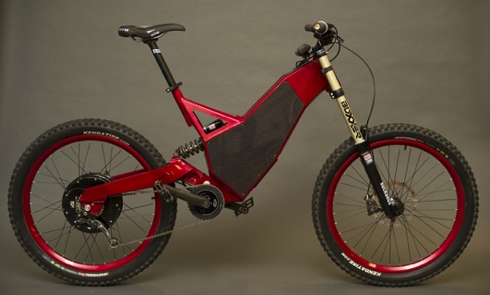
The latest 2017 HPC Revolution electric bikes are unlike any other bike with carefully optimised suspension performance and ‘proper geometry’. They are the flagship bike of Hi-Power Cycles (HPC) and are the result of three years of research and development, multiple prototypes, and hours of real world and CAD analysis.

Mark Peak, Yacht Toy Specialist at Superyacht Tenders and Toys, who has tried out the bikes, says “The HPC Revolution was a thrill to ride. Renowned for being the fastest, most nimble, lightest and powerful downhill electric bike in the world it did not disappoint. These bikes aren’t for the faint hearted as they offer extreme performance in all conditions. No matter of age and ability, these machines will leave the rider grinning from ear to ear.”
The flagship HPC Revolution looks striking in white and red too

SYTT offers a complete range of products for new builds from jetskis, wetsuits, dive kit and safety equipment to inflatables, towables, Seabobs, performance clothing, watersports toys and tenders via everything in between.

Working with superyachts worldwide and a large number of new build projects, Superyacht Tenders and Toys prides itself on its support and after sales service. All items purchased are supported for the lifetime of the goods, at no charge.

Josh Richardson, Director of Superyacht Tenders and Toys, said “These HPC Revolution electric bikes are not to be messed with. With the ability to reach speeds up to 40mph and a range of 50 miles, they are an exciting toy, unlike any other bike, and as such perfectly suited to the superyacht market and a great addition to any superyacht toy garage.’

To learn more about Superyacht Tenders and Toys, visit
www.superyachttendersandtoys.com

ENDS
Media enquiries via Marine Advertising Agency:
Alison Willis, alison@marineadagency.com
T: 0044 (0)23 9252 2044 or Mobile: 0044 (0)7980 009653

For further information:
Download - High Resolution images for editorial use http://superyachttendersandtoys.com/image-gallery/hpc-revolution-electric-cycles/

