NEWS RELEASE
For immediate release
8th September 2016

SUPERYACHT TENDERS AND TOYS OFFERS CUSTOM TENDER DESIGN SERVICE AT MONACO YACHT SHOW
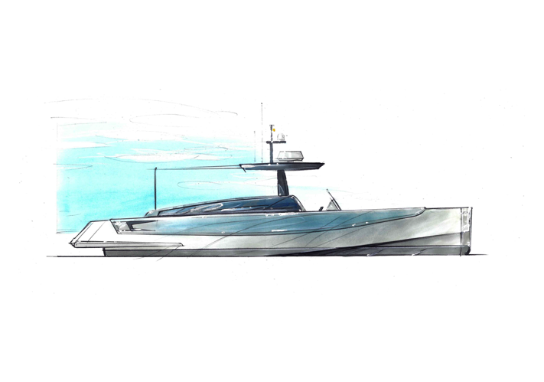
Superyacht Tenders and Toys (SYTT) will have its designer on hand at Monaco Yacht Show, which takes place 28th September to 1st October 2016, to offer custom tender design by appointment at the show.

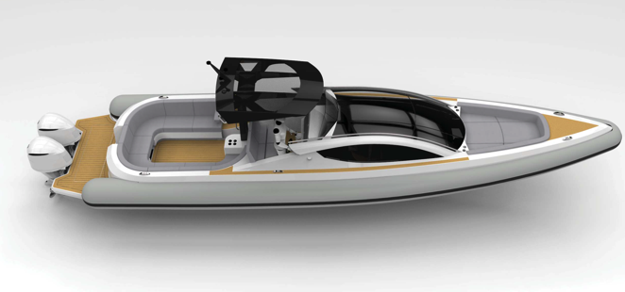
Superyacht Tenders and Toys, who outfitted, amongst others, the notable MY Ulysses, which will be at anchor off the show, is experienced in providing custom tender solutions for yachts. The company’s skilled designer creates individual designs to fit the client’s brief, taking into account the constraints of the mother vessel tender garage. Custom tenders offer owners the opportunity to possess something completely unique. Offering this design appointment service at Monaco Yacht Show allows yacht owners, captains, crew and professionals to visualise their custom tender and discuss preferences and requirements.
Custom tender design by appointment at Monaco Yacht Show

SYTT is well positioned to offer new tender consultancy services. The company has worked on a number of complex projects and works with all the major shipyards, allowing it to make informed recommendations. Not being affiliated to any particular brand allows the team to offer unbiased advice. As SYTT have built previously with all shipyards, they have unrivalled knowledge and experience to add to any tender build, also negotiating the best pricing.

The company is proud to have outfitted many of the yachts at this year’s Monaco Yacht Show including MY Ulysses, MY Saint Davids, MY Amore Mio, MY Capri, MY Bijoux, MY Giaola-Lu, SY Emmaline, MY Entourage and MY Ouranos. SYTT recently announced that it had outfitted two thirds of all new

build yachts built in Germany in the first half of 2016 – cementing its position as the go-to supplier for tenders and toys to new builds.

The company is encouraging visitors to the show to visit the Superyacht Tenders and Toys stand (QAA45 – Quai Antoine 1er Tent A) or to arrange a visit from the team to discuss their tender and toy needs. It prides itself on achieving exceptional value for its clients and offering superlative support and after sales service, essential added value. For example, all items purchased are supported for the lifetime of the goods, at no charge, and product specific training is also available.

Josh Richardson, Director of Superyacht Tenders and Toys, said, “We are excited to be able to offer a custom tender design service at Monaco Yacht Show again this year, this proved very popular last year. We are also excited that so many of the yachts that we have outfitted are at the show, it’s a great way to showcase our services. We look forward to discussing future projects and having the opportunity to show why Superyacht Tenders and Toys are trusted by so many captains and owners and why we are the number one supplier to new build yachts.”

To make an appointment with the team at Monaco Yacht Show email
info@superyachttendersandtoys.com or call +44 238 0016 363

To learn more about Superyacht Tenders and Toys, visit
www.superyachttendersandtoys.com

ENDS
Media enquiries via Marine Advertising Agency:
Alison Willis, alison@marineadagency.com
Emma Stanbury, emma@marineadagency.com
T: 023 9252 2044
For further information:
Download images for editorial use http://superyachttendersandtoys.com/image-gallery/monaco-yacht-show/

