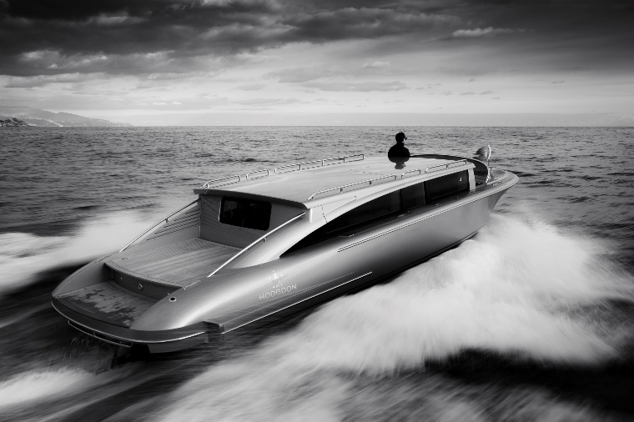

News Release
For immediate release
12 September 2016

Superyacht Tenders & Toys offers Yacht Carbon Offset option

Superyacht Tenders & Toys is delighted to jointly announce, with Yacht Carbon Offset, the introduction of its Yacht Carbon Offset option for craft with engines over 75hp. In outfitting some of the world’s most prestigious yachts with tenders such as limousines, chase boats, SOLAS rescue boats and high-powered RIBs, Superyacht Tenders & Toys recognises that several of its clients would welcome an “environmental upgrade” and the chance to offset their greenhouse gas emissions. This new Yacht Carbon Offset option is a response to this.

For each craft with engines over 75hp, the new owner will be invited to select a Yacht Carbon Offset option to counteract the estimated greenhouse gas impact of 200 hours of operation at cruising speed. Clients that charter tenders will also be given the option to offset the actual or estimated fuel requirement.

Claire Richardson of Superyacht Tenders and Toys, said: “We recognise that yacht owners are becoming more environmentally conscious both in their businesses and their leisure time but they don’t want to compromise on choice of tenders. This offers an alternative so that they can still enjoy high powered tenders but also address their environmental impact if they wish.”

Mark Robinson of Yacht Carbon Offset added: “The thrill of powered watertoys, jetskis and sport-boats has become a central part of the superyacht experience, and tenders are essential for transferring guests in safety and comfort. These craft are often powerful and busy, so it makes sense to react to the corresponding environmental impact. We are excited to be working with the growing team at Superyacht Tenders & Toys to bring this option to their discerning clients.”

Yacht Carbon Offset provides a fully-documented service to counteract the carbon footprint of superyachts. For details, visit www.yachtcarbonoffset.com

To learn more about Superyacht Tenders & Toys, visit www.superyachttendersandtoys.com

ENDS

For further information:
Yacht Carbon Offset:
Mark Robinson +44 20 7016 7700 info@yachtcarbonoffset.com

Superyacht Tenders & Toys:
Claire Richardson +44 2380 016 383 info@superyachttendersandtoys.com

Media enquiries:
Marine Advertising Agency
Alison Willis +44 2392 522 044 alison@marineadagency.com

Notes for editors:

Superyacht Tenders and Toys
Superyacht Tenders and Toys is the leading yacht tender and yacht toy consultancy company specialising in providing yachts, owners and captains with a one stop shop for all superyacht tender and toy needs.

The company offers choice, not compromise, offering the very best solution for your needs. Built upon the foundations of experience and a vast network of good relationships, Superyacht Tenders and Toys has the resources required to assist with any project or enquiry and to pass on the best possible prices on all purchases. Whether you are an owner, captain or industry professional, Superyacht Tenders and Toys has a tailor-made solution for you.

Superyacht Tenders and Toys handles all aspects of tender and toy ownership and is proud to support the world’s finest yachts. Based upon your purchase or rental requirements they will respond with all suitable options at the best price available together with timescales for supply and shipping. The support does not stop on delivery; Superyacht Tenders and Toys offers full service and repair facilities in the UK and globally through our partner network, plus warranty support, spare parts procurement and supply of safety equipment – all with global delivery.

Further details are available on www.superyachttendersandtoys.com

Yacht Carbon Offset
Yacht Carbon Offset provides a clear, auditable way to counteract the carbon footprint of a vessel’s engines and generators. Tonne for tonne, the yacht’s emissions are offset by equivalent greenhouse gas reductions from projects such as renewable power. Each project depends on the carbon funding, and Yacht Carbon Offset has Lloyds Register Quality Assurance Certification, so clients know that their action makes a real impact on net emissions.

The “pay as you go” service is calculated from the fuel quantities specified, whether a recent delivery, a single charter or for the whole season’s cruising. There’s no onboard equipment and there is no long term obligation for the yacht. The option can be included as an option for any charter client, or adopted as standard procedure by any yacht.

Carbon Offsetting is of interest to owners or charterers wishing to take practical steps to minimise environmental impact, and is also welcomed by prominent individuals or businesses that might welcome an “environmental upgrade”. It is particularly relevant when cruising in environmentally sensitive areas.

Yacht Carbon Offset Limited is an independent UK company which launched its specialist service in 2008. It was delighted to be the winner of the 2011 International Superyacht Society Fabien Cousteau Blue Award.

Further details are available on www.yachtcarbonoffset.com

