News Release
For immediate release
25th October 2016

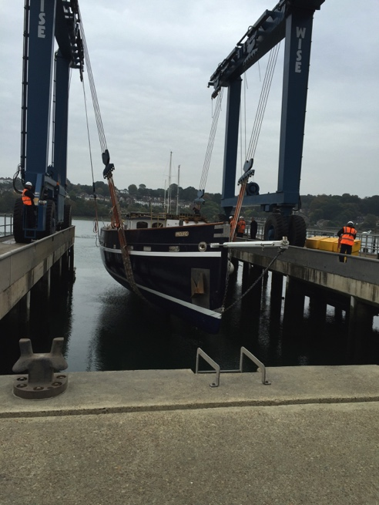
Ocean Youth Trust South’s new sail training vessel re-launched after 12-month refit
Ocean Youth Trust South’s new sail training vessel, Prolific, was re-launched on Monday 24th October 2016 following a 12-month refit at Saxon Wharf, Southampton.

Prolific will further the work of Ocean Youth Trust South, helping young people aged 12-25 – many of them disadvantaged and vulnerable – to develop the skills they need to succeed in life: confidence, team-work, communication, resilience and the ability to cope with unfamiliar experiences. The new sail training vessel, which was bought from Norway in 2015, is the long-term replacement for the Trust’s previous boat, John Laing, which has taken thousands of young people to sea over the last 26 years with the Ocean Youth Club and Ocean Youth Trust South.
Ocean Youth Trust South’s new sail training vessel Prolific is re-launched following 12-month refit
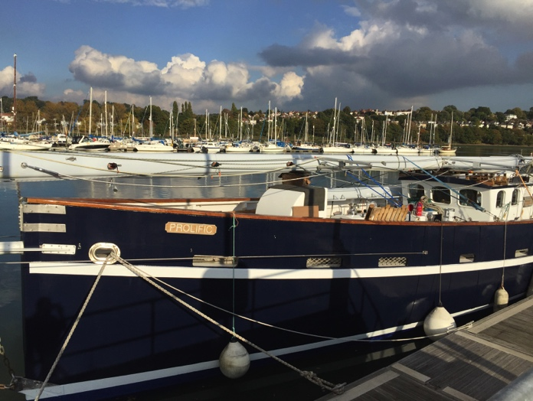
The extensive refit was only possible through the support of major sponsors like International Paint, who are responsible for Prolific’s beautiful paintwork, and Marina Developments Limited who, as well as helping to raise money for Prolific’s purchase, provide free berthing and support with the lift-out and storage during the refit. Sail specialist Andy Cassell from Ratsey and Lapthorn (Cowes) Ltd went on a trial sail in Prolific in order to be able to advise on how to get the best out of the sails for the work that the Trust does. Members of the Owen Clarke Design team also went out in the new vessel to advise on how to optimise Prolific’s rig for sail training, and are involved in the design of a new mizzen mast and other improvements. Other major sponsors include BSI A/S who supplied Prolific’s standing rigging at a special rate; Holman Fenwick Willan LLP, who gave legal advice throughout the purchase; and Spinlock who serviced all the deck hardware.
Back in the water – Ocean Youth Trust South’s new sail training vessel Prolific

Post-refit, Prolific, which was built in 2005 and is a hybrid of modern-day construction and an historic design based on 19th-century herring fishing vessels, offers modern accommodation and a low-maintenance design. Crucially the low-maintenance design will allow OYT South to focus on its charitable work (http://www.oytsouth.org/charity.asp) allowing the Trust to continue, with Prolific, for the next thirty years.

Over the winter, Prolific has a busy programme of sea trials and staff and volunteer training, as the adults who sail on the charity’s voyages get to grips with working on board a very different boat. From April to November 2017 there is a full programme of youth voyages, including an expedition to the Baltic and back in summer, visiting Germany, Denmark, Sweden, Finland, Lithuania and Poland, taking in some Tall Ships races and festivals. Much of the rest of the year involves local voyages out of Southampton.

Mark Todd, Ocean Youth Trust South’s Chief Executive, says: “There has been huge enthusiasm amongst our existing clients plus a number of organisations such as schools, other charities and youth groups which want to start sailing with us In Prolific – bookings now are busier than they have ever been and we are delighted that our decision to buy Prolific has created such a sense of excitement about her potential to make a lasting difference to young lives.

“Prolific’s refit has been a major project involving modifications to meet the charity’s requirements and the needs of the young people, plus significant amounts of new gear and extensive testing and servicing. Although she is now back in the water she is still awaiting a new mizzen mast and a complete new suit of sails. But we could never have reached this point without the invaluable help of a number of major sponsors. The purchase price and refit have been funded by the incredible generosity of a very large number of donors; but the whole project has been made possible by a number of key sponsors to whom we are enormously grateful.

“OYT South is thrilled to have brought this unique boat to the UK, and we hope that the sailing community in the Solent and around the British coast will welcome Prolific as she starts sailing in her new home waters.”

More details on Prolific can be found at: http://www.oytsouth.org/prolific.asp

Find the 2017 voyage programme with remaining vacancies for young people here: http://www.oytsouth.org/2017.asp.

Details on support from major sponsors:

Marina Developments Limited – they provide free berthing for both boats in addition to massive support with the lift-out and storage during the refit. They also helped to raise money for Prolific’s purchase and we really couldn't have taken on the project without them.

International Paint – Prolific’s beautiful paintwork is all thanks to International Paint, who provided invaluable advice plus Awlgrip for the masts; their latest polishing antifoul for underwater and Toplac for the hull; Woodskin for the deck lockers and the interior and exterior primers.

Holman Fenwick Willan LLP – major law firm with vast marine expertise – they provided all the legal advice on the purchase and import duty.

Ratsey and Lapthorn (Cowes) Ltd - discounted sails and advice- Andy Cassell came on a trial sail in Prolific to advise on how we can get the best out of the sails for the work we do. His years of experience and his understanding and appreciation of how we aim to work with young people have been crucial.

Owen Clarke Design - Merf Owen and Allen Clarke came on a trial sail to look at how to optimise the rig for sail training and produced a detailed rig analysis on the suitability and survivability for the rig in a sail training environment. They are also helping with the design of a new mizzen and other improvements and modifications including a new inner forestay.

BSI A/S - supplying all our standing rigging at discount

Spinlock – servicing all our deck hardware

ENDS

More information: Caroline White, caroline.white@oytsouth.org, 07986 354697

