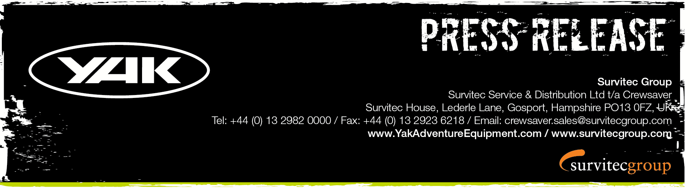
For Immediate Release
29th September 2016

#WheresYakAt competition, less than 1 week to go!
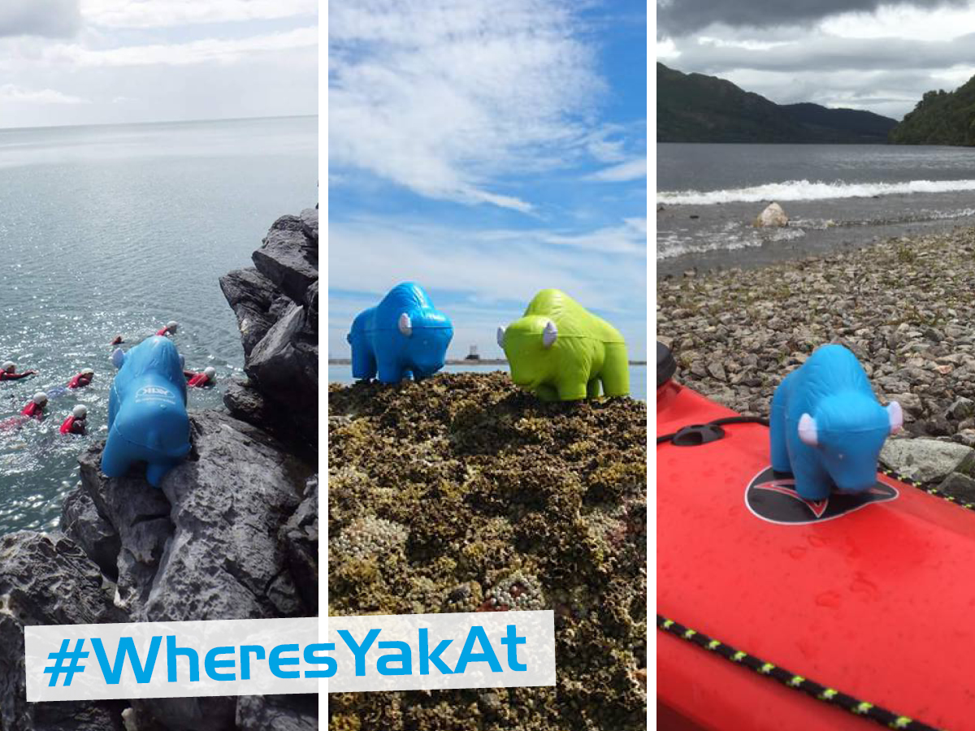
The #WheresYakAt competition has been hugely popular and with less than 1 week to go, you can still enter and be in for the chance of winning up to £1000 worth of Yak Adventure Equipment!

The photo competition has captivated the adventurer inside us all and Yak has received hundreds of entries capturing ‘squishy Yak’ in action. From paddling in the French Alps, days out at the Lee Valley White Water Centre and even lending a helping hand in the Europa Point lighthouse, Yak has certainly been busy!

#WheresYakAt - Win £500 worth of Yak gear
Contact Yak to find out how to receive your FREE squishy Yak and snap the best pic of your Yak going about its crazy business. Post your photo on the Yak Adventure Equipment Facebook page with #WheresYakAt, to be in with a chance of winning.
In addition, for the dedicated Yak fan, Yak introduced #WheresYakAtDoubleUp, a brand new competition whereby two Yaks are required to enter.
#WheresYakAtDoubleUp - Win £1,000 worth of Yak gear
If you have been dedicated enough to keep your green Yak from last year’s competition and have managed to get your hands on this year’s blue Yak then you can enter the #WheresYakAtDoubleUp competition. Capture what shenanigans the blue and green Yaks get up to when teamed up and post it on the Yak Adventure Equipment Facebook page with #WheresYakAt and #WheresYakAtDoubleUp.
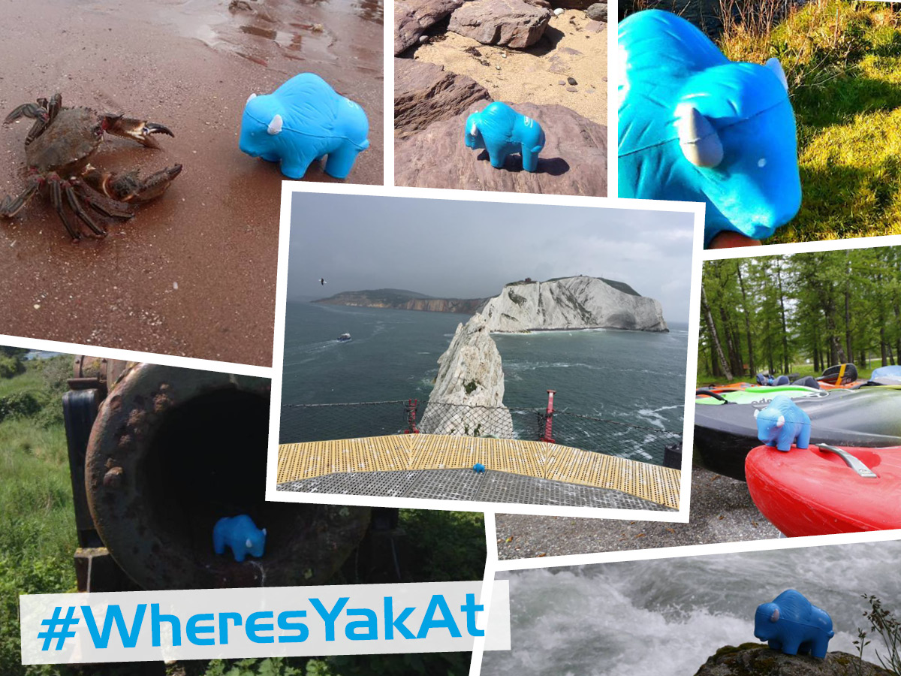
How to enter
‘Like’ the Yak Adventure Equipment Facebook page and upload your photo to the Yak Facebook page to enter with the #WheresYakAt & #WheresYakAtDoubleUp (if applicable). Make sure you say where it is and make your post public! You can post as many pictures as you like.

#WheresYakAt – The winner for this will be selected by you, to cast your votes hit ‘like’ on your favourite picture, the picture with the most ‘likes’ wins.
#WheresYakAtDoubleUp – The winner will be selected by the TriSUP Events team, the image chosen will be selected on its creativity, uniqueness and general fun factor.
Winners announced October 10th 2016. T’s & C’s apply, visit our website for details. E&OE.
ENDS//

For media information, hi-res images or product tests please contact:

Hazel Proudlock, Marketing Dept - Yak Adventure Equipment
T +44 (0) 1329 820406
E hazel.proudlock@survitecgroup.com

Or

Alison Willis – Marine Advertising Agency Ltd
T +44 (0) 23 9252 2044
E Alison@marineadagency.com

Notes to Editors
Part of the Survitec Group, which also owns Crewsaver, Yak Adventure Equipment produces and manufactures products that are purposely designed for whitewater, recreational and touring kayaking as well as canoeing. Yak Adventure Equipment offers a wide range of products to suit all styles and experience, giving paddlers more choice and opportunity to enjoy their sport with total peace of mind. Yak’s products include buoyancy aids, drysuits, cags, trousers, spray decks, gloves, footwear, headwear and buoyancy bags.
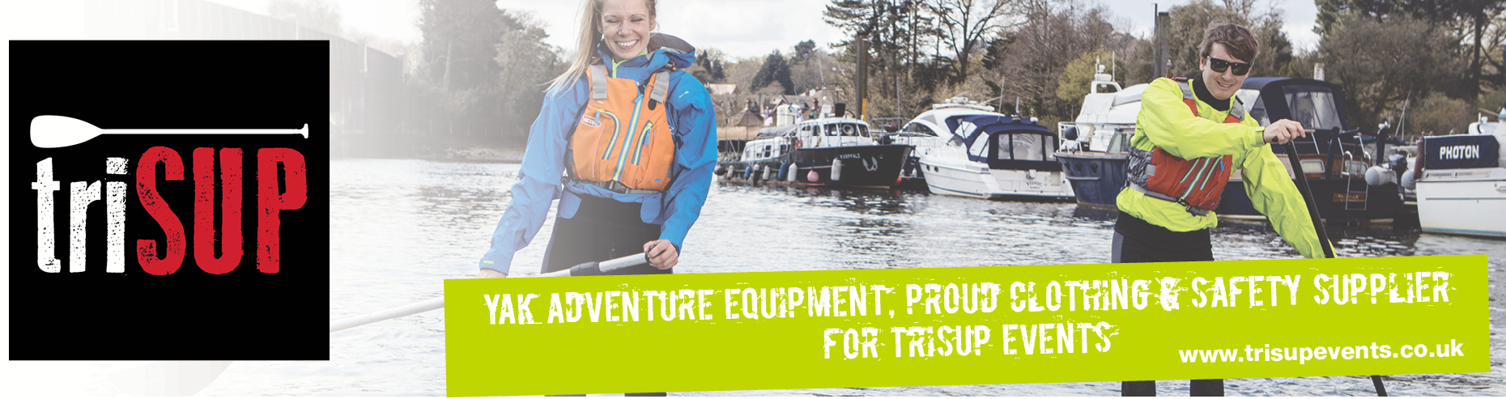
Together with Crewsaver, Yak has 50 years of experience manufacturing marine safety products that combine cutting edge technology with high performance and ultimate practicality.

