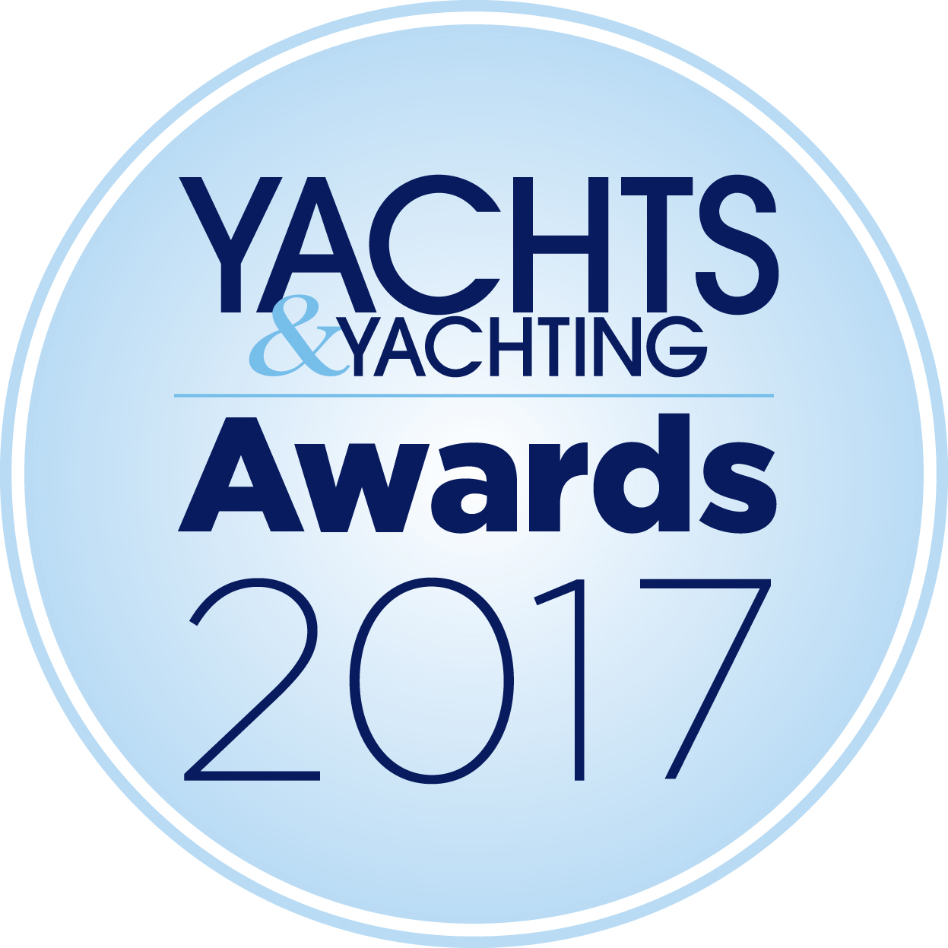
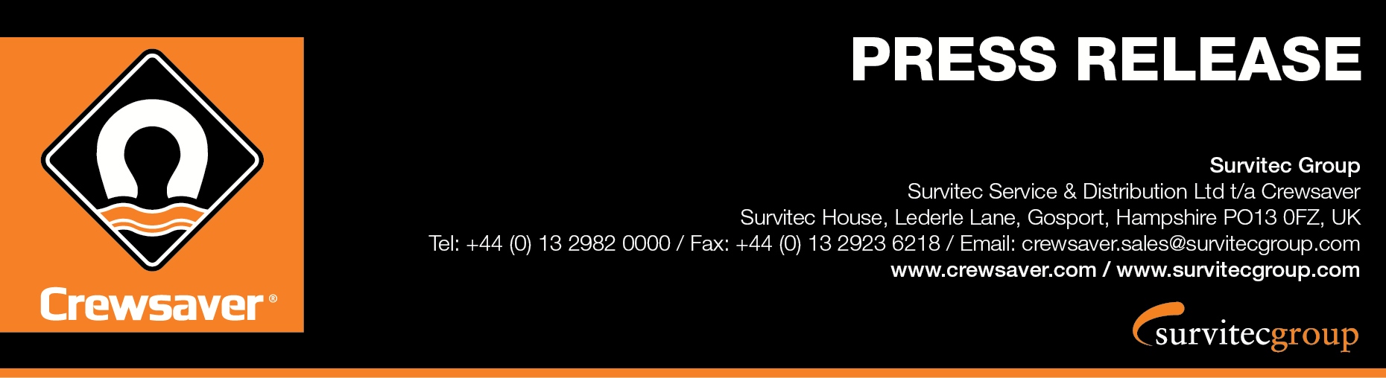
We are delighted that the Crewsaver “High Impact” ErgoFit 50N EX has been nominated for the prestigious Yachts & Yachting Kit Innovation Award for 2017!

The ErgoFit 50N EX ‘High Impact’ buoyancy aid was developed with Artemis Racing for the 35th America’s Cup and includes a multitude of safety and performance features. Forcefield armour protects the wearer against impact, Spare Air attachment points facilitate the use of a hands free air supply system whilst integrated airflow technology built into the structure of the buoyancy aid allows for the efficient transfer of heat. All of this is incorporated into a low profile and ergonomic Fusion 3D design to reduce snag risk to provide the ultimate in unhindered performance.
“With foiling becoming ever more popular we at Crewsaver think it is important that everybody has the opportunity to benefit from the same advanced safety and performance technology as an America’s Cup sailor.” – Hannah Burywood, Marketing Manager
“Technology and innovation in the America’s Cup have taken a huge step forward over the last few years, but the technology for commercially available safety equipment did not meet our team's needs. With Crewsaver, we wanted to find a supplier able to develop a best in class series of equipment that meets the demands of this new era of performance sailing. Crewsaver’s dedication to this project has impressed us all and we are extremely proud of the collaboration.” - Iain Percy, Team Manager for Artemis Racing
“We understand the dangers of racing these high performance catamarans at 40+ knots, and the safety of the guys on board is our number one priority which is why Crewsaver are our number one choice.” – Anthony Nossiter, Safety Officer for Artemis Racing
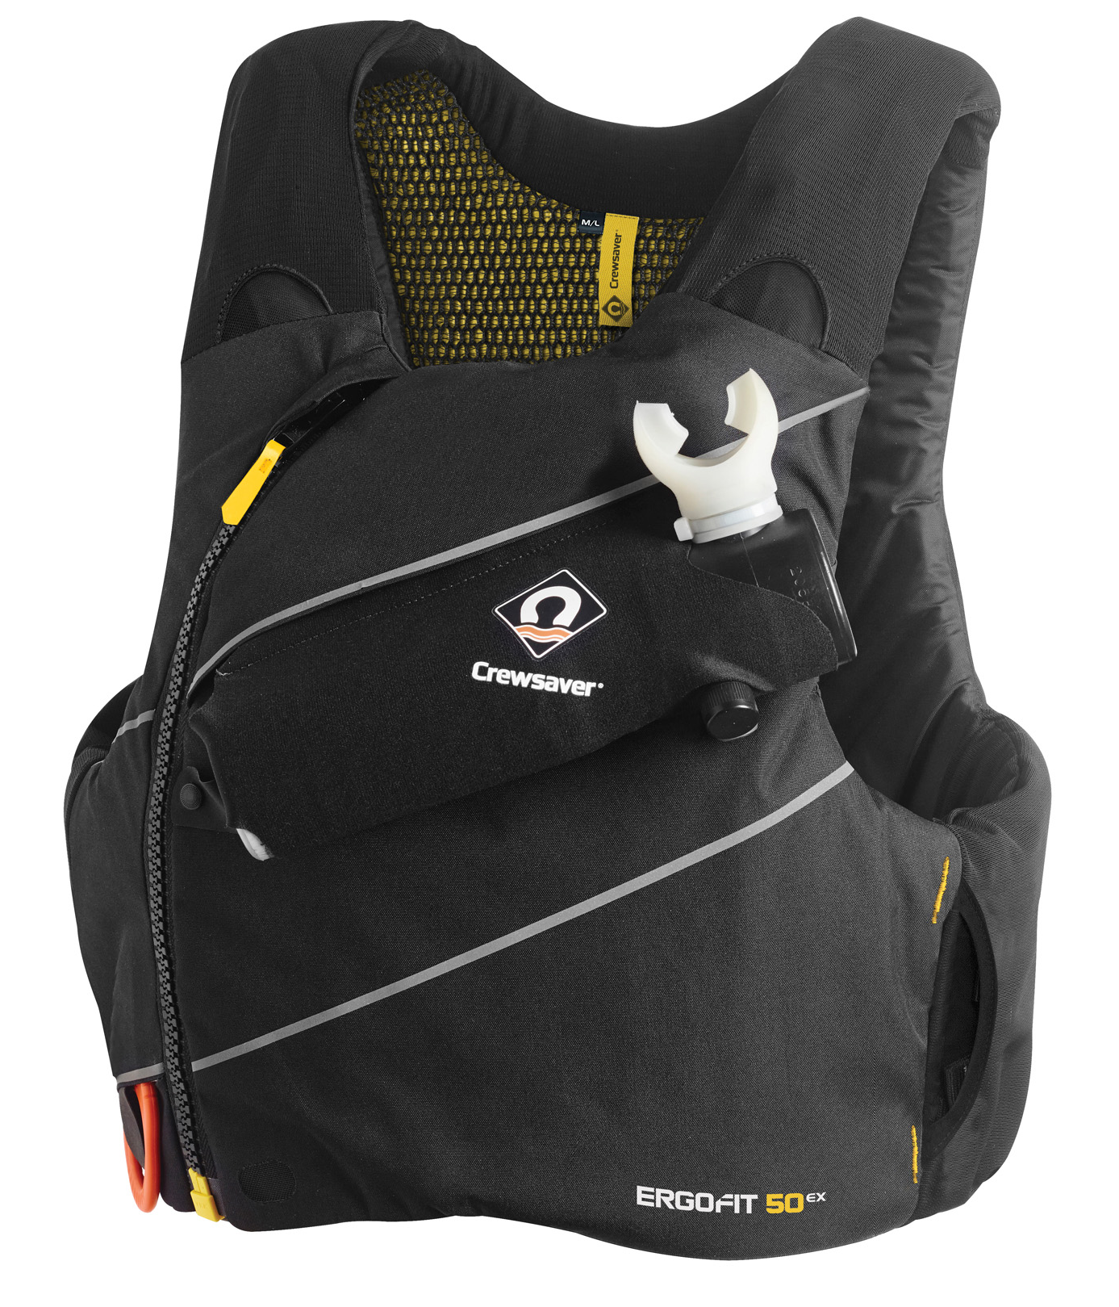
ErgoFit 50N EX “High Impact” Buoyancy Aid
- Breathable airflow technology
- Low profile sculpted design
- Dual adjustment for optimal fit
- Large slimline front pocket
- Removable hands free Spare Air pocket
- Durable outer cover material
- Concealed back pocket for hydration pack
- Hydration tube exits
- Stretch-to-fit breathable side and shoulder panels
- Ergonomic curved zip
- Quick access line cutter stowage
- Available with and without Forcefield armour to suit varying needs
To vote for the ErgoFit 50N EX visit: http://www.yachtsandyachting.co.uk/awards2017/
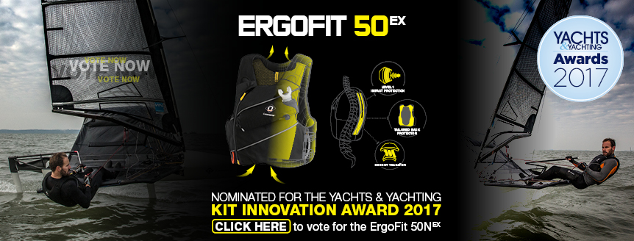
ENDS//

For media information, hi-res images or product tests please contact:

Crewsaver
Hazel Proudlock, Marketing Dept
T +44 (0) 1329 820406
E hazel.proudlock@survitecgroup.com

Or
Alison Willis – Marine Advertising Agency Ltd
T +44 (0) 23 9252 2044
E Alison@marineadagency.com

Notes to Editors

Crewsaver is a world-leading manufacturer of marine safety equipment and clothing for the commercial and leisure marine industries. Based in Gosport, Hampshire, the company designs and manufactures bespoke safety equipment for several countries’ Special Forces, and the aviation and oil industries. Crewsaver is the only company to hold an exclusive contract to supply lifejackets to the UK government’s Environment Agency and the Royal National Lifeboat Institution (RNLI). They are part of the Survitec Group.

www.crewsaver.com

Survitec Group holds market-leading positions worldwide in marine, defence and aerospace survival technology. Headquartered in Birkenhead, the company employs 2000 people across 10 manufacturing sites and 50 service centres, operating through a network of a further 550 distributors and agents to bring its best-in-class products and services to a global customer base. With an extensive history spanning over 160 years and a portfolio of some of the most reputable brands in the safety and survival industry, Survitec is committed to product innovation, technological advancement and quality assurance.
Key products within Survitec’s portfolio include marine, defence and aviation liferafts, world leading submarine escape technology, lifejackets for commercial airlines and the offshore industry as well as pilot flight equipment, including anti-g clothing used for the Eurofighter and JSF programmes. The Group also pioneered marine evacuation technology and today the unique MarinArk system is used on many major cruise ships across the globe.

www.survitecgroup.com
