*****Press release – Immediate release*****

21st November 2016

Mastercraft Boats and Superyacht Tenders and Toys add the new XT20 to bespoke superyacht tender offering

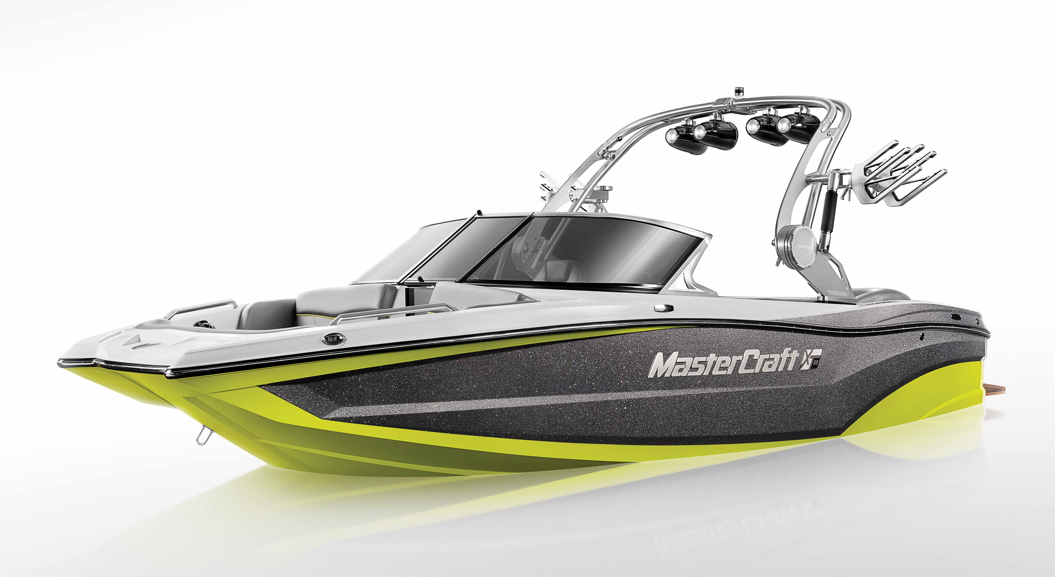
The new XT20 is MasterCraft’s latest multi-sport model and Superyacht Tenders and Toys has confirmed that it will be available as a bespoke superyacht tender with a Yanmar diesel inboard conversion. All factory units traditionally come with inboard petrol engines but on superyachts the diesel is seen as more attractive as it means the boat can be stored inside garages (as the fuel is less flammable) and also can be filled up with fuel direct from the mothership negating the need to carry petrol. This brings the number of MasterCraft models available for the bespoke treatment to seven, ranging in size from 6.10 metres to 7.92 metres.

The XT20 with its crossover hull is designed to handle all watersports including wakeboarding, waterskiing, wakesurfing, towsports or tubing. The X20 builds on the success of the recently launched XT23. The aggressive XT-series hull lines deliver agile, responsive handling with minimum bow rise. The ergonomic dashboard enables the driver to easily control everything from the size and shape of the wake to the sound and lighting systems through an intuitive touchscreen.

The XT20 is equipped with MasterCraft’s award winning Gen 2 Surf System that makes maintaining a consistent speed and creating perfect wake conditions a simple touchscreen operation. Michael Hardicker, MD of MasterCraft Boats UK, explains, ‘Whether it’s a member of the crew or a guest at the helm, it’s easy to give a professional tow and to quickly become an expert driver. The Gen 2 Surf System takes away the guesswork. You simply dial up what you need, whether that be a clean wake for waterskiing, perfectly sculpted lips for wakeboarding or chest-high curling surf waves. There is something to suit all abilities.’

The hull on the XT20 has been specifically designed to create a spacious lounge and plenty of storage space. Wrap-around seating accommodates up to 11 passengers in comfort and as with the XT23 the entire boat can be outfitted in MasterCraft’s new for 2017 ‘Cool Feel’ vinyl that remains cool to the touch even after extended exposure to direct sunlight.

MasterCraft’s new DockStar Handling System will also be available on the XT20. This enables boat drivers of any ability to confidently drive in reverse and more easily navigate tight docks and crowded marinas. The innovative system enables this through a pair of low-profile, flanking rudders that enable port-side reverse control, which was previously unattainable with inboard towboats, while also greatly assisting during docking and controlling the vessel at low speeds. The DockStar Handling System will be available on all seven of the bespoke superyacht tenders.

‘MasterCraft is constantly innovating and introducing new technology as well as new models. This means when we are talking to owners, designers or captains and crew, we can quickly match their requirements and create a tender that not only meets but exceeds their expectations. The introduction of the Yanmar inboard diesel option in 2014 has attracted a lot of interest and made having a dedicated sportsboat a much more attractive prospect,’ said Michael Hardicker.

To enquire about the XT20, please contact Superyacht Tenders and Toys at info@superyachttendersandtoys.com

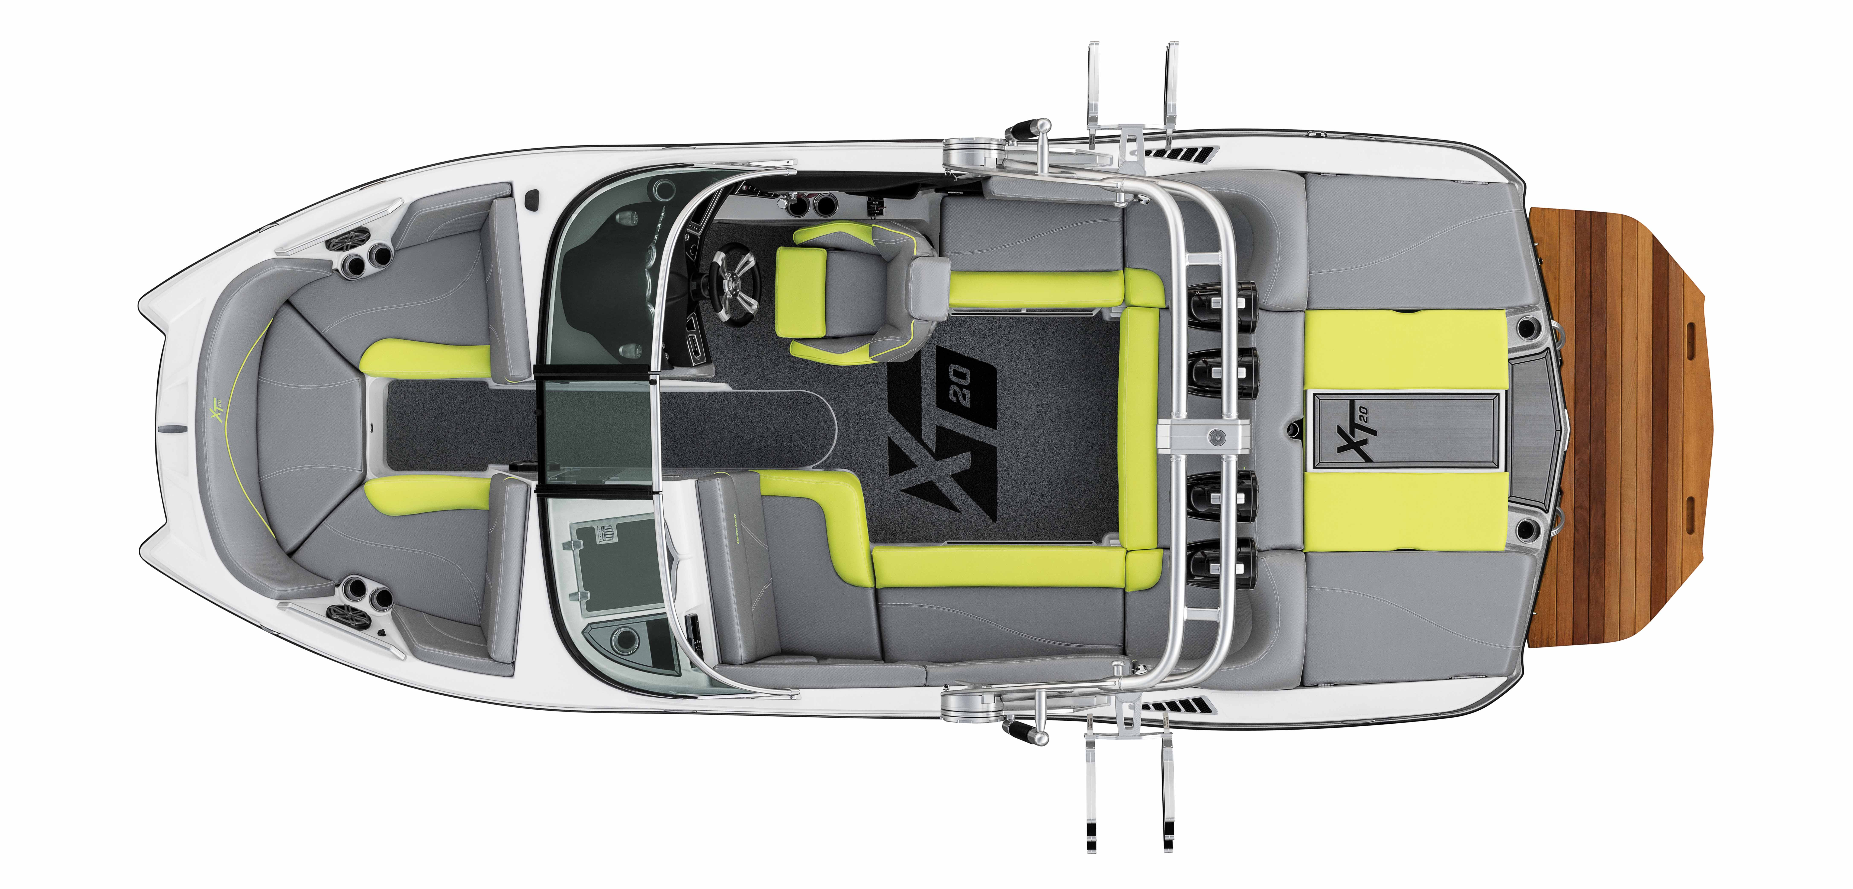
XT20 Specifications:
Length: 20’ / 6.1 M
Width Amidship: 98” / 2.49 M
Interior Width: 80” / 2 M
Dry Weight: 4,500 LBS / 2,041.2 KG
Ballast Weight: 1,115 LBS / 505.8 KG
Fuel Capacity: 45 G / 170.3 L
Seating: 11 people
Storage: 70 cubic feet / 1.9 cubic meters
Hull: Vector Drive
Colour Options: Infinite

Find out more at http://superyachttendersandtoys.com/tenders/watersports/
ENDS
Media enquiries via Marine Advertising Agency:
Alison Willis, alison@marineadagency.com
Emma Stanbury, emma@marineadagency.com
T: 023 9252 2044

Josh Richardson, Superyacht Tenders and Toys
T: UK +442380016363
T: France +33489733347
T: US +19643029066
E: info@superyachttendersandtoys.com
Notes to Editors:
Superyacht Tenders and Toys is the leading independent consultancy and management company specialising in all superyacht tender and toy needs and provides practical solutions for the World’s finest yachts.

