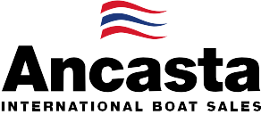

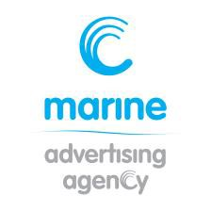
N e w s R e l e a s e
14th November 2016

Ancasta offers support to UK buyers heading to Nautic Paris

Ancasta International Boat Sales is offering support to UK buyers planning to attend the prestigious Salon Nautique Paris Boat Show, which takes place between 3rd and 11th December 2016. The show will see the World Premiere of the Beneteau Sense 51, and as the UK’s largest Beneteau Sail dealer, Ancasta is well placed to help UK buyers with appointments to see this and models from Ancasta’s new boat brands; Beneteau Sail, Beneteau Power, Prestige Motor Yachts, Lagoon Catamarans and CNB Yacht Builders.
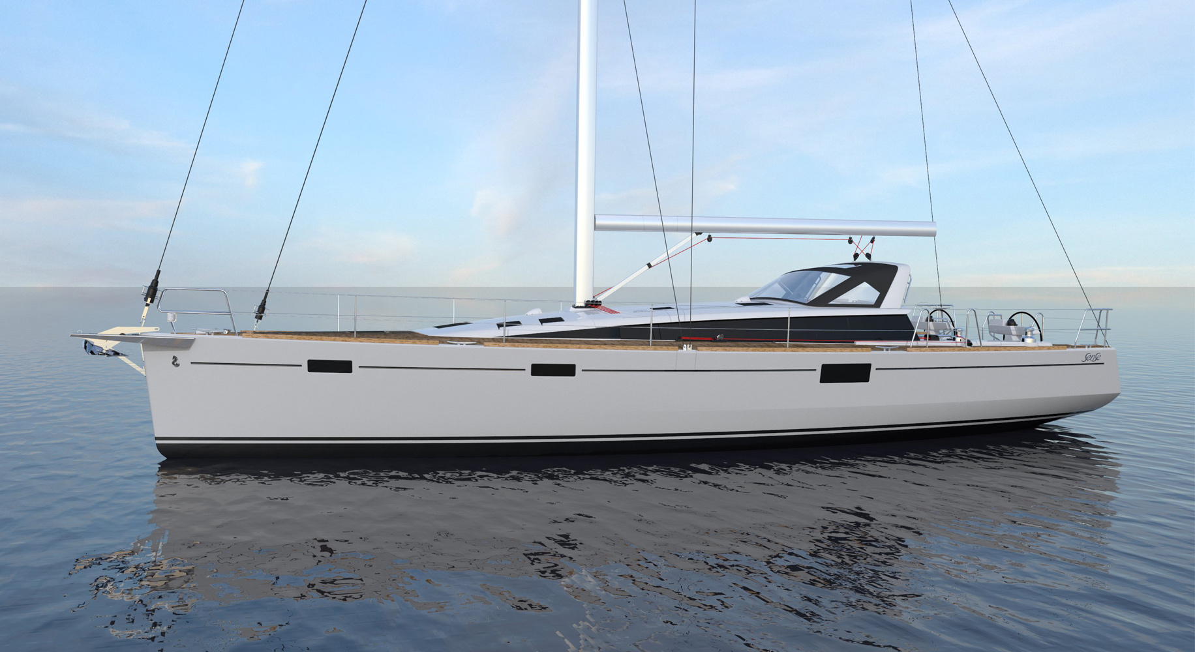
The Ancasta team can help UK buyers get the most out of visits to the show. As well as making appointments to see the models on display, Ancasta can help with travel arrangements. Those planning to visit are encouraged to contact Ancasta as soon as possible for help organising their trip.
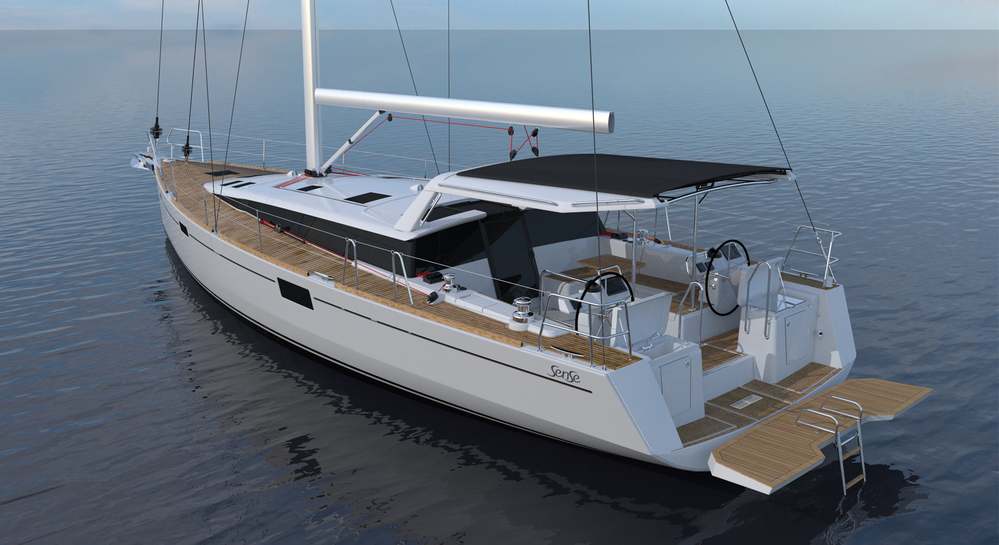
The new Beneteau Sense 51, which will have its World Premiere at the Paris show, is the latest addition to Beneteau’s Sense range. Designed by Berret-Racoupeau and Nauta Yachts, it follows the same sleek and elegant lines as its big sister the Sense 57. New innovative features include a fold-down swim platform and semi-rigid opening bimini. The well-thought out living spaces make the Sense 51 an ideal blue-water cruising boat. Large hull portholes provide more light and extensive sea views and the boat is conducive to outdoor living; the exterior galley has a plancha and sink concealed in the helm seats. Three cabins provide ample accommodation both the master cabin and main guest cabin are ensuite and there is a third cabin with bunks. Stylish features like fully concealed electrical appliances, when the galley is not in use, make the Sense 51’s interior spaces versatile.
Beneteau Sense 51
Ancasta will look after UK visitors, arranging appointments to view any of the models from its new boat brands that will be shown at Nautic Paris.

T: 023 9252 2044
E: Alison@marineadagency.com www.marineadagency.com
Marine Advertising Agency
15 Haslar Marina
Gosport PO12 1NU

The team will be presenting the following models:

From Beneteau Sail –
Oceanis 31
Oceanis 35.1
Oceanis 38.1
Oceanis 41.1
Oceanis 45
Sense 51 – WORLD PREMIERE
First 20
First 25

From Beneteau Power –
Swift Trawler 30
Swift Trawler 34
Swift Trawler 44
Gran Turismo 40
Gran Turismo 46
Gran Turismo 49 Fly

From Lagoon -
Lagoon 42

From Prestige -
Prestige 500
Prestige 450

From CNB -
CNB 76
Contact Ancasta now to make an appointment to view any of the above, email enquiries@ancasta.com or call +44 2380 450000.

For more information visit: http://www.ancasta.com/events/paris-boat-show-2016/

ENDS

Notes to editors
  - Ancasta International Boat Sales has 14 offices across Europe
  - Ancasta is the UK’s largest Prestige Luxury Motor Yachts dealer, the UK’s largest Beneteau Power and the UK’s largest Beneteau Sail dealer
  - Ancasta is exclusive UK dealer for Lagoon Catamarans
  - In addition Ancasta is a new boat dealer for CNB Yacht Builders and McConaghy Yachts
  - The Ancasta Group incorporates Hamble Yacht Services Refit & Repair and Advanced Rigging and Hydraulics, both operating from Port Hamble.
  - For more information on Ancasta visit www.ancasta.com
Media enquiries via Marine Advertising Agency: Alison Willis - alison@marineadagency.com Tel: 023 9252 2044

T: 023 9252 2044
E: Alison@marineadagency.com www.marineadagency.com
Marine Advertising Agency
15 Haslar Marina
Gosport PO12 1NU

