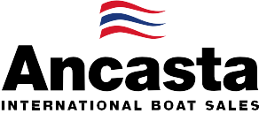

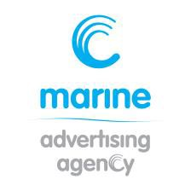
N e w s R e l e a s e
10th November 2016

Ancasta presents UK debut of Prestige 630 at 2017 London Boat Show

Ancasta will present the UK debut of the Prestige 630 at the 2017 London Boat Show, which takes place 6th-15th January 2017. Ancasta is the UK and Balearics’ largest Prestige Luxury Motor Yachts dealer.
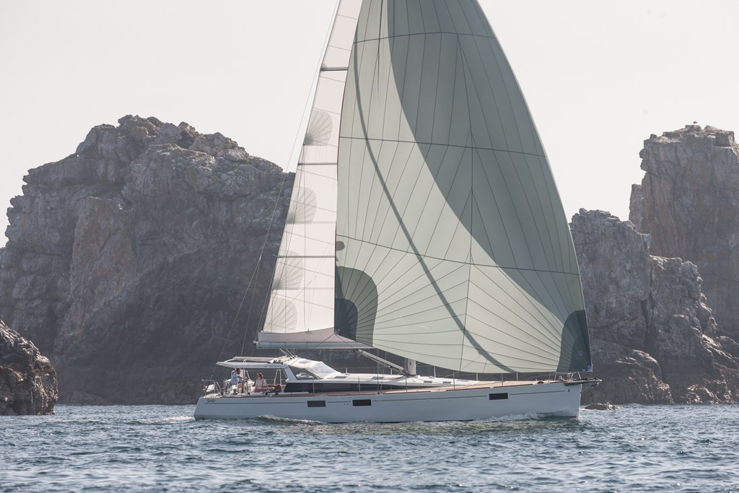
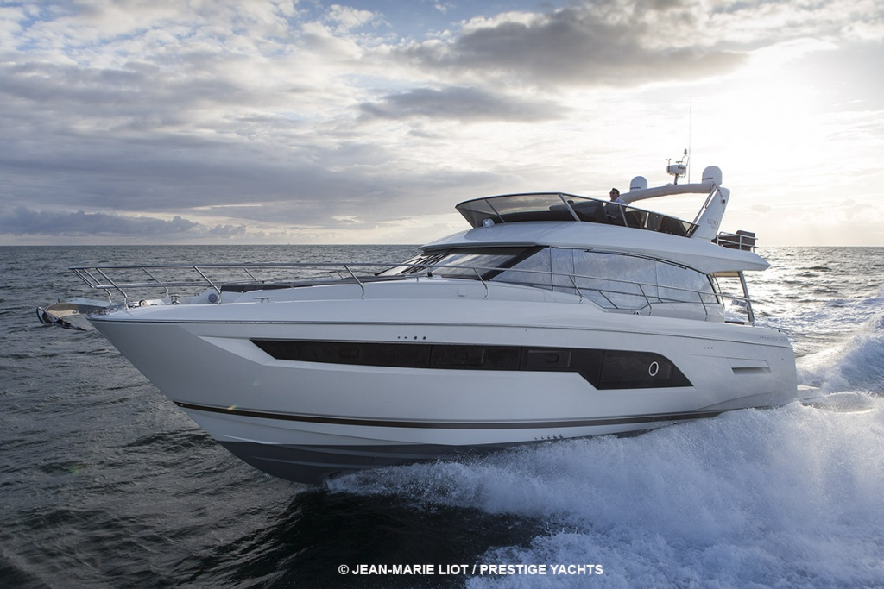
The new model is destined to be yet another highly popular motor yacht from Prestige, one of the big players in the luxury motor yacht market. The Prestige 630 features a Garroni designed interior, which is bathed in light, with one level living and the galley set to the aft of the boat. Luxurious furnishings in a selection of finishes and harmonious colour schemes create a level of interior design usually reserved for larger cruising yachts. Three cabins, all with their own ensuite, mean both owners and their guests are spoilt in the exceptional accommodation and there is an additional cabin for crew. The galley offers a bar style opening on to the cockpit, while the huge flybridge provides a superb area to relax or entertain in absolute comfort. Powered by twin Volvo IPS950 engines, she is capable of cruising at 24kts, and for a boat of this size is notably easy to manoeuvre. The Prestige 630 boasts all the key features that have made the range so successful. High tech design solutions combined with the selection of the IPS950 pod transmission engines leave the Prestige 630 positioned at the cutting edge of technology.
Prestige 630
Also at the show will be the Beneteau Sense 57, the big sister of the new Sense 51 which premieres in Paris in December. The Sense 57 is an ocean cruising yacht with a unique style. Features include an exterior galley with plancha and sink concealed in the helm seats, large hull portholes to give an extensive sea view and flood the interior with light, and an opening semi-hard top bimini.
Beneteau Sense 57

T: 023 9252 2044
E: Alison@marineadagency.com www.marineadagency.com
Marine Advertising Agency
15 Haslar Marina
Gosport PO12 1NU

Other highlights from Ancasta’s new boat brands at London Boat Show 2017 include the Prestige 560 and Prestige 680, which has proved popular since its debut at London Boat Show in 2016, the Beneteau Gran Turismo 40 and Swift Trawler 30 and 44. On the sail side, Ancasta is also presenting the Beneteau Oceanis 38.1, 41.1 and 45.
Ancasta will also have a presence at Boot Düsseldorf, which takes place from 21st to 29th January 2017, where they will be presenting a wide range of models from Beneteau, Prestige Motor Yachts, Lagoon Catamarans and CNB. The team can look after UK visitors and arrange appointments to view the following models:

From Beneteau Sail at Boot Düsseldorf –
Oceanis 35.1
Oceanis 38.1
Oceanis 41.1
Oceanis 45
Sense 51
Oceanis Yacht 62
First 25
From Beneteau Power at Boot Düsseldorf–
Swift Trawler 30
Swift Trawler 44
Gran Turismo 40
Gran Turismo 46
Gran Turismo 49 Fly

From Lagoon at Boot Düsseldorf -
Lagoon 450
Lagoon 42

From Prestige at Boot Düsseldorf -
Prestige 680
Prestige 630
Prestige 560
Prestige 500
Prestige 450

From CNB at Boot Düsseldorf -
CNB 76
Ancasta will be at London Boat Show from 6th to 15th January 2017, and at Boot Düsseldorf 21st to 29th January 2017. Contact Ancasta now to make an appointment to view any of the above, email enquiries@ancasta.com or call +44 2380 450000.

For more information visit: http://www.ancasta.com/events/

ENDS

T: 023 9252 2044
E: Alison@marineadagency.com www.marineadagency.com
Marine Advertising Agency
15 Haslar Marina
Gosport PO12 1NU

Notes to editors
  - Ancasta International Boat Sales has 14 offices across Europe
  - Ancasta is the UK’s largest Prestige Luxury Motor Yachts dealer, the UK’s largest Beneteau Power and the UK’s largest Beneteau Sail dealer
  - Ancasta is exclusive UK dealer for Lagoon Catamarans
  - In addition Ancasta is a new boat dealer for CNB Yacht Builders and McConaghy Yachts
  - The Ancasta Group incorporates Hamble Yacht Services Refit & Repair and Advanced Rigging and Hydraulics, both operating from Port Hamble.
  - For more information on Ancasta visit www.ancasta.com Media enquiries via Marine Advertising Agency:
Alison Willis - alison@marineadagency.com Tel: 023 9252 2044

T: 023 9252 2044
E: alison@marineadagency.com www.marineadagency.com
Marine Advertising Agency
15 Haslar Marina
Gosport PO12 1NU

