N e w s R e l e a s e
17th November 2016

Prestige announces impressive line-up for London Boat Show 2017 including
UK debut for Prestige 630 Yacht

Ancasta, Prestige’s UK dealer, has announced that Prestige will bring three of the largest models from its range to London Boat Show 2017, including the Prestige 630, which will have its UK debut at the event.
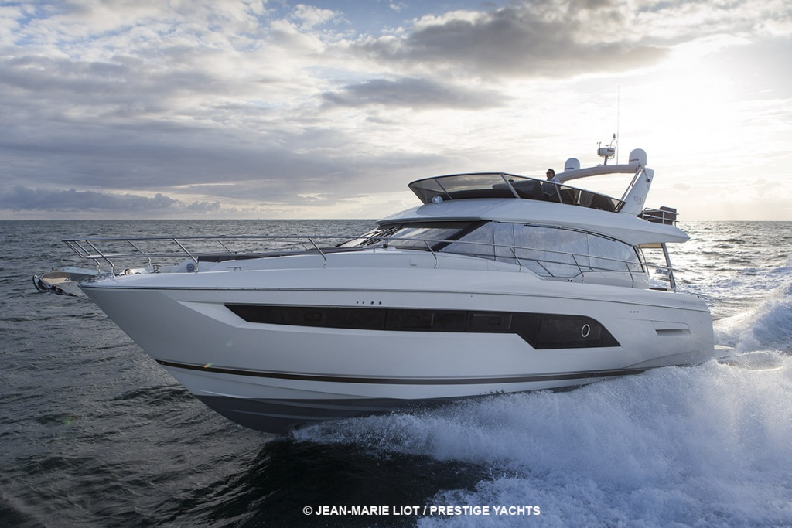
The Prestige 630 Yacht, the newest release from Prestige Motor Yachts, will make its UK debut at London Boat Show 2017 (6th - 15th January 2017) alongside the Prestige 680 and Prestige 560, cementing the luxury motor yacht brand’s position as one of the key players in the market. Ancasta International Boat Sales, who is Prestige Dealer of the Year for 2016, reveals that it is the first time that three of the largest models from the Prestige range will have been shown in the UK. Nick Hatfield, Ancasta’s Prestige Brand Manager commented ‘We are extremely excited about the London Boat Show, it’s the first time we have shown three of the largest Prestige Yachts in the UK and cannot wait for the show to get started. Prestige has now established itself as a serious player in the motor yacht market and we look forward to showing off the range of superb motor yachts’.

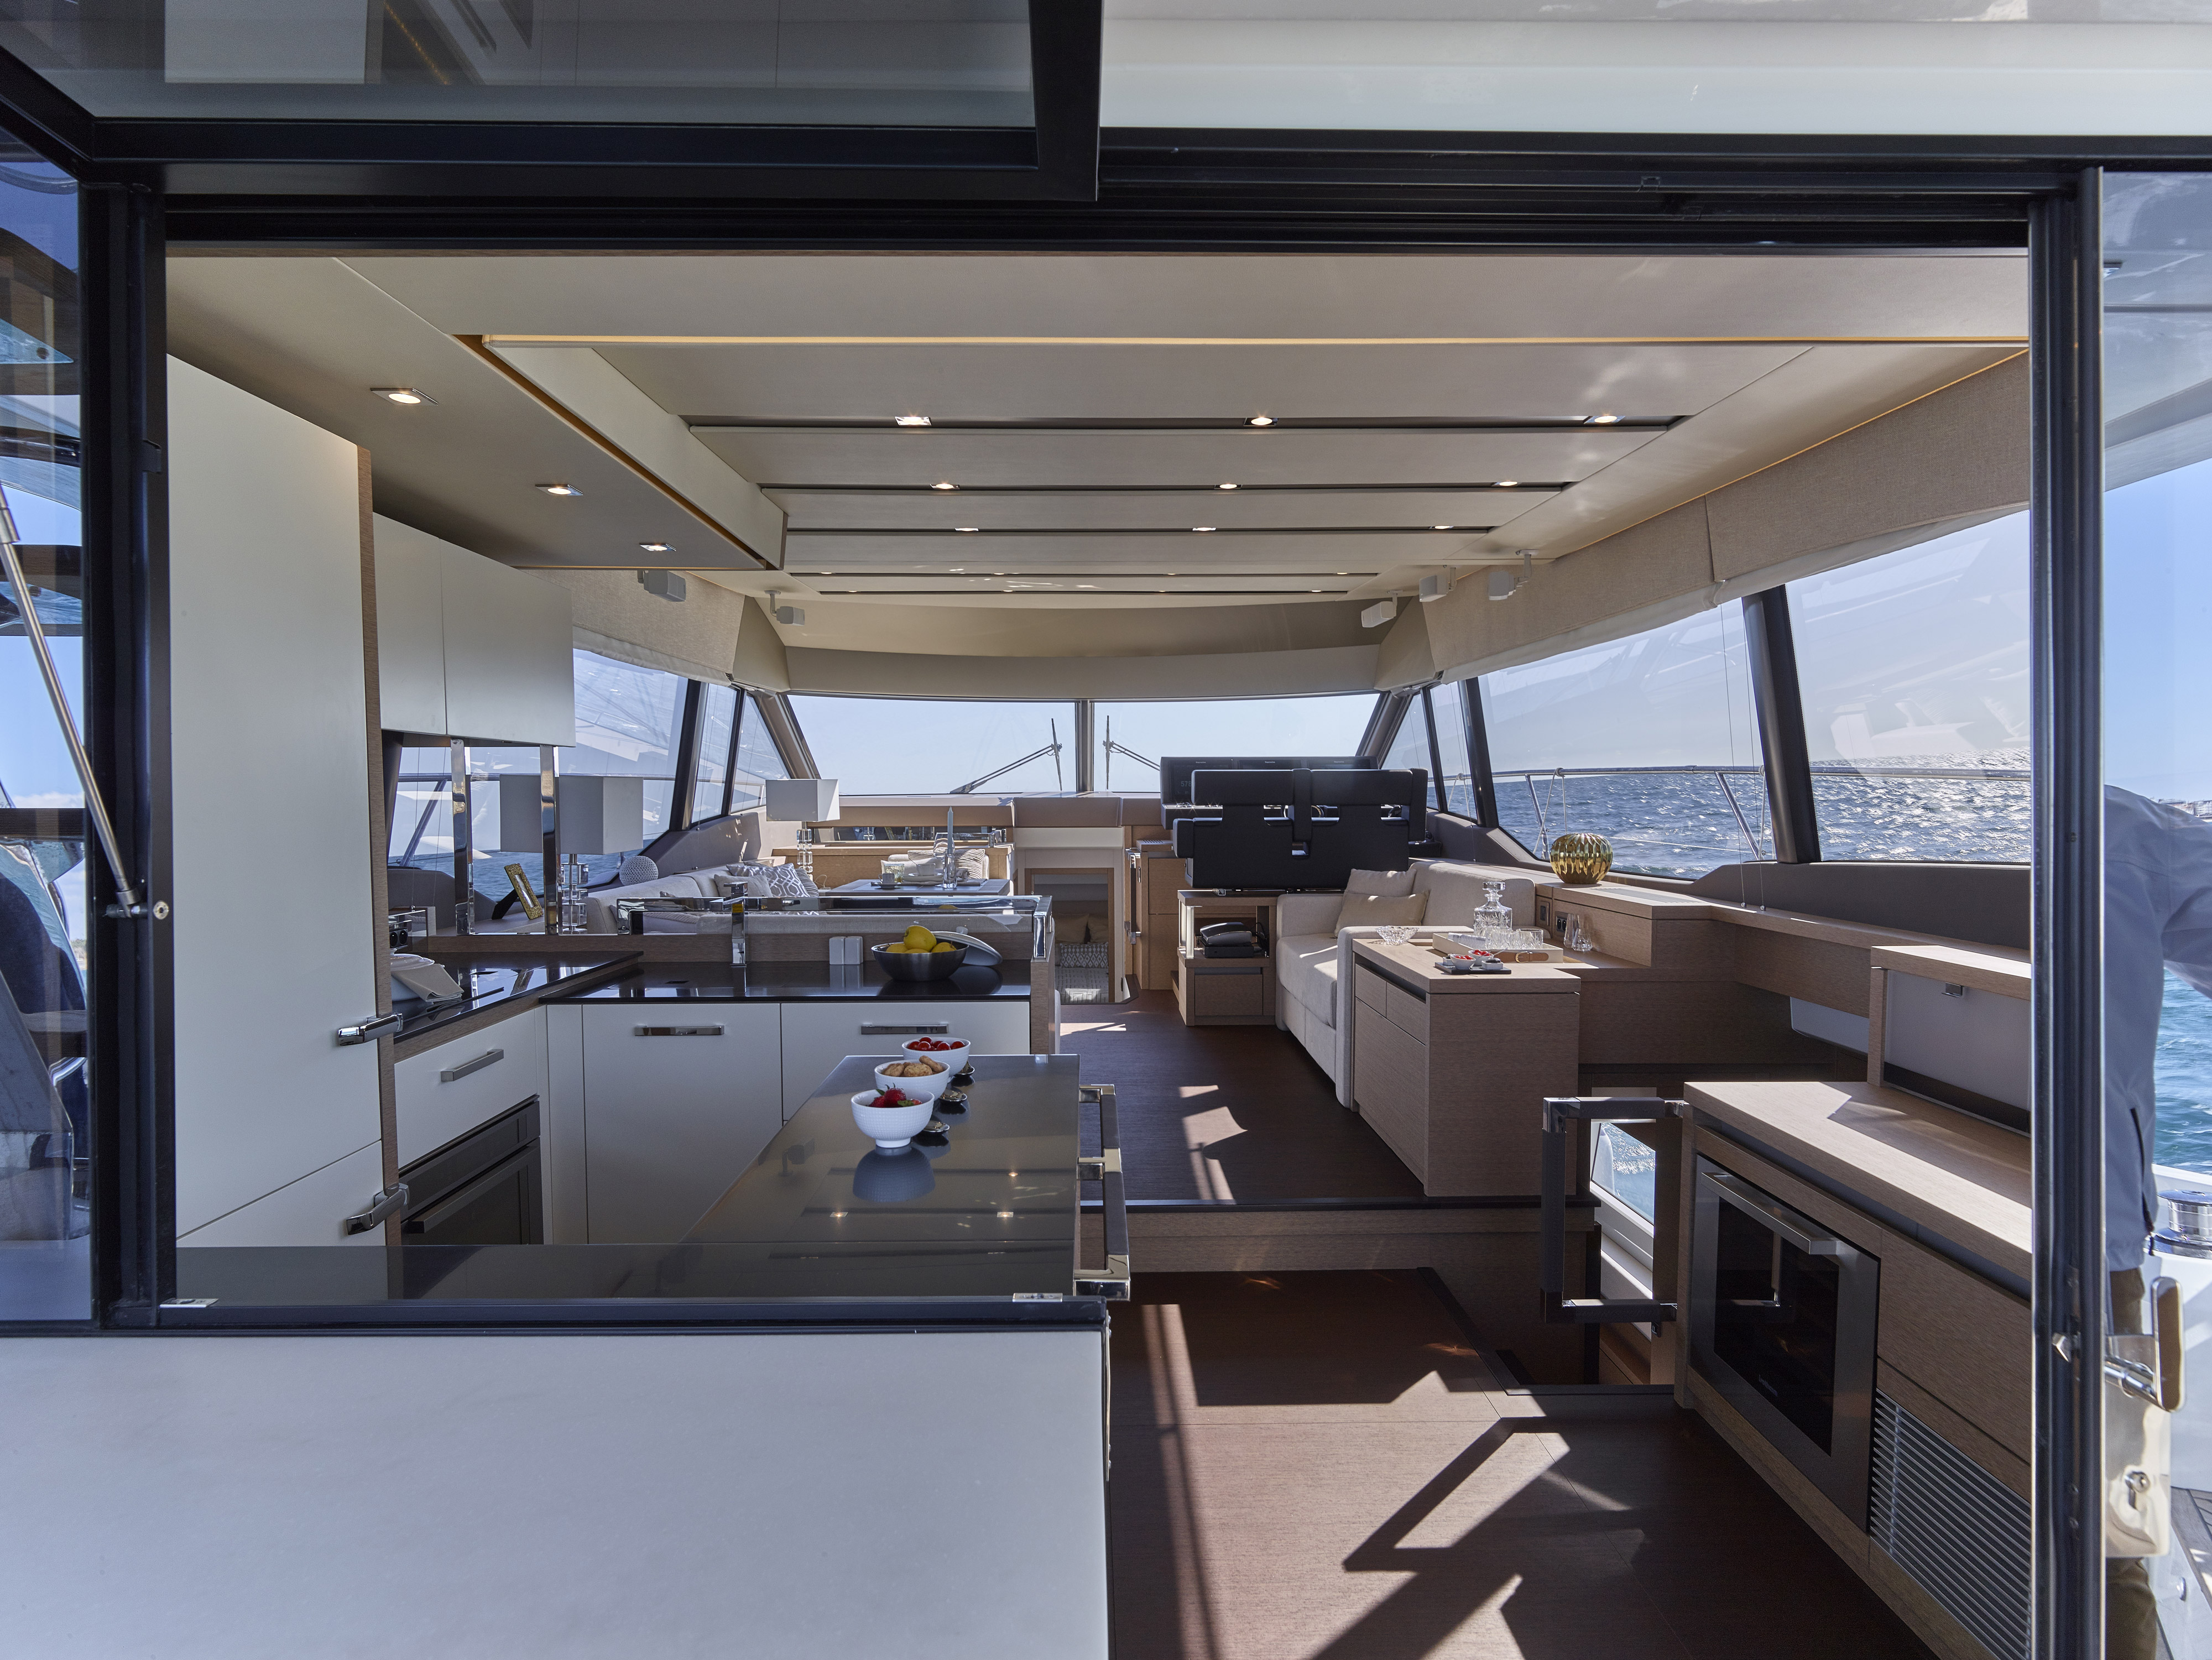
The brand will make a splash on the first day of London Boat Show with a glittering drinks reception at 2pm on the Prestige stand (E110) to introduce the Prestige 630 to the UK market and showcase the impressive credentials of the Prestige range.

The Prestige 630 Yacht, a 19m luxury flybridge motor yacht, was launched at Cannes Yachting Festival in September 2016. The new model is destined to be yet another highly popular yacht from the Prestige yard, one of the big players in the luxury motor yacht market.
The Prestige 630

T: 023 9252 2044
E: Alison@marineadagency.com www.marineadagency.com
Marine Advertising Agency
15 Haslar Marina
Gosport PO12 1NU

Coming from the drawing board of Garroni Design and with a J&J Design hull, the Prestige 630 reflects the lines and layout of the other successful motor yachts in the Prestige range. The Prestige 630 is powered by Twin Volvo IPS950 engines, which give superb economy and easy manoeuverability especially when short-handed. She is capable of a top speed of 28 Knots and a cruising speed of 24 knots.

The interior of the Prestige 630 is bathed in light. It offers one level living and the galley aft. Luxurious furnishings in a selection of materials and colour schemes create a level of interior design usually reserved for larger cruising yachts. Three cabins, all with their own en-suite, mean both the owners and their guests are spoilt in the exceptional accommodation and there is an additional cabin for crew. The galley offers a bar-like opening to the cockpit while the huge flybridge provides a superb area to relax or entertain in absolute comfort.
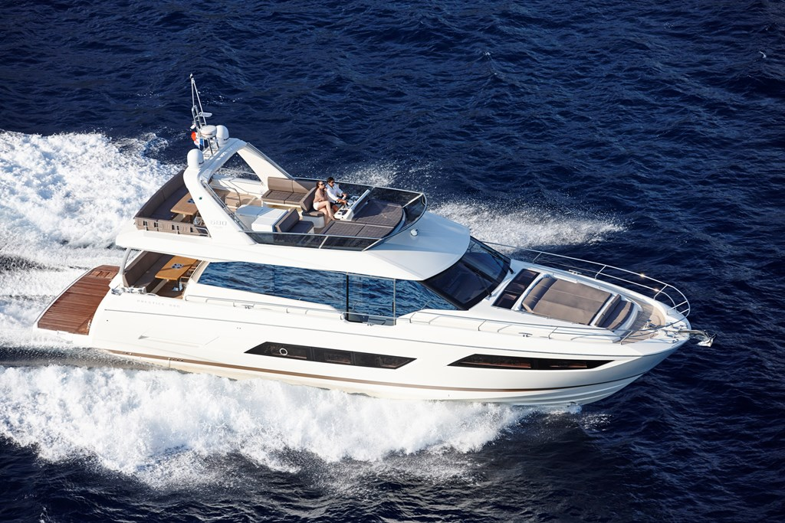
The Prestige 630 boasts all the key features, which have made the range so successful. High tech design solutions combined with the selection of the IPS950 pod transmission engines leave the Prestige 630 positioned at the cutting edge of technology.
Also on display at London will be the Prestige 680, which won the coveted Motorboat of the Year Award 2016, along with the newly released Prestige 560.

Prestige 630 Specification:

• Designer Garroni Design / J & J Design
• Base Price £990,435 ex VAT
• LOA 19.02 M
The Prestige 680
• Hull Length 16.83 M
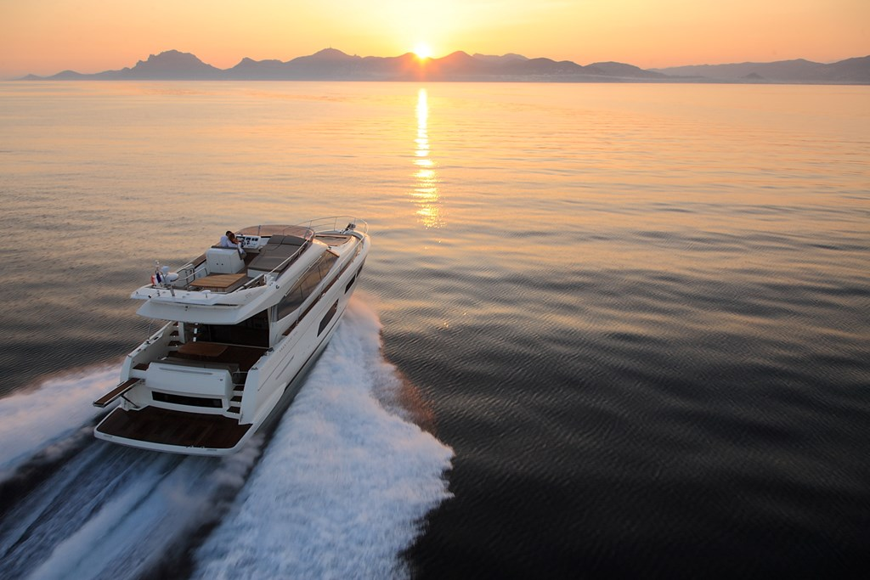
• Maximum Beam 5.15 M
• Engine Size Twin Volvo IPS950 D11-725HP
• Cruising Speed 24 Knots
• Maximum Speed 28 Knots
• Maximum Range 305 NM @ cruising speed
• Dry (Light) Weight 23,800 kg
• Displacement 33,000 kg
• Cabins Three Cabins plus Crew Cabin
• Fuel Capacity 2,700 litres
• Water Capacity 860 litres
The Prestige 560

The Prestige 630 will have its UK debut at London Boat Show in January 2017. Contact Ancasta now to make an appointment to view, email Nick Hatfield (nickhatfield@ancasta.com) or call +44 2380 450017.

For more information visit
http://www.ancasta.com/boats-for-sale/new-boats/prestige/prestige-yachts/630/
http://www.ancasta.com/boats-for-sale/new-boats/prestige/

ENDS

T: 023 9252 2044
E: Alison@marineadagency.com www.marineadagency.com
Marine Advertising Agency
15 Haslar Marina
Gosport PO12 1NU

Notes to editors
  - Ancasta International Boat Sales has 14 offices across Europe
  - Ancasta is the UK’s largest Prestige Luxury Motor Yachts dealer, the UK’s largest Beneteau Power and the UK’s largest Beneteau Sail dealer
  - Ancasta is exclusive UK dealer for Lagoon Catamarans
  - In addition Ancasta is a new boat dealer for CNB Yacht Builders and McConaghy Yachts
  - The Ancasta Group incorporates Hamble Yacht Services Refit & Repair and Advanced Rigging and Hydraulics, both operating from Port Hamble.
  - For more information on Ancasta visit www.ancasta.com Media enquiries via Marine Advertising Agency:
Alison Willis - alison@marineadagency.com Tel: 023 9252 2044

T: 023 9252 2044
E: alison@marineadagency.com www.marineadagency.com
Marine Advertising Agency
15 Haslar Marina
Gosport PO12 1NU

