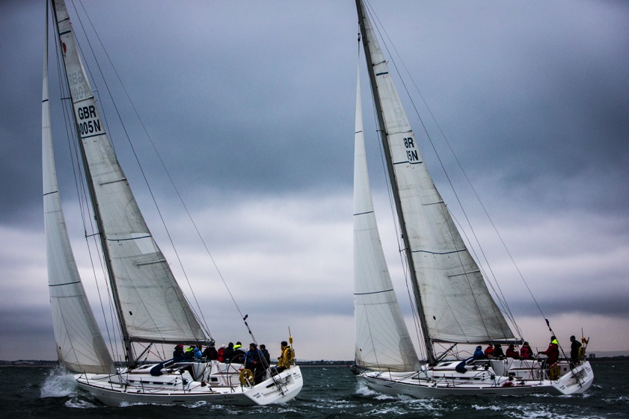
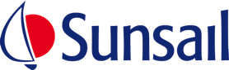
For Release: 6th January 2017

Crewsaver & Survitec Group announce exciting new partnership with Sunsail UK

Survitec Group, the world’s leading marine safety equipment supplier, has formed an exciting partnership with Sunsail UK, one of the UK’s largest Yacht Charter businesses based in Port Solent.

The rolling agreement will see Survitec Group supply the entire Sunsail UK fleet with all of its safety equipment requirements including Crewsaver lifejackets and liferafts, PainsWessex pyrotechnics, and an array of rescue and safety equipment.

In addition, Survitec Group will become Sunsail’s safety equipment service provider; all of Sunsail’s lifejackets, liferafts and fire extinguishers will be serviced out of Survitec Group’s service station in Southampton.

“Safety is of paramount importance to us at Sunsail and so being able to partner with the world’s leading marine safety equipment supplier is a really positive development for us. We look forward to working closely with the team at Survitec in 2017 and beyond, allowing us to keep safety at the top of our agenda.” Simon Boulding, Events Director – Sunsail.
“We are thrilled to be partnering with Sunsail, which is a great business offering a fantastic service. It’s a pleasure to work with a company that takes such care and attention to ensure that it has nothing but the very best onboard for the comfort and safety of its customers.” Mark Hart, Head of Marine Sales – Survitec Group

This agreement follows on from Sunsail and Survitec Group’s existing successful relationship as part of the team organising the Survitec Group Marine Industry Regatta.

ENDS//

For media information, hi-res images or product tests please contact:

Crewsaver
Hazel Proudlock, Marketing Dept
T +44 (0) 1329 820406
E hazel.proudlock@survitecgroup.com

Or
Alison Willis – Marine Advertising Agency Ltd
T +44 (0) 23 9252 2044
E Alison@marineadagency.com

Notes to Editors

Crewsaver is a world-leading manufacturer of marine safety equipment and clothing for the commercial and leisure marine industries. Based in Gosport, Hampshire, the company designs and manufactures bespoke safety equipment for several countries’ Special Forces, and the aviation and oil industries. Crewsaver is the only company to hold an exclusive contract to supply lifejackets to the UK government’s Environment Agency and the Royal National Lifeboat Institution (RNLI). They are part of the Survitec Group.

www.crewsaver.com

Survitec Group holds market-leading positions worldwide in marine, defence and aerospace survival technology. Headquartered in Birkenhead, the company employs 2000 people across 10 manufacturing sites and 50 service centres, operating through a network of a further 550 distributors and agents to bring its best-in-class products and services to a global customer base. With an extensive history spanning over 160 years and a portfolio of some of the most reputable brands in the safety and survival industry, Survitec is committed to product innovation, technological advancement and quality assurance.
Key products within Survitec’s portfolio include marine, defence and aviation Liferafts, world leading submarine escape technology, lifejackets for commercial airlines and the offshore industry as well as pilot flight equipment, including anti-g clothing used for the Eurofighter and JSF programmes. The Group also pioneered marine evacuation technology and today the unique MarinArk system is used on many major cruise ships across the globe.

www.survitecgroup.com

