

**N e w s R e l e a s e**

**For immediate release**

**20th January 2017**

**Venezia Certosa Marina offers visitors the chance to explore Venice by traditional boat**

**The Venezia Certosa Marina in Venice is offering visitors the chance to explore Venice aboard their own traditional Topetta or Bragozzo. The marina can arrange the hire of these classic Venetian motorboats so that keen sailors can experience sailing along Venice’s canals.** The marina is an ideal stop-off point for those chartering or cruising in the Adriatic, with 300-berths and an enviable location, less than 10 minutes from St Mark’s Square; the marina is a hidden gem. It is located on Certosa Island, a 24-hectare natural paradise that has recently been regenerated to showcase its valuable natural heritage.

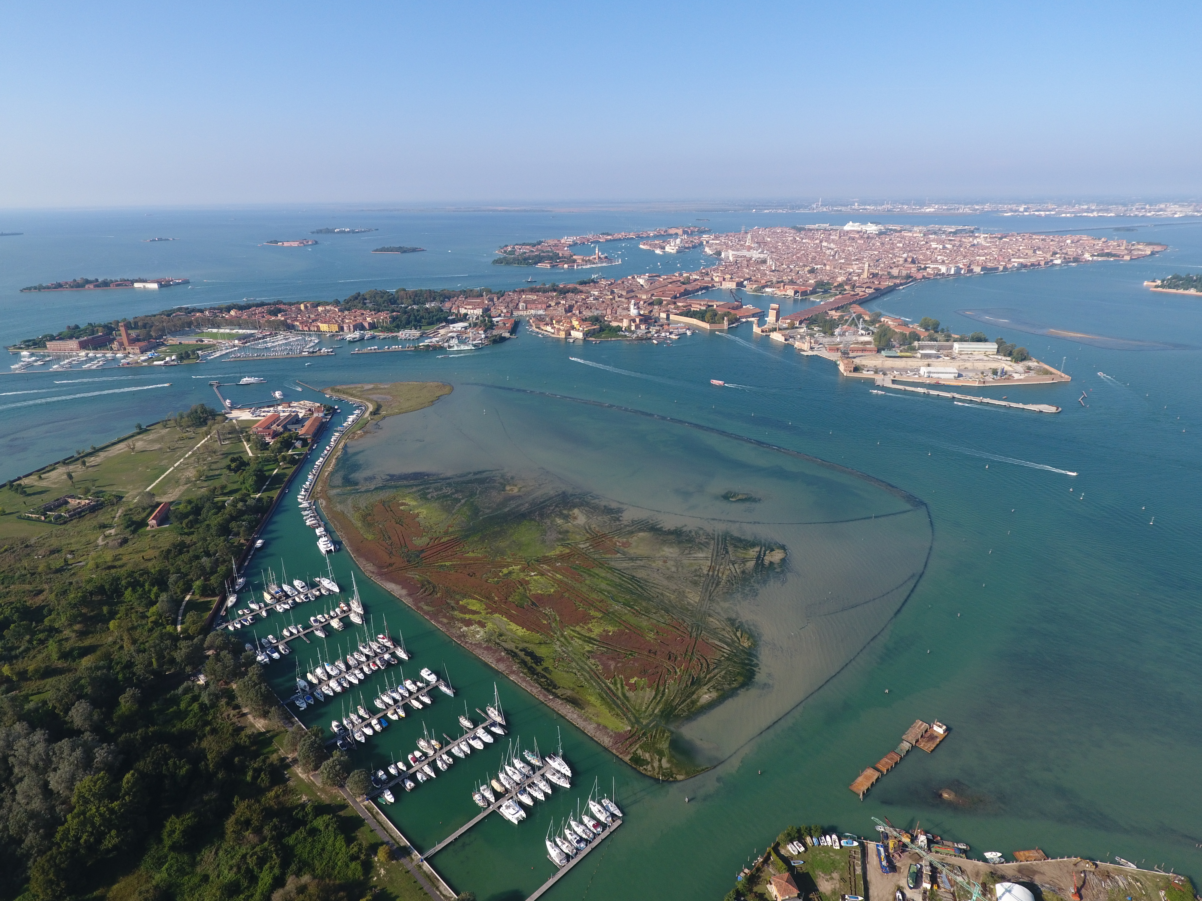The marina is ideally located to make the most of Venice. Visitors can effectively use their boats as a base from which to explore the city, whether aboard a traditional 6-7m wooden Topetta (now days with an outboard motor) or a Bragozzo, a larger traditional fishing boat. Chartering a Bragozzo for a day sail is a great way to explore the lagoon; visit the islands of Murano, Burano and Torcello, as well as the lesser known islands in the Northern lagoon. Experiencing Venice in a traditional boat is a must.

Venezia Certosa Marina’s enviable location

Photo credit: Vdv Srl

Bragozzo boats can carry between nine and fifty passengers depending on their size, these can be hired for a half or full day. The cost of a day’s hire is approximately €25-€40 per person, including a skipper. The price is dependent on the number of people, the size of the boat and where you want to sail. Topetta can be chartered without a skipper allowing you to experience navigating Venice’s canal system first hand! These cost from around €200 for a day’s hire (including fuel) and can carry up to six people.

The marina also offers visitors the option of discovering Venice by kayak. Guided kayaking tours of both Venice and its lagoon give a unique perspective on the city. A half day tour in a group of 2-6 people with a guide costs from €90 per person. Tours start and finish at the Certosa Hotel just next to the marina.

Public transport makes access to the heart of Venice from Venezia Certosa Marina easy for when you don’t want to sail, the marina is just 15 minutes by public transport from the city and lagoon.

Being inside the lagoon, and less than one mile from the open sea, the marina is easy to access with sheltered moorings as all boats are protected by the surrounding islands and by a 4m wide breakwater. Deep draft yachts can also be accommodated. Fresh water, power and WiFi are all available and 24 hour security gives peace of mind. Shoreside facilities include indoor or outdoor dry storage, hotel, a restaurant and bar, chandlery, and laundry and dry cleaning facilities. The on-site boatyard, where craftsmen build traditional Venetian boats, is also available for maintenance and repairs. A sailing school, hotel and the possibility of kayak excursions into Venice are also all available.



For more information visit <http://marina.ventodivenezia.it/>

ENDS

**Media enquiries:**

Alison Willis

Marine Advertising Agency

T: 023 92 52 2044, Mobile: 07980 009653

E: Alison@marineadagency.com