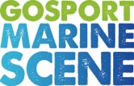

News Release
For immediate release
1 February 2017

AFTER GREAT ANTICIPATION, THE GOSPORT MARINE FESTIVAL RETURNS!

Official launch is on Wednesday, February 1st

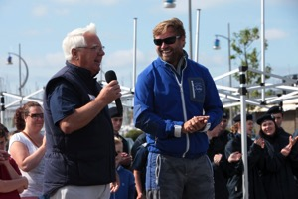
The Gosport Marine Festival 2017 will be held 10am – 5pm on Saturday, May 27, building on the great success of the 2015 event. Alex Thomson’s huge achievement in the Vendée Globe has once again focused attention on Gosport as the home of ocean racing.

Aiming to connect Gosport people with the sea that surrounds us, this free community event has something for the whole family. There will be opportunities for people of all ages and abilities to find out more about boating of every kind and Gosport’s marine recreation, sporting and employment industries.
John Beavis & Alex Thomson – GMF 2015

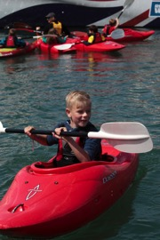
Gosport Marine Festival Chairman, John Beavis MBE, said: "The festival attracted 5,000 visitors in 2015. It is a great family event, especially for young people who can come along and enjoy themselves. First timers are most welcome and there is plenty for experienced sailors too. If you don’t fancy going afloat, you can watch in safety or enjoy the exhibitions and entertainment ashore."

The activities confirmed include:
- Sailing dinghies, big yachts, kayaking and rowing in Haslar Marina for 12+ year olds
- Windsurfing, paddleboarding and kayaking for 6 - 11 year olds at the Cockle Pond
- Short voyages for disabled people aboard the Wet Wheels accessible catamaran
- Little Shipmates provide seafaring activities for children too young to go afloat
- Marine art and craft exhibition, mainly by local artists
- Food and drink by Hampshire producers
- Live entertainment all day by local performers
- Marine services and employment stands.

Safety is top priority and John Beavis said: "All the waterborne activities are supervised by experienced, qualified people, and buoyancy aids and lifejackets are all provided. This event would not be possible without the support of over 150 volunteers who are giving their time freely and the generosity of local Charities, businesses and our sponsors."
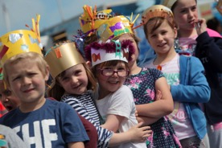
Organised by Gosport Marine Scene and Gosport Borough Council, the day will centre on Haslar Marina, in Trinity Church and on its surrounding Green, in the Timespace and, just around the corner, at the Cockle Pond/model yachting lake near Walpole Park.

There will be more than 800 places to go afloat. Further details and booking for all the activities are online at www.gosportmarinefestival.org.uk

The event is supported by Dean and Reddyhoff, the owners of Haslar Marina, the Gosport Sea Cadets, Crewsaver, Marine Advertising Agency, Wave 105, Radio Haslar, Andy Biggs Watersports, Lee-on-the-Solent and Stokes Bay Sailing Clubs, Gosport Model Yacht and Boat Club and many other activity providers.

ENDS

Media enquiries:

For further information and requests for interviews, please contact:
Mike Shepherd
Tel.: 023 9252 2044; or mobile 07786 265 455
Email: mike@marineadagency.com

GMF Chairman contact details:
John Beavis
Tel: 023 92793 063: or mobile 07952 199288
Email: johnw.beavis@gmail.com
Notes for Editors

About Gosport Marine Scene and Gosport:
Organiser of Gosport's: Marine Business Network, Gosport Marine Festival June 2015, Talent & Career Programme
Gosport Peninsula is a centre of excellence in ocean racing, sail training, marine tourism and trade.
Gosport is the home of: Alex Thomson Racing & Hugo Boss, Clipper Round the World Race, Global Ocean Race, Sail Training International, ASTO, Ocean Youth Trust South, Lee-on-Solent RYA Onboard, Toe in the Water . . . just for starters

