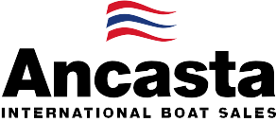

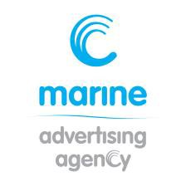
N e w s R e l e a s e
13th February 2017

Ancasta unveils plans for new Prestige 460

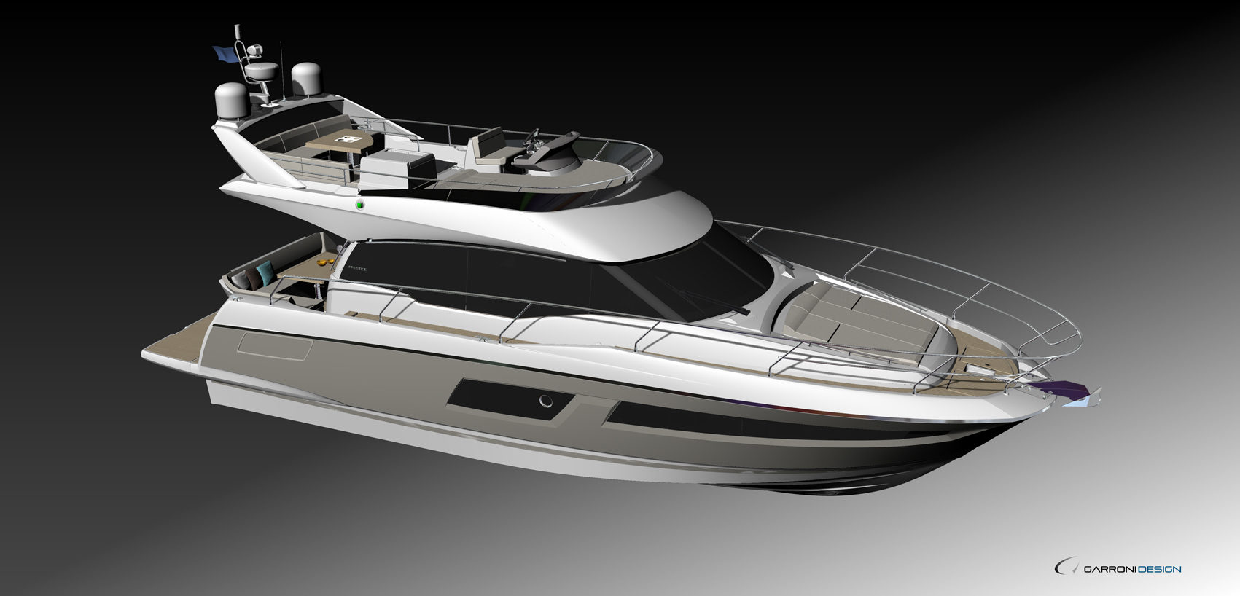
Ancasta, Prestige’s largest UK dealer, has unveiled the plans for the Prestige 460, which will launch at Cannes Yachting Festival in September 2017.

The Prestige 460 will be the newest luxury motor yacht in the flybridge range from the Prestige yard, one of the key players in the luxury motor yacht market.

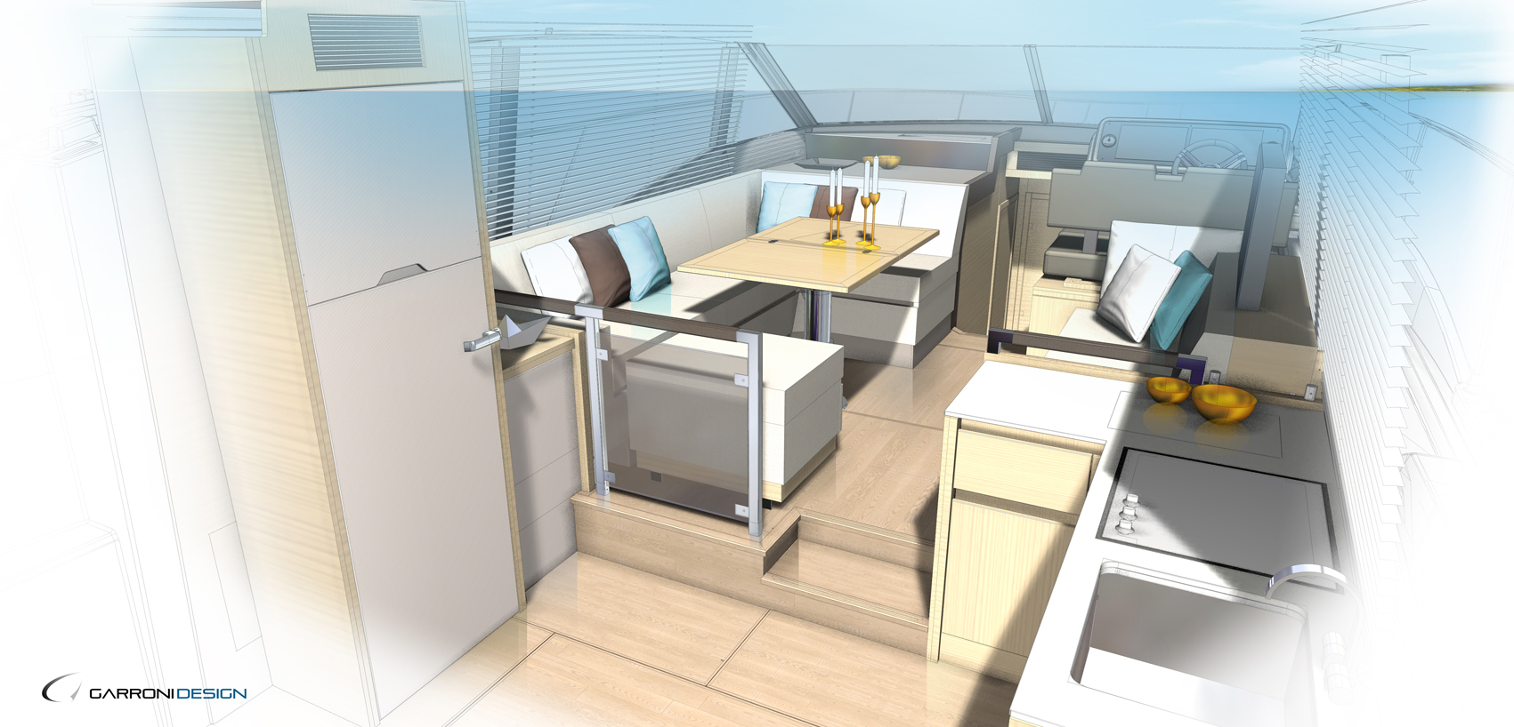
Powered by twin Volvo IPS500 or IPS600 engines, which allow for better efficiency and easy handling, the new Prestige 460 will take over the hull lines of the excellent Prestige 450.

The deck and all the layouts of the new model have been rethought and benefit from the latest improvements in terms of design and ergonomics.
Designs for the new Prestige 460
Designed by Garroni Design and engineered by JP Concepts, the Prestige 460 will offer contemporary and timeless design, consistent with the DNA of the latest Prestige Yachts; the Prestige 630 and the Prestige 680. The Prestige DNA makes these luxury motor yachts stand out, features include enlarged wheelhouse windows, which will be a particular feature in the design of the Prestige 460, and which bathe the interior in light.

Ancasta International Boat Sales, awarded Prestige Dealer of the Year for 2016, has announced that the Prestige 460 will launch on the European market at the 40th edition of the Cannes Yachting Festival, which takes place from 12th to the 17th September 2017.

Contact Ancasta to find out more about the new Prestige 460, and the rest of the Prestige range, email Nick Hatfield (nickhatfield@ancasta.com) or call +44 2380 450017.

For more information visit:
http://www.ancasta.com/boats-for-sale/new-boats/prestige/flybridge-line/460/
http://www.ancasta.com/boats-for-sale/new-boats/prestige/

ENDS

T: 023 9252 2044
E: Alison@marineadagency.com www.marineadagency.com
Marine Advertising Agency
15 Haslar Marina
Gosport PO12 1NU

Notes to editors
  - Ancasta International Boat Sales has 14 offices across Europe
  - Ancasta is the UK’s largest Prestige Luxury Motor Yachts dealer, the UK’s largest Beneteau Power and the UK’s largest Beneteau Sail dealer
  - Ancasta is exclusive UK dealer for Lagoon Catamarans
  - In addition Ancasta is a new boat dealer for CNB Yacht Builders and McConaghy Yachts
  - The Ancasta Group incorporates Hamble Yacht Services Refit & Repair and Advanced Rigging and Hydraulics, both operating from Port Hamble.
  - For more information on Ancasta visit www.ancasta.com Media enquiries via Marine Advertising Agency:
Alison Willis
alison@marineadagency.com
Tel: 023 9252 2044

T: 023 9252 2044
E: alison@marineadagency.com www.marineadagency.com
Marine Advertising Agency
15 Haslar Marina
Gosport PO12 1NU

