Press Release: For Immediate distribution - 08/03/17

Benefit from the same advanced safety and performance technology as an America’s Cup sailor with Crewsaver’s ErgoFit 50N EX – Available now!
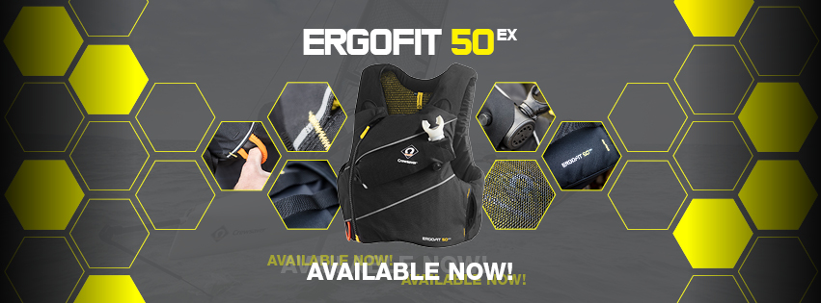
With the America’s Cup fast approaching, high performance sailing is on everybody’s mind and we find ourselves in a new era of sailing. With this revolution comes a demand for personal safety equipment that can offer the very highest in protection and performance. This is where the ErgoFit 50N EX comes into its own. Designed exclusively with Artemis Racing for the America’s Cup, the ErgoFit 50N EX represents a revolution in buoyancy aid design.

In high performance sailing, entrapment is a real risk; as a result Crewsaver has built-in the facility for a chest mounted Spare Air cylinder. The cylinder’s unique positioning allows for hands-free use of the device meaning that, even with arms trapped, the user is able to receive air underwater. In case of entanglement, the buoyancy aid features a readily accessible integrated line cutter, which is easily deployed with a downward motion.
The Fusion 3D design is uniquely constructed to contour to the shape of the wearer’s body to provide a close and unrestricting fit. Airflow technology incorporated throughout the buoyancy aid allows for the efficient transfer of heat during the exertions of racing conditions. Forcefield armour, that consists of CE level 1 back protection with high density impact foam in the front panels, is available as an optional extra.

Alongside high tech safety features, the buoyancy aid has also been developed for practicality. It hosts a rear pocket, with concealed shoulder channels, that allows for storage of a hydration pack to keep the user properly hydrated whilst out on the water.
Iain Percy, Team Manager for Artemis Racing, comments: “Technology and innovation in the America’s Cup have taken a huge step forward over the last few years, but the technology for commercially available safety equipment did not meet our team's needs. With Crewsaver, we wanted to find a supplier able to develop a best in class series of equipment that meets the demands of this new era of performance sailing. Crewsaver’s dedication to this project has impressed us all and we are extremely proud of the collaboration.”

ErgoFit 50N EX with Armour RRP Inc. VAT: £170
ErgoFit 50N EX RRP Inc. VAT: £85
For further information or to find a stockist visit www.crewsaver.com

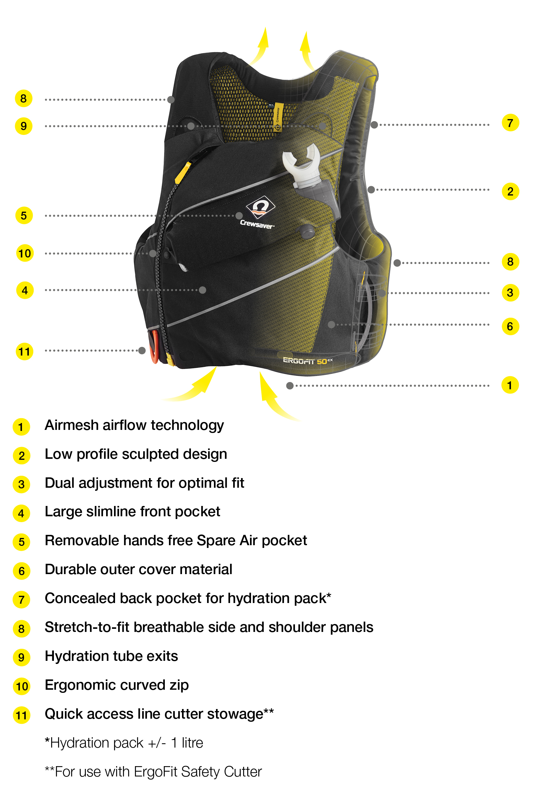

//ENDS//

For media information, hi-res images or product tests please contact:

Crewsaver
Hazel Proudlock, Marketing Dept
T +44 (0) 1329 820406
E hazel.proudlock@survitecgroup.com

Alison Willis – Marine Advertising Agency Ltd
T +44 (0) 23 9252 2044
E Alison@marineadagency.com

Notes to Editors

Crewsaver is a world-leading manufacturer of marine safety equipment and clothing for the commercial and leisure marine industries. Based in Gosport, Hampshire, the company designs and manufactures bespoke safety equipment for several countries’ Special Forces, and the aviation and oil industries. Crewsaver is the only company to hold an exclusive contract to supply lifejackets to the UK government’s Environment Agency and the Royal National Lifeboat Institution (RNLI). They are part of the Survitec Group.

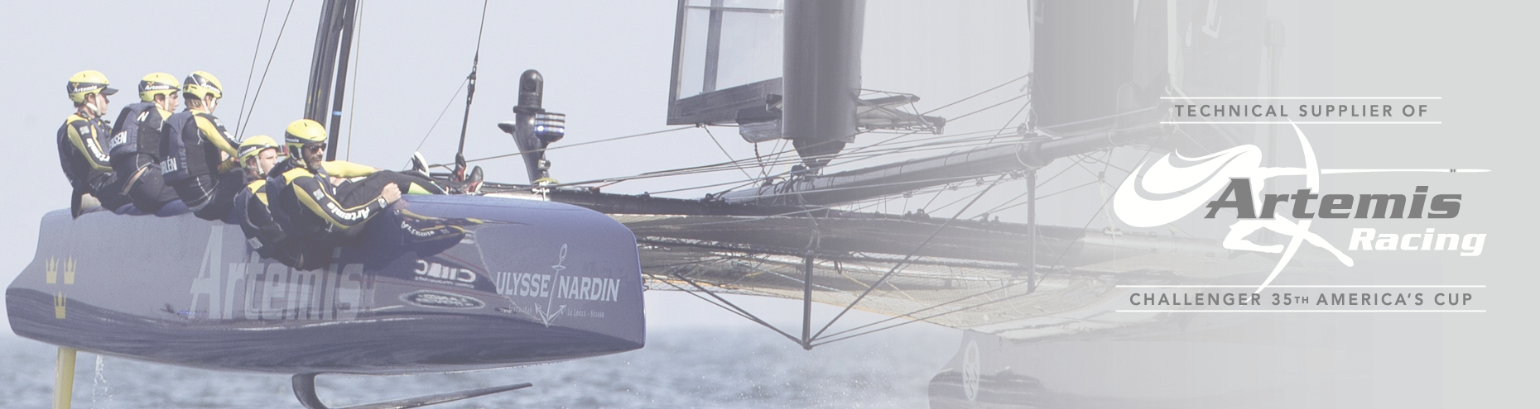
www.crewsaver.com

Survitec Group is a global leader in survival and safety solutions to the marine, defence, aviation and offshore markets. Survitec has over 3,000 employees worldwide covering 8 manufacturing facilities, 15 offshore support centres and over 70 owned service stations. It is further supported by a network of over 500 3rd party service stations and distributors. Across its 160-year history, Survitec Group has remained at the forefront of innovation, design and application engineering and is the trusted name when it comes to critical safety and survival solutions.
www.survitecgroup.com

