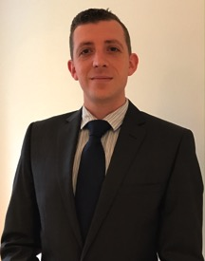
Paul Callus appointed as Crewsaver European & Middle East Sales Manager
Crewsaver is proud to announce the new appointment of Paul Callus as European & Middle East Sales Manager effective from the 6th January 2017. Paul is no stranger to the marine industry and has a strong background in both commercial and leisure marine sales and services. Previous roles of managing a large chandlery and as a BDM for Survitec Group allowed Paul to develop strong business relationships through effective customer service and in-depth marine product knowledge. This amalgamation of skills makes Paul the perfect fit to develop and strengthen Crewsaver’s retail and distributor network in both Europe and the Middle East.
Crewsaver Sales Director, David Duffin says “Crewsaver has an exciting year ahead and we are delighted that Paul, with his in-depth knowledge of marine safety products, is joining the team.”
Paul says “Crewsaver offers an inspiring array of safety products and has an impressive distribution network that I’m looking forward to meeting and working with.”
Contact Paul
Paul.callus@SurvitecGroup.com
+44 (0)7436 563 920

//ENDS//

For media information, hi-res images or product tests please contact:
Crewsaver
Hazel Proudlock, Marketing Dept
T +44 (0) 1329 820406
E hazel.proudlock@survitecgroup.com

Alison Willis – Marine Advertising Agency Ltd
T +44 (0) 23 9252 2044
E Alison@marineadagency.com

Notes to Editors

Crewsaver is a world-leading manufacturer of marine safety equipment and clothing for the commercial and leisure marine industries. Based in Gosport, Hampshire, the company designs and manufactures bespoke safety equipment for several countries’ Special Forces, and the aviation and oil industries. Crewsaver is the only company to hold an exclusive contract to supply lifejackets to the UK government’s Environment Agency and the Royal National Lifeboat Institution (RNLI). They are part of the Survitec Group.

www.crewsaver.com

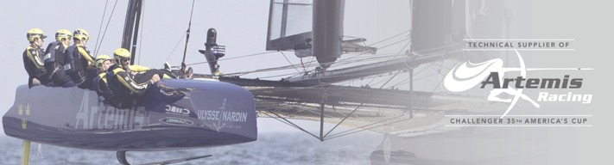
Survitec Group is a global leader in survival and safety solutions to the marine, defence, aviation and offshore markets. Survitec has over 3,000 employees worldwide covering 8 manufacturing facilities, 15 offshore support centres and over 70 owned service stations. It is further supported by a network of over 500 3rd party service stations and distributors. Across its 160-year history, Survitec Group has remained at the forefront of innovation, design and application engineering and is the trusted name when it comes to critical safety and survival solutions.
www.survitecgroup.com

