For Immediate Release: 13/03/17
Crewsaver Warsash Spring Championship 2017
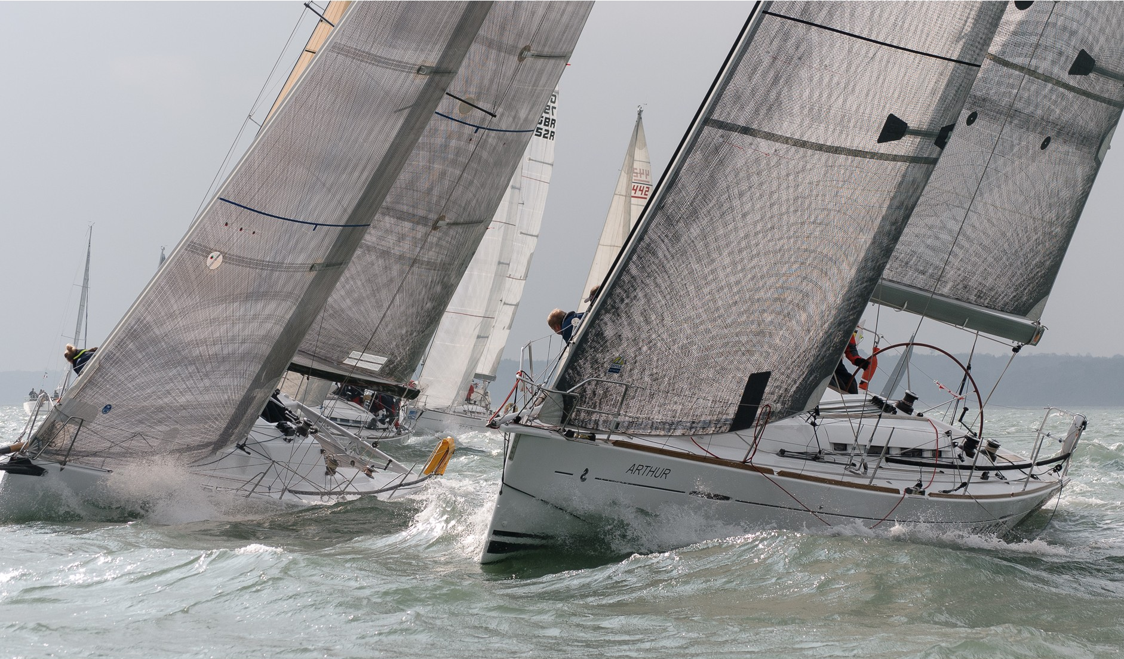
Crewsaver announces continued sponsor partnership with Warsash Sailing Club

As part of an ongoing three-year sponsorship agreement, Crewsaver will be donating a generous array of prizes to the Crewsaver Warsash Spring Championship 2017, which takes place over two weekends, 8th-9th and 22nd-23rd April 2017, supporting both the entrants and volunteers involved. Prizes include the popular Crewfit 180N Pro (RRP £110) from the Fusion 3D lifejacket range, which will be given to the Black Group Championship winners.
Photo Credit: 2016 Warsash Sailing Club

Three additional lifejackets will be provided to the bosuns and a further six for the race event’s weekly draw! Participants in the competitive White Group Championship will also all be in with the chance of winning the compact and lightweight Crewfit 165N Sport (RRP £66)!

Race participants are strongly recommended to be #Lifejacketsafe when out on the water by wearing a personal flotation device that has been well maintained and is suitable for the conditions. To support this, Andark Diving and Watersports, in conjunction with Crewsaver, will be providing 15% off Crewsaver products (T&C’s apply) to entrants throughout the Warsash Sailing Club’s spring racing events.

Peter Bateson, Series/Championship Chairman: “Thanks to Crewsaver’s generosity competitors in this year’s Spring Championship and Series have the chance to win some seriously good safety kit. We are very grateful to Crewsaver for their continued support and look forward to working with them through this year’s series”

Crewsaver will also be supporting the Warsash Spring Series by offering a further six Crewfit 180N Pro lifejackets to the Series’ weekly draw.

The much anticipated prize-giving will be held at Warsash Sailing Club on the 19th May 2017. A Crewsaver representative will be on hand to present the winners with their lifejackets and to answer any questions guests may have about how they can be #LifejacketSafe.

Find out more about the events http://warsashspringseries.org.uk/2017/index.htm

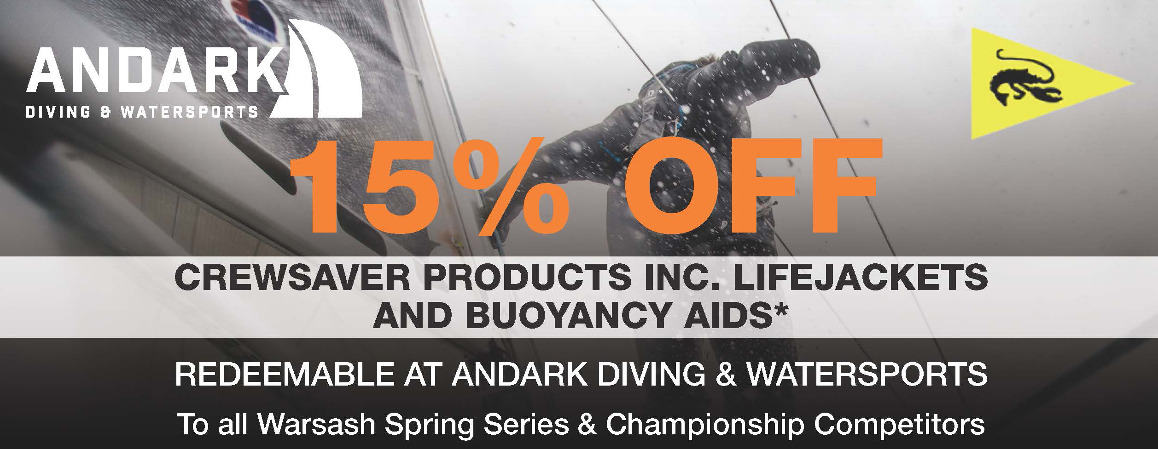

//ENDS//

For media information, hi-res images or product tests please contact:

Crewsaver
Hazel Proudlock, Marketing Dept
T +44 (0) 1329 820406
E hazel.proudlock@survitecgroup.com

Alison Willis – Marine Advertising Agency Ltd
T +44 (0) 23 9252 2044
E Alison@marineadagency.com

Notes to Editors

Crewsaver is a world-leading manufacturer of marine safety equipment and clothing for the commercial and leisure marine industries. Based in Gosport, Hampshire, the company designs and manufactures bespoke safety equipment for several countries’ Special Forces, and the aviation and oil industries. Crewsaver is the only company to hold an exclusive contract to supply lifejackets to the UK government’s Environment Agency and the Royal National Lifeboat Institution (RNLI). They are part of the Survitec Group.

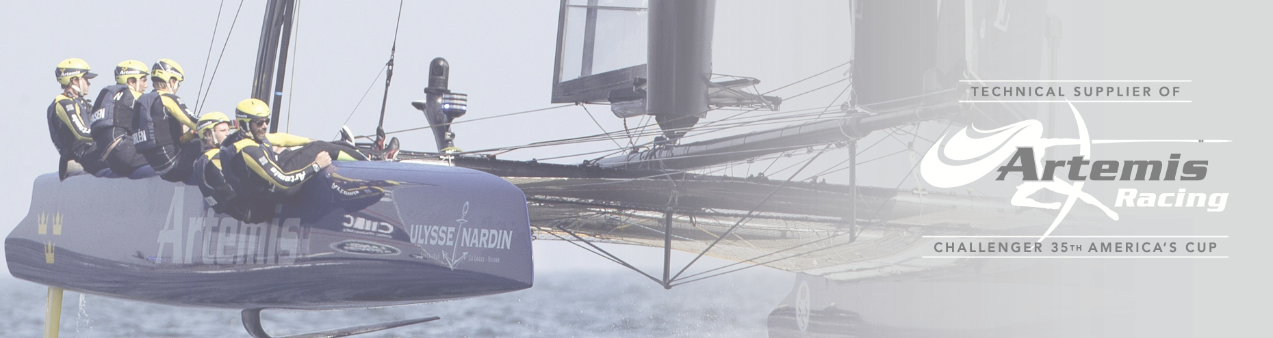
www.crewsaver.com

Survitec Group is a global leader in survival and safety solutions to the marine, defence, aviation and offshore markets. Survitec has over 3,000 employees worldwide covering 8 manufacturing facilities, 15 offshore support centres and over 70 owned service stations. It is further supported by a network of over 500 3rd party service stations and distributors. Across its 160-year history, Survitec Group has remained at the forefront of innovation, design and application engineering and is the trusted name when it comes to critical safety and survival solutions.
www.survitecgroup.com

