Press Release
For immediate release
16th March 2017

Mara Buoy expands into USA

Following the success of Mara Buoy in the UK, Jebb Smith Ltd has licensed Mara Buoy RI LLC to manufacture, market and sell the Mara Buoy products into the USA, Canada and the Caribbean. Their sales office, headed up by Mark Donahue, is based in Tiverton, Rhode Island.
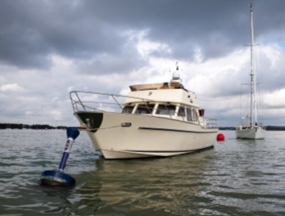
“MARA EFS provides a new solution to an old problem with mooring systems,” MARA BUOY RI owner Mark S Donahue said in a statement. This sales agreement brings that solution to the USA, Canada and the Caribbean. “A modern, safe and clean method to secure your vessel is something the customers will notice very quickly. In addition, this method of mooring is designed to reduce the stress associated with securing the mooring pendant and ensure a welcomed end to a day of fun.”

The Mara Buoys are a range of innovative mooring systems for yachts and small commercial vessels. They have a number of features, which revolutionize mooring systems.

The Mara Buoy design offers substantial improvement over current systems in terms of longevity, safety, ease of use, reliability, maintenance and night-time visibility. They can also be personalized to include yacht names, logo or artwork.

There are two versions of the buoy, the Mara Buoy Dynamic and the Mara Buoy Static.

With the Mara Buoy Dynamic the mooring line pick up point is at deck level and the mooring line ‘gives’ upon pick up allowing the deckhand time to make fast. It features a galvanized steel backbone through which the mooring force is transmitted from the mooring line to the mooring chain. Reliability is increased by the fact that the mooring line runs over radiused surfaces, which reduces chaff. Allowing the line to swivel inside the galvanized steel backbone eliminates an underwater swivel.

To make maintenance easier, inspection of the mooring line and swivel are carried out through a window in the backbone. Underwater connection is by way of a shackle to the mooring chain, which gives a simple, strong connection. Reflective surfaces help to improve night-time visibility and close quarters navigation.

With the Mara Buoy Static the mooring line pick up point is also at deck level, but with this system the yacht’s mooring line is passed through an eye at the end of the Mara Buoy line and brought back on board. The eye is designed with large bend radiuses and uses low friction materials which combine to substantially reduce chaff.
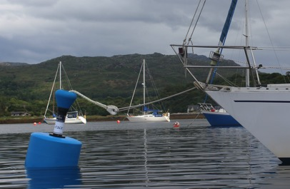
In both the Mara Buoy Dynamic and the Mara Buoy Static structural integrity is of the highest order and both products offer safety and reliability far in excess of standard mooring systems.

Full details can be found on our website http://www.maraefs.com and on Mara Buoy’s Facebook page, https://www.facebook.com/Mara-Buoy-1681873772028059/.

Mara Buoys are in production and orders are being taken.

Visit www.maraefs.com or email info@marefs.com for further information. For orders in the USA, Canada or the Caribbean, please contact Mark Donahue, Mara Buoy RI LLC, on +401 266 4523.

High-resolution images are available for download here: http://marineadagency.com/media-centre/

ENDS//

Notes to Editors

Mara EFS is a brand name of Jebb Smith Ltd. Jebb Smith Ltd is a family owned business. Mara EFS has over three decades of offshore engineering heritage behind it. European Registered Design No 003124676-0001

Media enquiries via Marine Advertising Agency

Mike Shepherd - mike@marineadagency.com
Emma Stanbury – emma@marineadagency.com
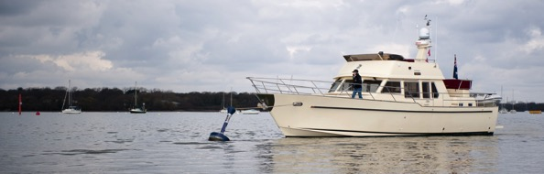
Tel: 023 9252 2044
Mara Buoy Dynamic

