For release 4th April 2017

Crewsaver extends liferaft range with the launch of two new liferafts
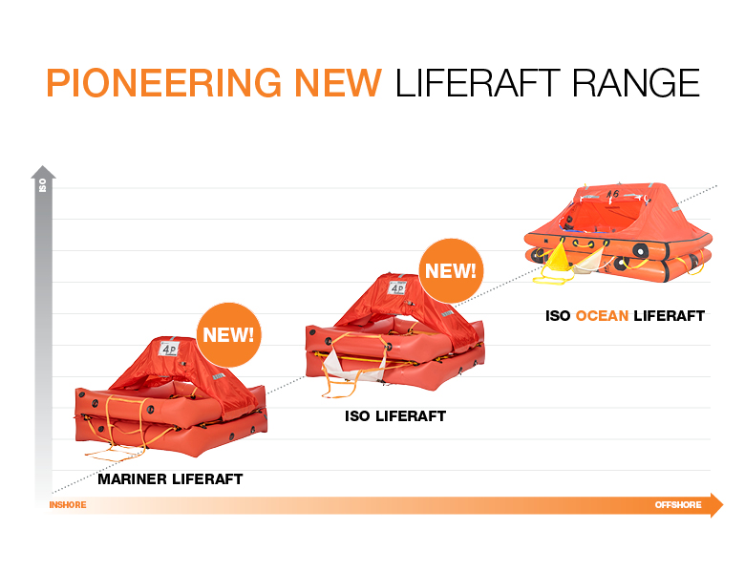
Following the success of the Crewsaver ISO Ocean liferaft, Crewsaver is delighted to announce the launch of two new liferafts; the Crewsaver Mariner and the Crewsaver ISO.

Now, no matter what level you are operating at, be it inshore or offshore, or what approval standard you might be looking to meet, there is a Crewsaver liferaft to suit and offered at a highly competitive price point.

Crewsaver liferafts are manufactured by Survitec Group’s European manufacturing facilities, which have been designing and manufacturing liferafts for both the commercial and leisure markets since 1940, helping to ensure a design and build quality that you can trust and rely on.

These liferafts can be serviced at a number of Survitec Group’s extensive network of service stations globally to help provide an effective and efficient servicing process for your long term convenience and continued safety. In addition, each liferaft comes with a 12-year warranty, providing it is serviced by a Crewsaver approved service station every three years.

“We are delighted to be able to offer this complete liferaft range, helping consumers to remain as safe as possible whilst getting the best value for money.” said David Duffin, Sales Director for Crewsaver.

//ENDS//

For media information, hi-res images or product tests please contact:
Crewsaver
Hazel Proudlock, Marketing Dept
T +44 (0) 1329 820406
E hazel.proudlock@survitecgroup.com

Alison Willis – Marine Advertising Agency Ltd
T +44 (0) 23 9252 2044
E Alison@marineadagency.com

Notes to Editors

Crewsaver is a world-leading manufacturer of marine safety equipment and clothing for the commercial and leisure marine industries. Based in Gosport, Hampshire, the company designs and manufactures bespoke safety equipment for several countries’ Special Forces, and the aviation and oil industries. Crewsaver is the only company to hold an exclusive contract to supply lifejackets to the UK government’s Environment Agency and the Royal National Lifeboat Institution (RNLI). They are part of the Survitec Group.

www.crewsaver.com
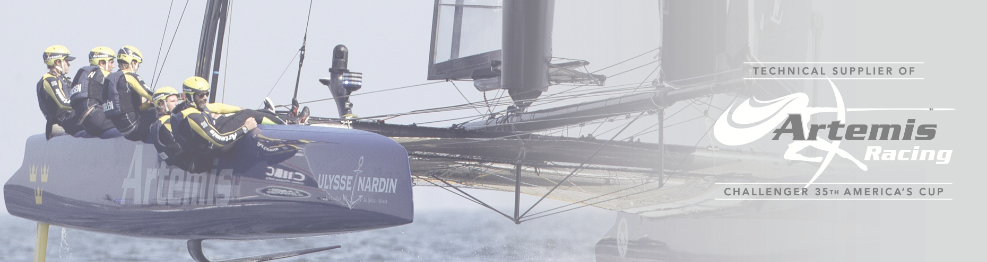
Survitec Group is a global leader in survival and safety solutions to the marine, defence, aviation and offshore markets. Survitec has over 3,000 employees worldwide covering 8 manufacturing facilities, 15 offshore support centres and over 70 owned service stations. It is further supported by a network of over 500 3rd party service stations and distributors. Across its 160-year history, Survitec Group has remained at the forefront of innovation, design and application engineering and is the trusted name when it comes to critical safety and survival solutions.
www.survitecgroup.com

