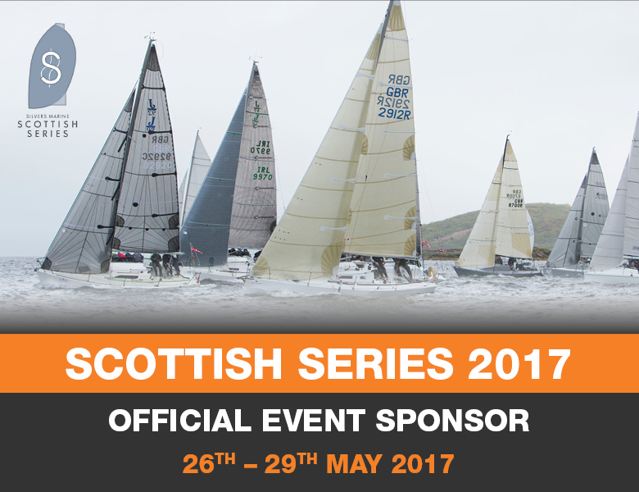
For release: 6th April 2017
Silvers Marine Scottish Series: 26th – 29th May 2017

Crewsaver, a Survitec company, and one of the world’s leading safety equipment manufacturers, announces continued sponsorship of the highly anticipated Scottish Series 2017.

Preparations are well underway by the Scottish Series organising authority, Clyde Cruising Club, as the anticipation builds for the prestigious event that is now in its 43rd year. Crewsaver is a historic sponsor of the Scottish Series and is delighted to be providing this year’s event with six 2’6” dumpy mark buoys. The highly visible buoys are easy to manoeuvre and will be used to map out the trapezoid courses whilst providing minimal disruption to air flow in the area for the competitors.

Scottish Series Event Chairman, David Denholm says “Support is great and that is what we have from Crewsaver in Newtons! But puns apart, it is tremendous to have the input and support from such a well-respected company within the maritime safety industry. Without the work put in by Crewsaver and the rest of the industry, sailing would not be nearly as safe as it is today, and would not be that great environment where yachtsmen can pit themselves against the elements. It is therefore again a privilege to link the Crewsaver brand with the One Design fleets for Silvers Marine Scottish Series 2017. In 2016 this racetrack provided some of the closest racing especially in the Hunter 707 fleet and it was from this class that the overall Scottish Series winner emerged. For 2017 we hope that that same competitive spirit and expertise will again be displayed. 2016 saw some wonderful champagne sailing. Yes, we could do with touch more breeze than last year, but hopefully, not so much that the real lifesaving powers of Crewsaver are demonstrated.”

“The Scottish Series promises to be a weekend of highly competitive sailing and it is with delight that we continue our sponsorship for the 3rd year running. As always we encourage entrants to be #LifejacketSafe and we also look forward to seeing the competitors put the mark buoys to good use on the new trapezoid course.” – Hannah Burywood, Crewsaver Marketing Manager

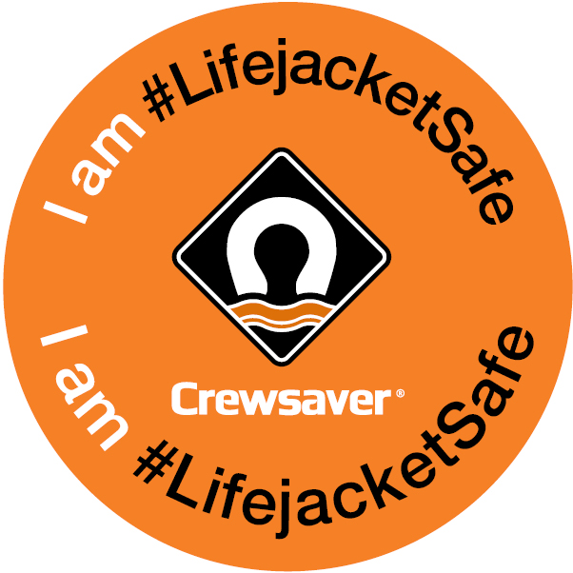
Are you #Lifejacketsafe… Crewsaver, in conjunction with the Scottish Series, highly recommend entrants to be #LifejacketSafe by wearing a suitable and well maintained personal flotation device. To support this, all entrants will receive a discount voucher that can be redeemed against Crewsaver lifejackets and buoyancy aid purchases at Kip Marina, Crhu Marine, Largs Chandlers, Bosuns Locker, Tarbert Chandlery and Ardfen Chandlery (T&Cs apply). For further information on personal flotation devices or to find your nearest lifejacket service station visit www.Crewsaver.com
Photo credit: Marc Turner, PFM Pictures

//ENDS//

For media information, hi-res images or product tests please contact:
Crewsaver
Hazel Proudlock, Marketing Dept
T +44 (0) 1329 820406
E hazel.proudlock@survitecgroup.com

Alison Willis – Marine Advertising Agency Ltd
T +44 (0) 23 9252 2044
E Alison@marineadagency.com

Notes to Editors
Crewsaver is a world-leading manufacturer of marine safety equipment and clothing for the commercial and leisure marine industries. Based in Gosport, Hampshire, the company designs and manufactures bespoke safety equipment for several countries’ Special Forces, and the aviation and oil industries. Crewsaver is the only company to hold an exclusive contract to supply lifejackets to the UK government’s Environment Agency and the Royal National Lifeboat Institution (RNLI). They are part of the Survitec Group.
www.crewsaver.com

Survitec Group is a global leader in survival and safety solutions to the marine, defence, aviation and offshore markets. Survitec has over 3,000 employees worldwide covering 8 manufacturing facilities, 15 offshore support centres and over 70 owned service stations. It is further supported by a network of over 500 3rd party service stations and distributors. Across its 160-year history, Survitec Group has remained at the forefront of innovation, design and application engineering and is the trusted name when it comes to critical safety and survival solutions.
www.survitecgroup.com
