12th April 2017

*****Press release - Immediate release*****

Superyacht Tenders and Toys starts building custom deck equipment

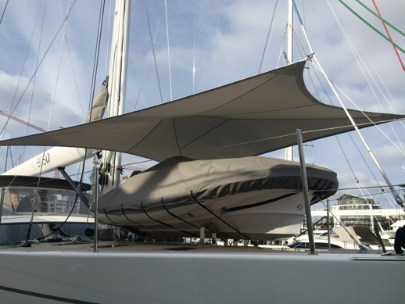
Superyacht Tenders and Toys has teamed up with some of the leading stainless, carbon, composite and inflatable manufacturers and is designing and building fully customisable equipment for superyachts with the highest level of construction and finishing. It can offer products from its extensive range of previous projects, or work with clients to realise any new custom designs.
Awnings from SYTT
Some exciting projects include Games Decks to go on superyachts made entirely from carbon, which can be used for playing basketball, football, tennis and volleyball making great use of deck space. Also popular this year are stylish and lightweight carbon sun awnings, poles and railings and carbon swim ladders, boarding poles and steps. All products are of the highest quality and extend the usage and improve the appearance of any vessel.
Another product really taking off this year is the adjustable aluminum Jet Ski trolley. These are adjustable in height and width and reinforced to fit a wide range of craft including the heaviest jet skis on the market. These are easily moveable by hand with locking wheels and lashing points, allowing jet skis to be moved around the garage to permit access and safe storage, making any tender garage more functional and effective and freeing up more space.
Peter Emmons, at Superyacht Tender and Toys explains, ‘Coming from the world of high performance yachting, we know our clients, the people we design for, and we understand how the products are used. We have teamed up with manufacturers who have all the design, engineering and manufacturing capacity to answer the diverging needs of our clients and we are excited about some of the diverse projects we have in the pipeline.’ Contact Superyacht Tenders and Toys for any custom equipment enquiries.
To learn more about Superyacht Tenders and Toys, visit
www.superyachttendersandtoys.com
ENDS

Find high-res images of Superyacht Tenders and Toys custom deck equipment here:
http://superyachttendersandtoys.com/image-gallery/superyacht-tenders-toys-starts-building-custom-deck-equipment/

Media enquiries via Marine Advertising Agency:
Alison Willis, alison@marineadagency.com
Emma Stanbury, emma@marineadagency.com
T: 023 9252 2044
Or
Josh Richardson, Superyacht Tenders and Toys
T: UK +442380016363
T: France +33489733347
T: US +19643029066
E: info@superyachttendersandtoys.com
Notes to Editors:
Superyacht Tenders and Toys is the leading independent consultancy and management company specialising in all superyacht tender and toy needs and provides practical solutions for the World’s finest yachts.

