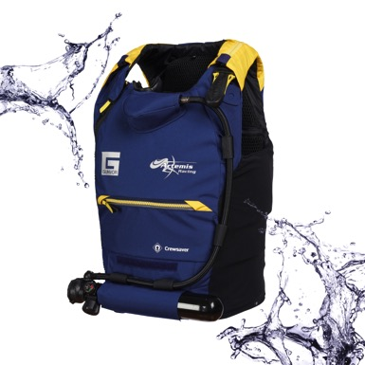

For Immediate Release
30th May 2017

Crewsaver supplies latest buoyancy aid designs to Artemis Racing ahead of the 35th America’s Cup

With the 35th America’s Cup just days away, Crewsaver, Technical Supplier to Artemis Racing, has supplied the team with the latest buoyancy aid technology advancing the design both in terms of safety features and overall performance gains. As part of their safety collaboration with Artemis Racing, Crewsaver developed two armoured buoyancy aids for the Artemis Racing team and through this ongoing partnership, Crewsaver has been working with the Artemis Racing team to make continued improvements to the team’s high performance buoyancy aids.
Artemis Racing will now compete in the 35th America’s Cup fully equipped in the latest and most advanced personal safety technology available. This will see the team benefit from an overall lower profile product, which is more aero dynamic, achieved through both fabric and fit modifications.
Key developments also include a significant update to the stowage options for the compressed air carbon cylinder and regulator, which now has an additional storage option on the front of the buoyancy aid as well as the reverse, allowing the sailor to customise their buoyancy aid to suit the needs of what they are doing in relation to where they are on the boat and what is most comfortable to them.
As highlighted in the Crewsaver #LifejacketSafe campaign, it is extremely important that users wear correctly fitting safety products not only for their overall comfort but safety too. Crewsaver has introduced modifications to all sizes and introduced a medium size product for the smaller sailors, to ensure that the entire team no matter what their size range is wearing a product offering a highly advanced bespoke fit.
The buoyancy aid continues to benefit from removable Force Field CE level 2 full back protector, whilst articulated high density foam also protects from front and side impacts. Other features include stretch-to-fit designs, approved to the CE ISO 12402 standard, high visibility shoulder panels and various equipment attachment points providing easy access to safety knives and communication equipment.
Airflow technology has been applied throughout and has been combined with vented stretch mesh side panels to allow the transfer of heat. This technology will help the team to regulate their body temperature during the exertions of racing in a range of climates.
‘Working with Crewsaver & Survitec on this project has given us the opportunity to take our buoyancy aid technology to the next level, throughout this project Crewsaver haven’t stood still, instead, together, we have step by step refine and refined again every aspect of our buoyancy aid designs to ensure the team are fully equipped to meet the needs of this new era of high performance sailing.’ Julien Cressant, Sailor & Rescue Diver for Artemis Racing
Nigel Parkes, Crewsaver design manager commented ‘Working with Artemis Racing gives us a very unique and exciting opportunity to not only design great product but in addition to learn and refine our designs from the constant testing and valuable feedback received from the team.’
//ENDS//
For media information, hi-res images or product tests please contact:

Crewsaver
Hazel Proudlock, Marketing Dept
T +44 (0) 1329 820406
E hazel.proudlock@survitecgroup.com

Alison Willis – Marine Advertising Agency Ltd
T +44 (0) 23 9252 2044
E Alison@marineadagency.com

Notes to Editors

Crewsaver is a world-leading manufacturer of marine safety equipment and clothing for the commercial and leisure marine industries. Based in Gosport, Hampshire, the company designs and manufactures bespoke safety equipment for several countries’ Special Forces, and the aviation and oil industries. Crewsaver is the only company to hold an exclusive contract to supply lifejackets to the UK government’s Environment Agency and the Royal National Lifeboat Institution (RNLI). They are part of the Survitec Group.

www.crewsaver.com

Survitec Group Survitec is a global leader in survival and safety solutions to the marine, defence, aviation and offshore markets. Survitec has over 3,000 employees worldwide covering 8 manufacturing facilities, 15 offshore support centres and over 70 owned service stations. It is further supported by a network of over 500 3rd party service stations and distributors. Across its 160-year history, Survitec Group has remained at the forefront of innovation, design and application engineering and is the trusted name when it comes to critical safety and survival solutions.
www.survitecgroup.com

