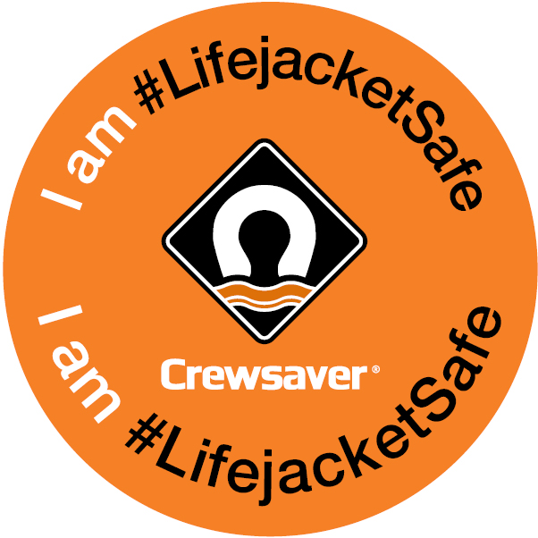
For release: 3rd May 2017

Crewsaver continues to take the lead on lifejacket safety through #LifejacketSafe initiative

“I’m not planning on falling in…” It’s something that we have all heard before and we may even be guilty of thinking it ourselves. However, as stated by the Maritime and Coastguard Agency, “Accidents can happen at any time in any weather. Good training and common sense help, but lives could be saved every year if people wore correctly-fitted, well maintained lifejackets or buoyancy aids. It’s surprisingly difficult to get back on board your boat once you’re in the water, and the cold water will affect how your body works. Wearing a lifejacket with crotch straps and spray hood could double your chances of survival, and increase your likelihood of being found.” *

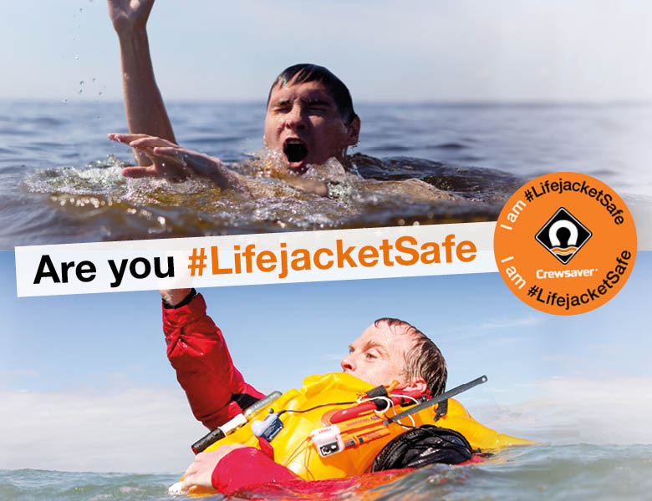
Crewsaver is determined to bring about change in people’s attitudes towards lifejacket safety, not wearing a lifejacket in the most extreme cases can be fatal; equally wearing a lifejacket that has not been looked after correctly or is not fit for purpose can also be very damaging. Often boaters are spotted out on the water either not wearing a lifejacket at all, wearing a damaged lifejacket or one that is incorrectly fitted.
The #LifejacketSafe campaign aims to increase safety awareness by highlighting the importance of not only wearing a personal flotation device, but also making sure it is worn correctly and is well maintained. So if the worst should happen, you are well equipped and can rest assured that your safety equipment is not going to let you down.
In 2014, the RNLI reported that out of the 6,752 lifejackets checked at their lifejacket clinics, a staggering 587 of lifejackets might not have worked as the carbon dioxide bottle had already been fired or was missing altogether.**
With this in mind, top of the #LifejacketSafe agenda will be to drive the importance of lifejacket maintenance and servicing. Crewsaver will provide users with weekly top tips on not only buying the correct lifejacket for your activity, but also on how to keep it ready for action should the unthinkable (but possible) happen. Users can access these tips, along with upcoming #LifejacketSafe competitions and challenges through both the Crewsaver website and social media pages.

“Following the success and interest the campaign generated at Southampton Boat Show 2016 we are delighted to be able to develop it. We will be highlighting some very real issues and finding as many ways as we can to provide safety information to the end user, helping to ensure they remain as safe as possible when out on the water,” says Hannah Burywood, Crewsaver Marketing Manager.
A FINAL THOUGHT… did you know… Figures from the RNLI’s 2015 Operational Statistics reports show that 166 lifeboat launches were in response to an emergency man overboard incident. ***

References

*MCA, (2014). Lifejackets Save Lives: Safety Advice From MCA

**RNLI, (2014). Operational Statistics

***RNLI, (2015). Operational Statistics

//ENDS//

For media information, hi-res images or product tests please contact:
Crewsaver
Hazel Proudlock, Marketing Dept
T +44 (0) 1329 820406
E hazel.proudlock@survitecgroup.com

Alison Willis – Marine Advertising Agency Ltd
T +44 (0) 23 9252 2044
E Alison@marineadagency.com

Notes to Editors

Crewsaver is a world-leading manufacturer of marine safety equipment and clothing for the commercial and leisure marine industries. Based in Gosport, Hampshire, the company designs and manufactures bespoke safety equipment for several countries’ Special Forces, and the aviation and oil industries. Crewsaver is the only company to hold an exclusive contract to supply lifejackets to the UK government’s Environment Agency and the Royal National Lifeboat Institution (RNLI). They are part of the Survitec Group.
www.crewsaver.com

Survitec Group is a global leader in survival and safety solutions to the marine, defence, aviation and offshore markets. Survitec has over 3,000 employees worldwide covering 8 manufacturing facilities, 15 offshore support centres and over 70 owned service stations. It is further supported by a network of over 500 3rd party service stations and distributors. Across its 160-year history, Survitec Group has remained at the forefront of innovation, design and application engineering and is the trusted name when it comes to critical safety and survival solutions. www.survitecgroup.com
