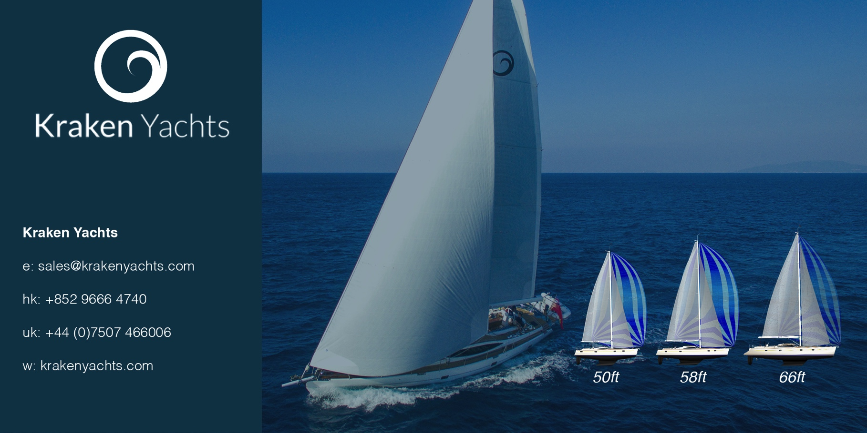
For immediate release
May 2017

PRESS RELEASE. KRAKEN YACHTS.

Kraken designer Kevin Dibley wins ‘2017 Yacht Designer of the Year’ award.

Kraken Yachts Ltd. is delighted to add to the many messages of congratulations winging their way to Kevin Dibley (designer of the new range of Kraken blue water cruisers) on his being named ‘2017 Yacht Designer of the Year’ at the Asian Marine and Boating Awards ceremony.
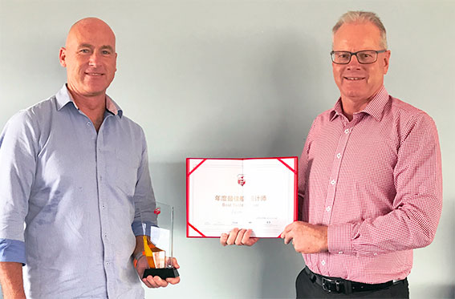
New Zealand-based Kevin Dibley is the first Kiwi to win this prestigious award and joins an impressive list of previous winners that includes such famous names as Ed Dubois and Bill Dixon.

Dibley started his design career as the Design Director at NZ based boatbuilding firm, Eagle Yachts Ltd. Then in the mid ‘90s he started working alongside America’s Cup legend Laurie Davidson. Two of the notable designs Dibley worked on with Davidson were the Norwegian Juice Dragon’s for the Volvo 60 round the world race and the Davidson 52 Pendragon lV that went on to form the basis for the internationally successful TP52 class.
Peter Busfield of the NewZealand Marine Industry Association presents Kevin Dibley (left) with the
2017 Yacht Designer of the Year award

Since setting up his fast-growing Dibley Marine office (www.dibleymarine.com) in Auckland and Queenstown (NZ), Dibley has designed a wide variety of craft. These include high performance racing yachts (such as the Custom Dibley 72), blue water cruisers (such as the Kraken range), impressive explorer motor yachts (80ft Manu-Moana), planing power cruisers (such as the Sapphire 55) and a large number of production craft (both power and sail).

Explaining his design philosophy, Dibley said: “I was first taught the theory of yacht design using hand drawings and calculations as well as spline weights and French curves. From this ‘old school’ foundation I moved onto CAD design and drawings in the early 1990's.

“My early background and experience have been invaluable for understanding 'cause and effect' and knowing how one small change can have a domino effect all the way down the line. My aim is to always combine technology and artistry in such a way that each client falls in love with both his yacht’s performance and its aesthetics.”

Find out more at http://www.krakenyachts.com/

ENDS

Notes to Editors

Kraken Yachts, Gold Coast Marina, 1 Castle Peak Rd., Castle Peak Bay, N.T., Hong Kong.... and in the UK on the Hamble, Hampshire.
www.krakenyachts.com
sales@krakenyachts.com

Hong Kong: +852 26189335
Hong Kong cell phone: +852 9666 4740
UK cell phone: +44 7507 466006

High resolution images of the Kraken 50 for editorial use can be found online at: http://marineadagency.com/gallery/new-kraken-50-now-production/

Chairman: Dick Beaumont. He has developed companies and has lifelong extensive business interests worldwide. He has covered over 100,000 miles cruising the world under sail.
Managing Director: Roger Goldsmith. He oversees business affairs and design coordination that are managed from the Hong Kong headquarters
Sales Director: Mark Williams; previously sales manager at Discovery Yachts.

