**News Release**

**For immediate release**

**3rd May 2017**

**Ancasta announces line up for Poole Harbour Boat Show (19th-21st May 2017)**

Ancasta has announced its line up for Poole Harbour Boat Show 2017, which takes place from 19th to 21st May 2017. Ancasta is delighted to be back at the show, following its success last year. As the UK’s largest Beneteau Power and Beneteau Sail dealer, it will be presenting the Beneteau Oceanis 38.1 and 41.1 as well as the popular Swift Trawler 30 and 44 motor yachts. Ancasta looks forward to welcoming visitors to berths A49-46 and A44-38.

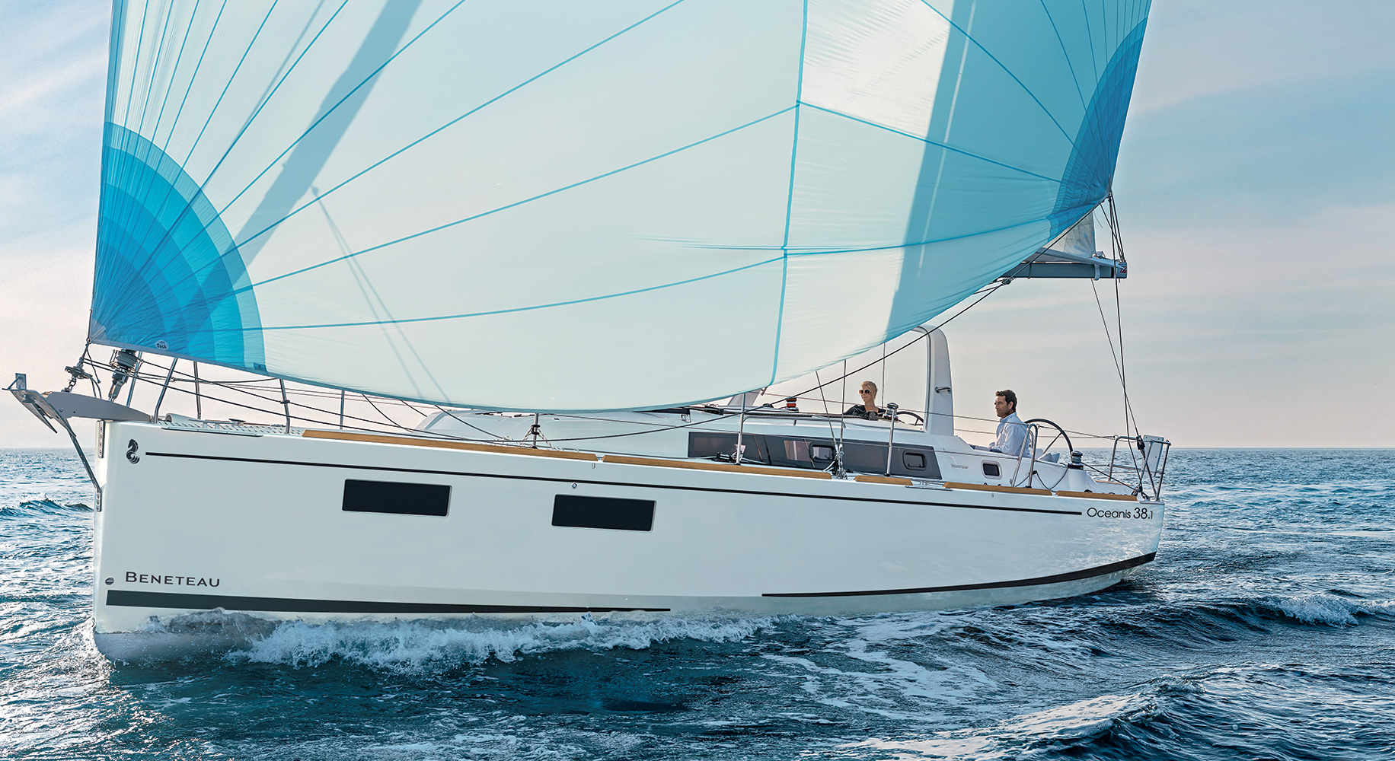Both the Beneteau Oceanis 38.1 and 41.1, which debuted in the UK in Autumn 2016, are designed with Finot-Conq hulls and Nauta interiors. The Oceanis range continues to offer a variety of different layouts, from number of cabins and bathrooms to a choice of galley layout, enabling clients to customise their boats to suit their style of sailing.

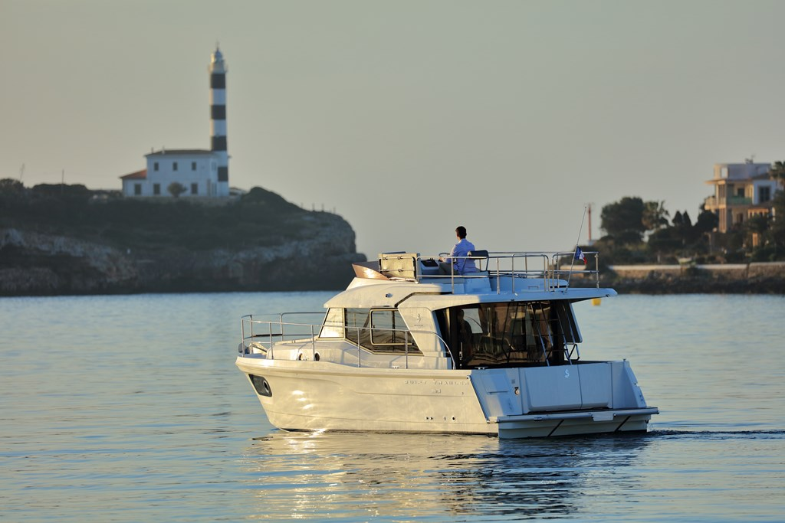The Swift Trawler models at the show combine classic style and design with modern technology and boast incredible sea-keeping qualities for long distance or coastal cruising. Uninterrupted windows allow light to flood into the saloon. The Swift Trawler 30 is the newest in the latest generation of the range.

The Beneteau Oceanis 38.1

Poole Harbour Boat Show is open Friday 19th, Saturday 20th and Sunday 21st May from 10am to 5.30pm.

Swift Trawler 30

To arrange appointments to view, please contact Ancasta on 02380 450 000 or email [enquiries@ancasta.com](mailto:enquiries@ancasta.com).

The Beneteau Swift Trawler 30

For more information visit <http://www.ancasta.com/events/poole-harbour-boat-show-2017>

**ENDS**

**Notes to editors**

* Ancasta International Boat Sales has 15 offices across Europe
* Ancasta is the UK’s largest Prestige Luxury Motor Yachts dealer, the UK’s largest Beneteau Power and the UK’s largest Beneteau Sail dealer
* Ancasta is exclusive UK dealer for Lagoon Catamarans
* In addition Ancasta is a new boat dealer for CNB Yacht Builders and McConaghy Yachts
* The Ancasta Group incorporates Hamble Yacht Services Refit & Repair and Advanced Rigging and Hydraulics, both operating from Port Hamble.
* For more information on Ancasta visit www.ancasta.com

Media enquiries via Marine Advertising Agency: Alison Willis - [alison@marineadagency.com](mailto:alison@marineadagency.com), tel: 023 9252 2044