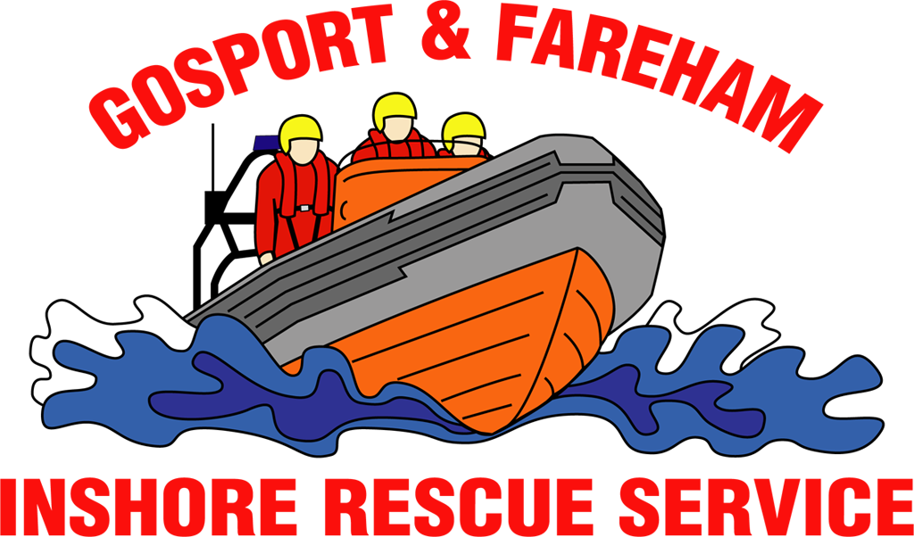

N e w s R e l e a s e
For immediate release
14th July 2017

FREE EVENT WILL BE PACKED WITH EMERGENCY SERVICES

Police, bomb disposal and ambulance crews will be among the large collection of emergency services showcasing their skills at Gosport & Fareham Inshore Rescue Service’s 10th anniversary open day.

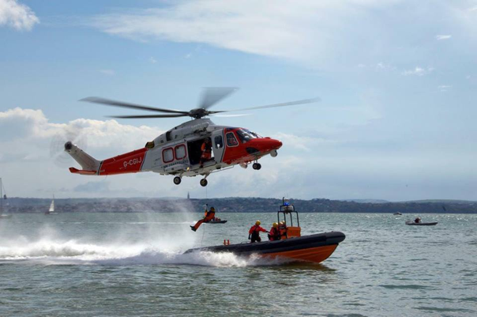
The event, which starts at 1100 and runs until 1600 this Sunday (July 16) is free to attend and packed with things for the family to see and do.

An exercise between Gosport Lifeboat and the Coastguard Rescue Helicopter 175 – based at Lee-on-the-Solent – has been scheduled, subject to operational requirements.

This exercise would see a winchman placed on Gosport Independent Lifeboat, just off the shore in Stokes Bay, Gosport, for the public to see.

GAFIRS fundraising officer James Baggott said: ‘This free event is packed with family friendly fun and activities. Not only will you be able to meet your local emergency services, but there’ll also be a cake sale, tuck shop and face painting and lots more.
‘We hope the local community can come down and support their local independent lifeboat station. Already this year our volunteer crews have been called out 61 times by the Coastguard to assist those in distress at sea.’

The event will take place at Gosport Lifeboat Station, Lifeboat Lane, Stokes Bay, and will include displays from:
- GAFIRS
- UK Coastguard
- Hampshire Constabulary
- South Central Ambulance
- Bomb Disposal Ramora
- UK SERV Bloodrunners
- Gosport Safer Community Team

Subject to operational requirements, all the services will be carrying out demonstrations for the public during the day. Chip-pan fire safety, saving a life, a look inside a liferaft and a joint frontline emergency services demonstration are also set to take place at the free event.

For more information, visit GAFIRS.org.uk.

ENDS

Media Enquiries & radio interviews:
James Baggott
Fundraising Officer
Gosport & Fareham Inshore Rescue Service
T: 07747 600855
E: fundraising@gafirs.org.uk
W: GAFIRS.org.uk

