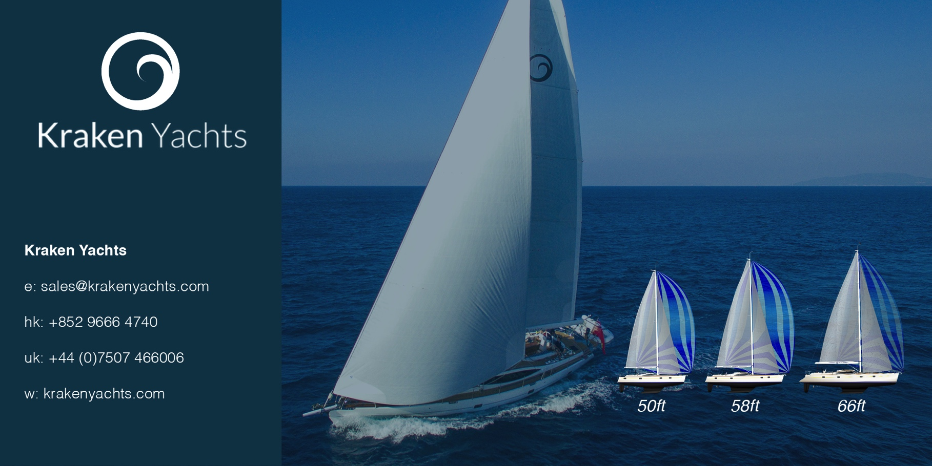
For immediate release
25th July 2017

PRESS RELEASE. KRAKEN YACHTS.

New KRAKEN 50… ‘Built for Purpose’ by Kraken Yachts Ltd.

Unlike many modern cruising yachts, the new Kraken 50 does not set out to be ‘all things to all people’. Kraken Yachts commissioned award-winning New Zealand designer Kevin Dibley to produce a yacht that is ‘Built for Purpose’.

That purpose is to be a true Blue Water Cruiser.

Kraken chairman and founder Dick Beaumont has over 100,000 miles under his keel and sums up the Kraken ‘ethos’ saying ‘There is no such thing as “one yacht for all purposes”... You cannot have the best of all worlds, whatever the salesman tells you.

‘When purchasing a new yacht, you should look at the build and design and how the yacht will perform in heavy weather, how comfortable its motion is and how easily it can be controlled. Why risk sailing across oceans in a yacht that is only suitable for recreational shoreline sailing or racing – rather than for true blue water cruising?’

The Kraken 50 does not cut corners or compromise. Unlike many production yachts, it offers - as standard - features that ensure safe and comfortable blue water cruising.

- It has a twin headsail rig. This sail combination adapts well to all weather conditions and – thanks to the standard electric winches - is easily handled from the cockpit by a small crew.
- For offshore safety and protection against UFOs (unidentified floating objects), the Kraken 50 incorporates a tough full-length skeg that is moulded as an integral part of the hull. Whereas many modern yachts have no skeg at all.
- The Kraken 50’s Zero Keel ™ (so called because it has zero keel bolts) is also an integral part of the hull with the lead ballast encapsulated in a long bulb. It cannot become detached; whereas an iron keel bolted beneath a flat-bottomed hull can.
- The Kraken 50 has a deep, well-protected centre cockpit with high seatbacks for security. These are carefully angled for maximum comfort in a seaway.
- An internal raised navigation station enables crew to stay warm and dry when on watch in bad weather.

The Kraken 50’s builder Xiamen Hansheng has been manufacturing award-winning yachts and motor cruisers since 1984 and is one of few yards to have ISO 9001 certification for quality control. The Kraken 50 - a quality semi-custom built blue water cruiser - has a generous standard inventory and costs little more than a run of the mill mass-produced yacht ... and considerably less than an expensive European semi-custom cruiser.

The first Kraken 50 will be launched in January 2018. Meanwhile its large sister – the Kraken 66 White Dragon – has already reached Madagascar on its maiden blue water cruise.

Find out more at http://www.krakenyachts.com/

ENDS

IMAGES

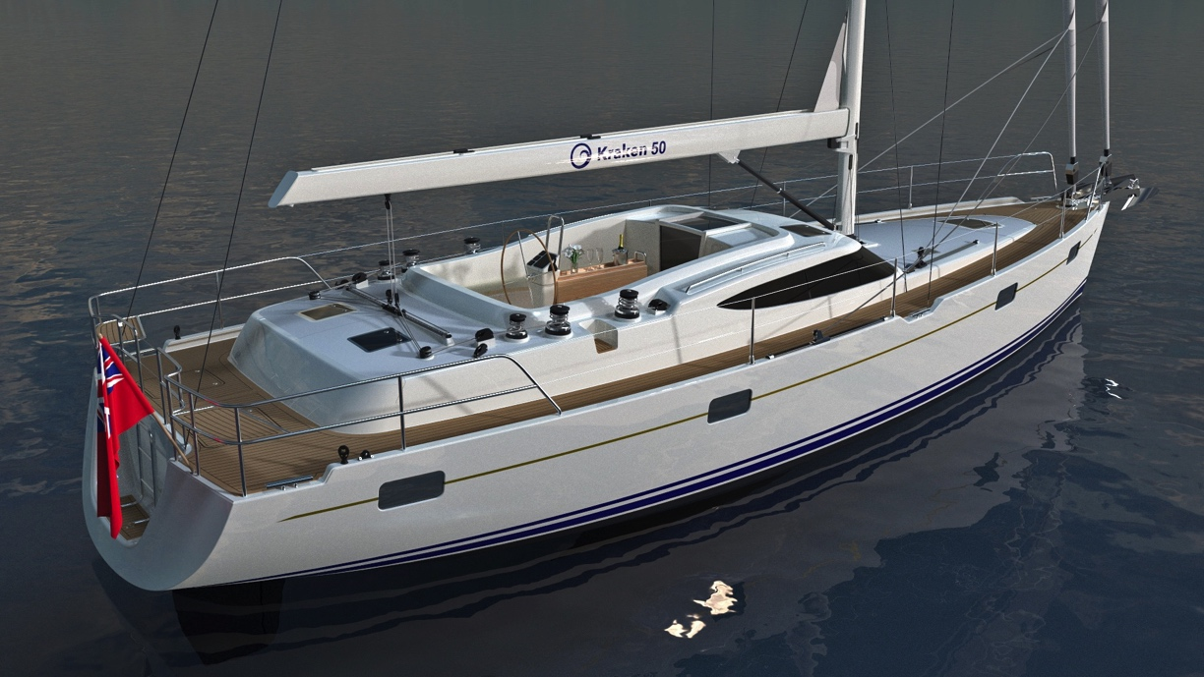
The Kraken 50 has a comfortable, safe and secure centre cockpit. In bad weather, crew can keep watch from the comfort of a raised navigation station in the saloon
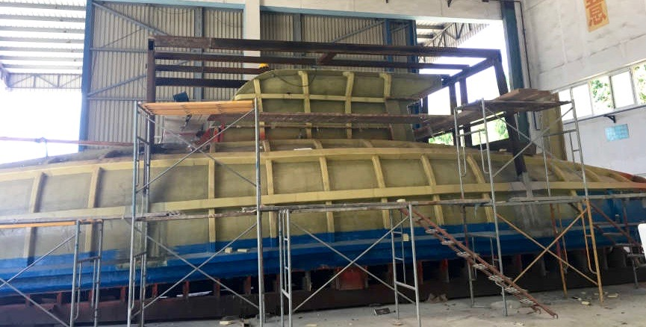
The Kraken 50 mould tool shows the Zero Keel ™ that is moulded as an integral part of the hull. The lead ballast is bonded inside the streamlined bulb that is extensively reinforced with Kevlar laminates.

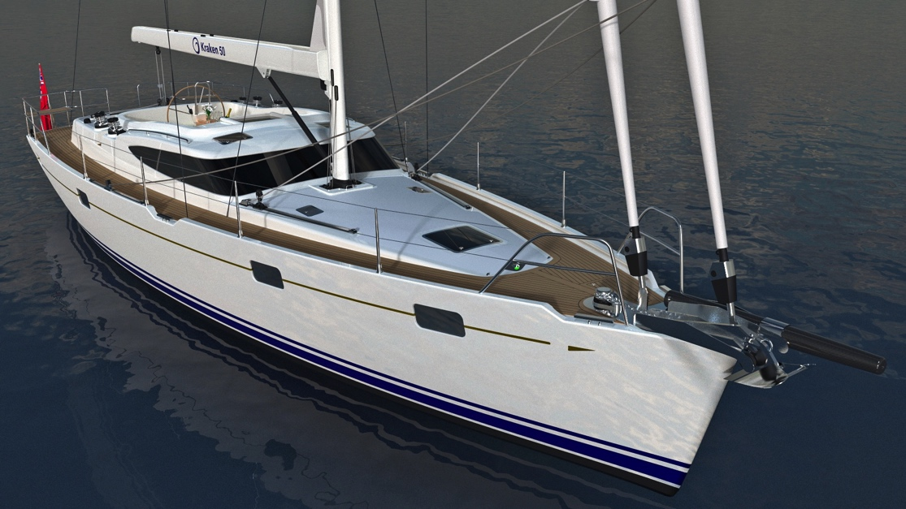

The Kraken 50 has deep, safe bulwarks and secure side decks.

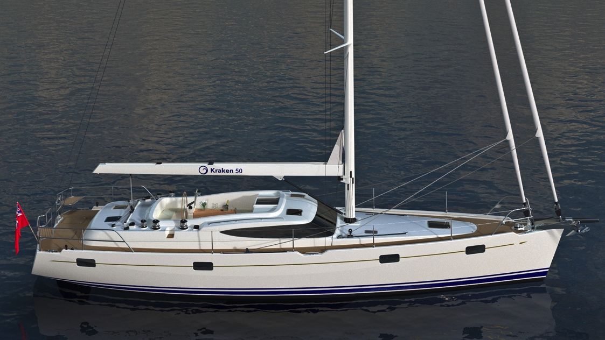
The furling twin headsail rig is easily controlled from the cockpit where electric winches are standard

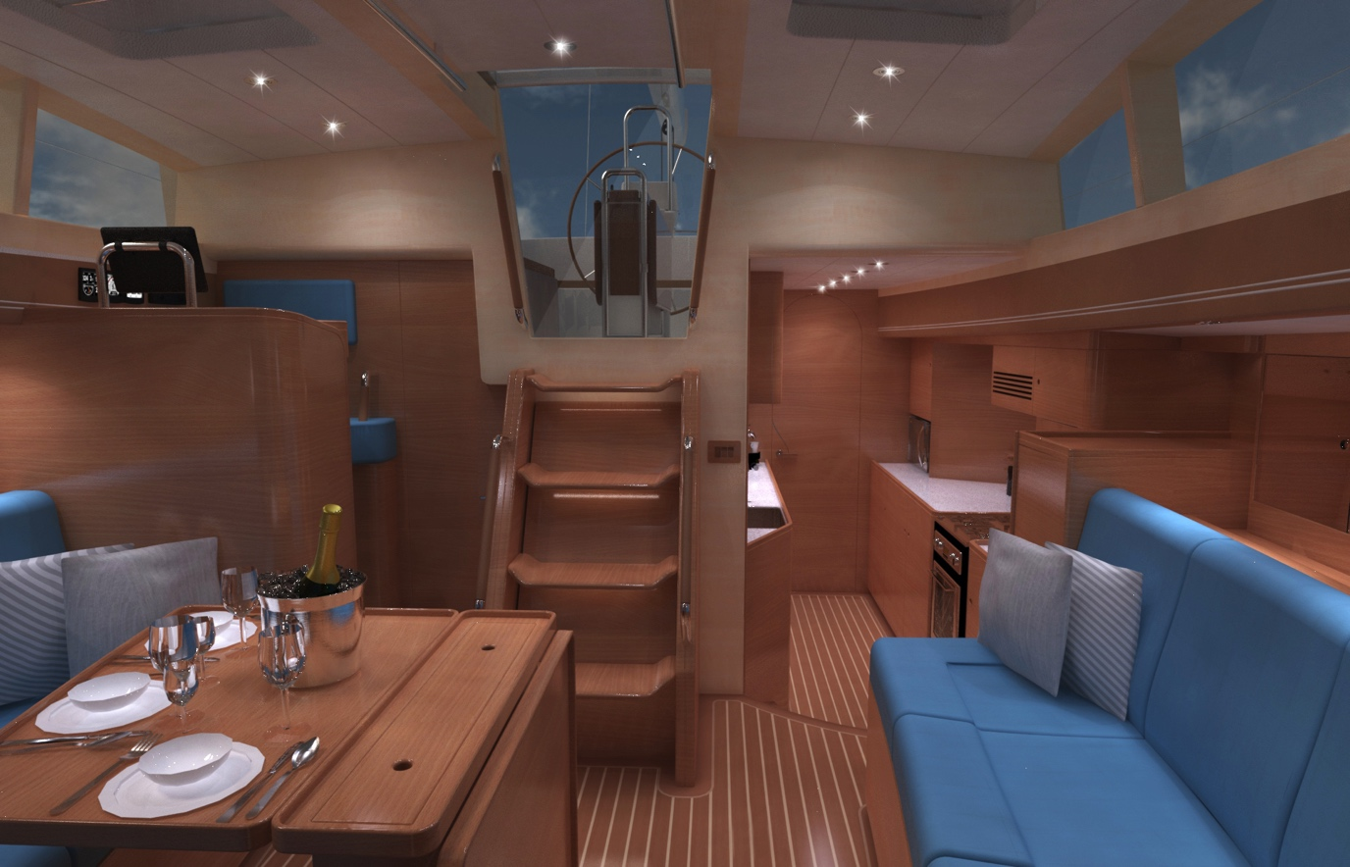
Note the raised interior navigation / watch keeping station (aft and to starboard).

Notes to Editors

Kraken Yachts Ltd.
Gold Coast Marina, 1 Castle Peak Rd., Castle Peak Bay, N.T., Hong Kong.
Swanwick Marina, Southampton, SO31 1ZL, UK
www.krakenyachts.com
sales@krakenyachts.com
Hong Kong: +852 26189335
Hong Kong cell phone: +852 9666 4740
UK +44 (0) 1489 809126
UK cell phone: +44 7507 466006

More high resolution images of the Kraken 50, which is currently in build, can be found online at: http://marineadagency.com/gallery/new-kraken-50-now-production/

Chairman: Dick Beaumont. He has developed companies and has lifelong extensive business interests worldwide. He has covered over 100,000 miles cruising the world under sail.
Managing Director: Roger Goldsmith. He oversees business affairs and design coordination that are managed from the Hong Kong headquarters
Sales Director: Mark Williams; previously worked with several other prestigious sailboat manufacturers.

Price:
From US $695,000 Ex VAT Ex Hong Kong. Delivery, launch, rig and commissioning are also available at Southampton, UK.

KRAKEN 50
Length Overall | 15.24 m | 50 ft
Waterline Length | 13.74 m | 45’ 1”
Beam Overall | 4.50 m | 14’ 9”
Draft | 2.30 m | 7’ 6”
Displacement | 16,850 kg (Lightships) | 37,148 lbs
Ballast Weight (LEAD) | 6,327 kg | 13,948 lbs
Sail Area | 143.53 sq.m | 1,545 sq.ft
Engine Power | 80 HP | 60 KW
Fuel Tank | 860 litres | 227 Gallon
Fresh Water Tanks | 700 litres | 154 Gallon
CE Certification | RCD Category ‘A’ Ocean

