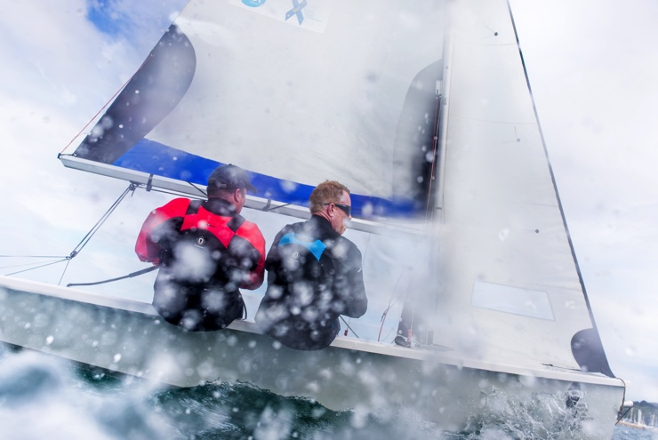
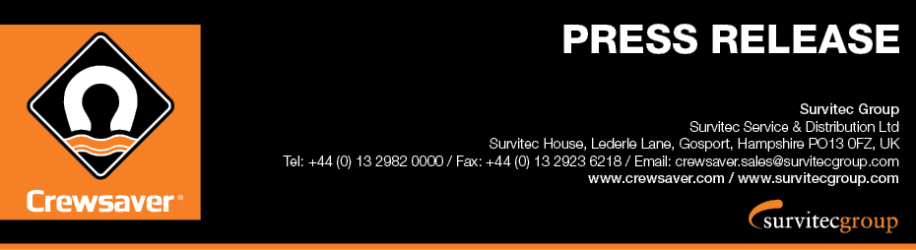
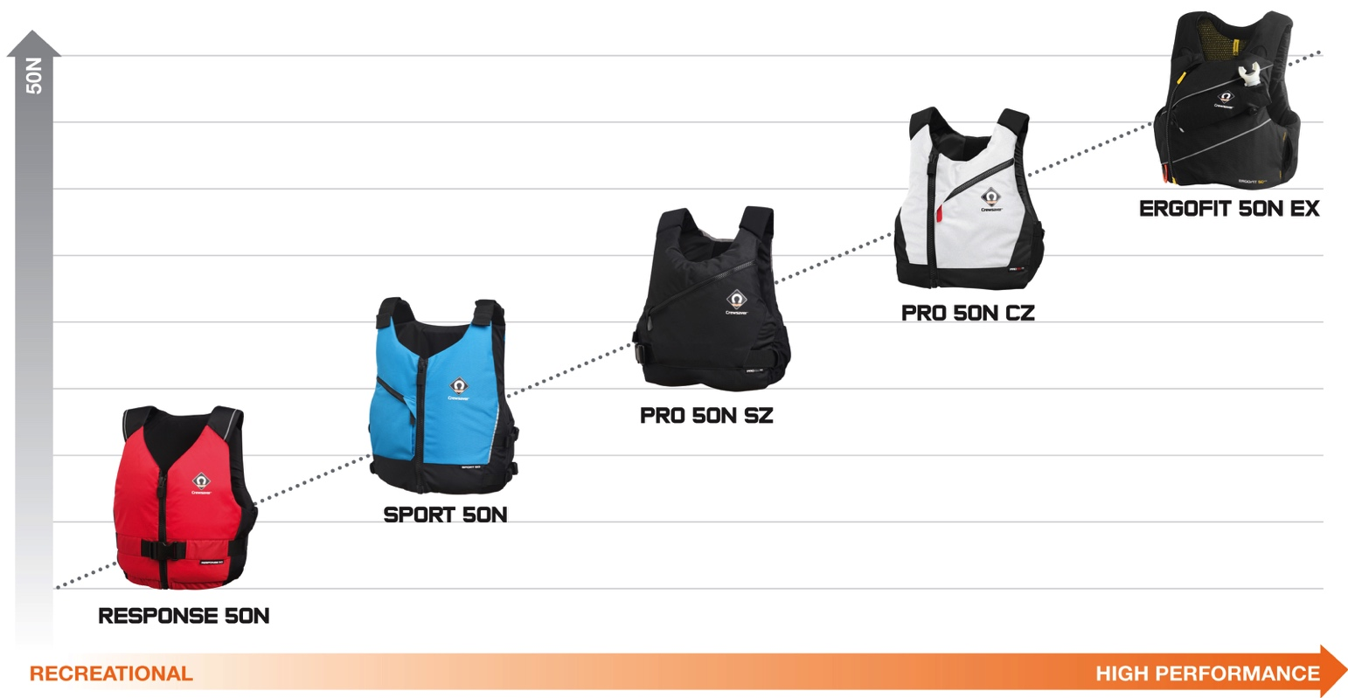
For immediate release: 21.08.17

Crewsaver Fusion 3D buoyancy aid range AVAILABLE NOW

Crewsaver, who celebrates 60 years of pioneering lifejacket technology this year, is delighted to announce that the new Fusion 3D buoyancy aid range has arrived!
Crewsaver’s new range of buoyancy aids has something very special to offer any watersport enthusiast and at every price point. Just like the popular Crewsaver Fusion 3D lifejacket range, the new buoyancy aids feature Fusion 3D technology to provide a uniquely unrestricting and comfortable fit. The range, consisting of five trailblazing designs, features combinations of lightweight and soft contoured buoyancy foam which is encased in finely tailored covers to support the designed-to-fit profile.
In addition, airflow mesh has been incorporated into the mid to high-end buoyancy aids. Crewsaver originally developed the airflow technology for the America’s Cup Challengers, Artemis Racing, to encourage the transfer of heat, which in-turn increases the breathability of the buoyancy aid.
“We aim to safeguard lives through high quality safety equipment and it is that philosophy which is at the heart of everything we do. Whilst developing our Fusion 3D buoyancy aids we endeavoured to create a range that people want to wear. We’re confident that the new buoyancy range is so comfortable that you will forget you’re wearing it!” – Beth Gill, Crewsaver Designer.
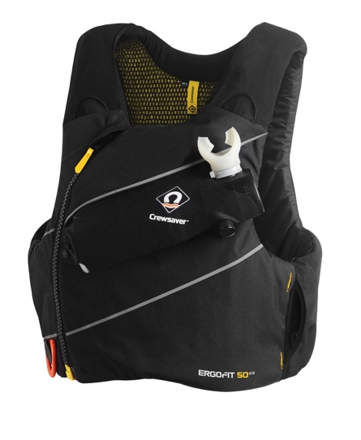
ERGOFIT 50N EX
The Crewsaver ErgoFit 50N EX buoyancy aid, a revolution in personal safety equipment, provides the most advanced specification a buoyancy aid has to offer to date. Combining high specification safety features such as Spare Air attachments, optional body armour and line cutter stowage, with a low profile, and snag free design, you can expect nothing but the best in safety and performance technology. RRP: £80 RRP: £160 with armour

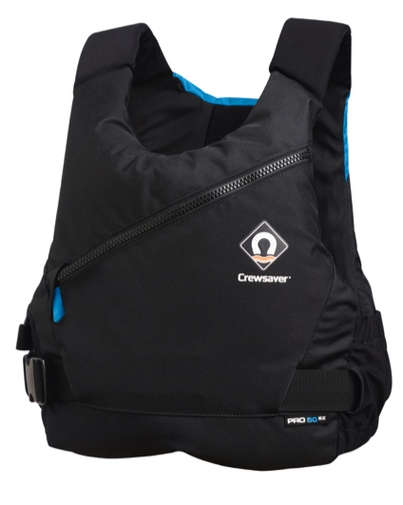
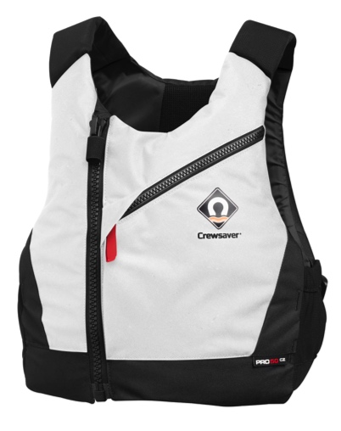
PRO 50N SZ & PRO 50N CZ
Fusion 3D design and unique body shaping foam that adapts to the profile of the wearer, combined with internal airflow mesh, ensure that the Pro 50N fits each user perfectly whilst offering the ultimate in comfort, fit and breathability performance. These features, plus an expandable bellow pocket with attachment point, make this the perfect safety companion for a multitude of watersport activities. The low profile Pro 50N is available in both centre zip ‘CZ’ and side zip ‘SZ’ options. The Pro 50N CZ is available in both a stylish bright white and black and the Pro 50N SZ is available in black/grey and black/blue options. RRP: £59.95
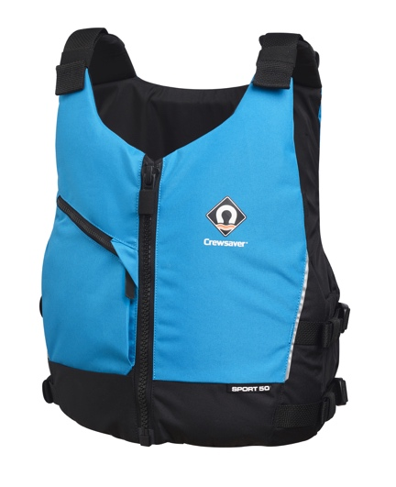

SPORT 50N
The Sport 50N offers the ideal solution for those who seek a high quality product at a highly competitive price point. Adjustable shoulder and dual waist straps combined with a unique arrangement of lightweight soft foam mean that the Sport 50N provides a bespoke and comfortable fit. This centre zip buoyancy aid features an expandable bellow pocket and reflective piping. Available in bright blue and red options. RRP: £49.95

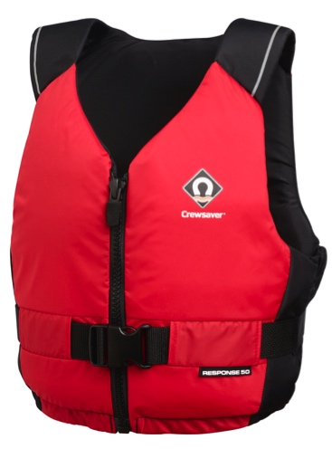
RESPONSE 50N
The perfect introduction to the Crewsaver buoyancy aid range, the Response 50N provides an entry-level buoyancy aid with an advanced contoured foam construction helping to ensure comfort and correct fit. In addition the Response 50N houses an array of features including a centre zip, padded shoulder straps, adjustable waist, key pocket and reflective print detailing. Available in red and black colour options. RRP: £34.95

Visiting the TheYachtMarket.com Southampton Boat Show?
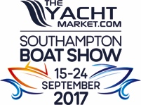
Crewsaver welcomes visitors to TheYachtMarket.com Southampton Boat Show to join them on stand J340 - Ocean Hall, where the new buoyancy aid range will be available to view for the first time and they will be able to purchase buoyancy aids from the new range.

//ENDS//
For media information, hi-res images or product tests please contact:

Crewsaver
Hazel Proudlock, Marketing Dept
T +44 (0) 1329 820406
E hazel.proudlock@survitecgroup.com

Alison Willis – Marine Advertising Agency Ltd
T +44 (0) 23 9252 2044
E Alison@marineadagency.com

Notes to Editors

Crewsaver is a world-leading manufacturer of marine safety equipment and clothing for the commercial and leisure marine industries. Based in Gosport, Hampshire, the company designs and manufactures bespoke safety equipment for several countries’ Special Forces, and the aviation and oil industries. Crewsaver is the only company to hold an exclusive contract to supply lifejackets to the UK government’s Environment Agency and the Royal National Lifeboat Institution (RNLI). They are part of the Survitec Group.

www.crewsaver.com

Survitec Group Survitec is a global leader in survival and safety solutions to the marine, defence, aviation and offshore markets. Survitec has over 3,000 employees worldwide covering 8 manufacturing facilities, 15 offshore support centres and over 70 owned service stations. It is further supported by a network of over 500 3rd party service stations and distributors. Across its 160-year history, Survitec Group has remained at the forefront of innovation, design and application engineering and is the trusted name when it comes to critical safety and survival solutions.
www.survitecgroup.com

