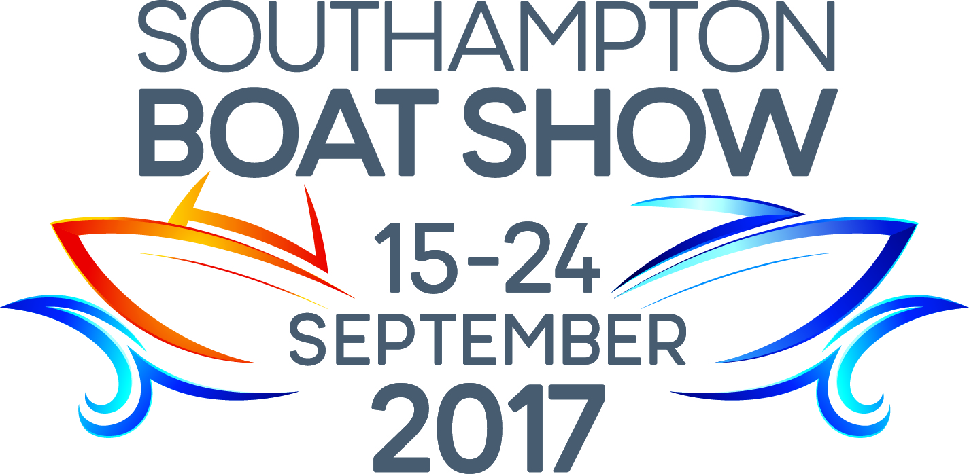
For Immediate Release: 2nd August 2017
Southampton Boat Show 15th – 24th September 2017
Ocean Hall - Stand J340

Crewsaver celebrates 60 years of pioneering lifejacket technology at the Southampton Boat Show
Crewsaver celebrates a special anniversary this year and invites visitors to the TheYachtMarket.com Southampton Boat Show to join them on their stand (J340) to celebrate 60 years of pioneering lifejacket technology. To mark the occasion, Crewsaver has designed a limited-edition lifejacket, the Crewfit 180N Pro Diamond that is up for grabs in its daily competition.
As well as getting involved in the anniversary celebrations, visitors to the Crewsaver stand at the show can also benefit from; expert safety advice including #LifejacketSafe top tips and free boat show gifts, as well as seeing Crewsaver’s brand-new range of buoyancy aids and drysuits, which will be available for sale (for the very first time!) at the show via Crewsaver’s show retailers.
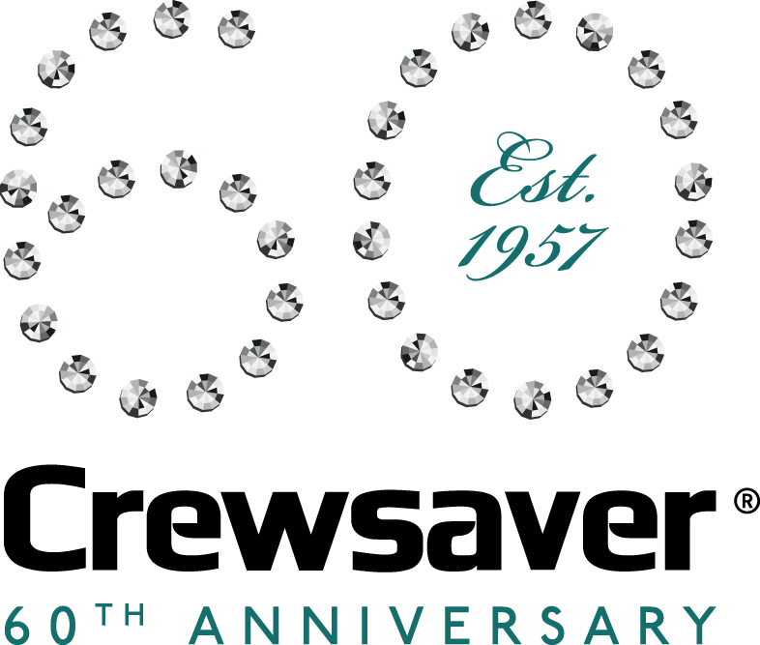
Join Crewsaver on Stand J340, Ocean Hall for;
- #LifejacketSafe top tips
- Expert safety advice
- New products
- Competitions
- Special offers & free gifts
- 60 year anniversary celebrations
Find Crewsaver on retailer stands;
- Andark Diving & Watersports F001
- Force 4 Chandlery B017 & J227
- Jimmy Green Marine J338
- Marine Super Store F006

//ENDS//
For media information, hi-res images or product tests please contact:
Crewsaver
Hazel Proudlock, Marketing Dept
T +44 (0) 1329 820406
E hazel.proudlock@survitecgroup.com

Alison Willis – Marine Advertising Agency Ltd
T +44 (0) 23 9252 2044
E Alison@marineadagency.com

Notes to Editors

Crewsaver is a world-leading manufacturer of marine safety equipment and clothing for the commercial and leisure marine industries. Based in Gosport, Hampshire, the company designs and manufactures bespoke safety equipment for several countries’ Special Forces, and the aviation and oil industries. Crewsaver is the only company to hold an exclusive contract to supply lifejackets to the UK government’s Environment Agency and the Royal National Lifeboat Institution (RNLI). They are part of the Survitec Group.
www.crewsaver.com

Survitec Group is a global leader in survival and safety solutions to the marine, defence, aviation and offshore markets. Survitec has over 3,000 employees worldwide covering 8 manufacturing facilities, 15 offshore support centres and over 70 owned service stations. It is further supported by a network of over 500 3rd party service stations and distributors. Across its 160-year history, Survitec Group has remained at the forefront of innovation, design and application engineering and is the trusted name when it comes to critical safety and survival solutions. www.survitecgroup.com

