N e w s R e l e a s e
17th August 2017

Prestige 520 to have UK Launch at
TheYachtMarket.com Southampton Boat Show 2017

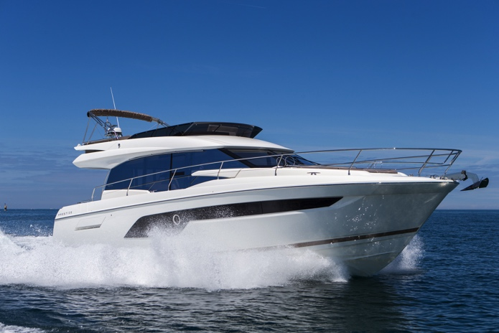
The Prestige 520 will have its UK launch at TheYachtMarket.com Southampton Boat Show, while the Prestige 460 will debut in the UK at the show, which takes place 15-24th September 2017.

Prestige has chosen the show for the UK launch of the Prestige 520, the latest in the luxury motor yacht brand’s Flybridge line, illustrating the importance it places in the UK market. The Prestige Flybridge range is known for offering a vast spacious flybridge with socialising, sunbathing and dining in mind.
Prestige 520

The Prestige 520 has an ‘XXL’ Flybridge, unique on a 52ft motor yacht, meaning that there is plenty of space for relaxing in comfort. The bright, inviting saloon is designed for socialising with sofas that face each other and an innovative helm bench seat, which adjusts electronically to face the saloon, creating the perfect space for entertaining.

The huge saloon windows not only let light in, which in turn gives uninterrupted views, but also allow the outside and inside spaces to flow harmoniously into each other. The boat is full of clever details making life on board easier while maximising the available space.

The Prestige 520 incorporates all the latest innovations from Garroni Design and Jean-François de Premorel, Prestige’s head of product design.
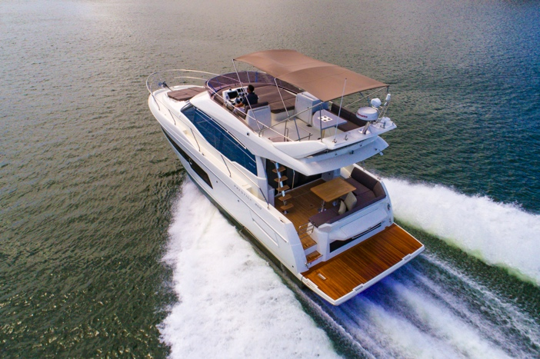
The Prestige 460, making its UK debut at the TheYachtMarket.com Southampton Boat Show, was released in March 2017 and is one of the newest models in the Prestige flybridge range. Powered by twin Volvo IPS500 or IPS600 engines, the Prestige 460 combines efficiency with easy handling, contemporary design with timeless elegance. The deck and layouts have been rethought, from its predecessor the 450 which has meant a bigger saloon and an owners cabin which looks like it’s stolen from a much larger boat, while oversized saloon windows flood the interior with light. The Prestige 460 is designed by Garroni Design and engineered by JP Concepts.
Prestige 460

The full list of Prestige models available to view at TheYachtMarket.com
Southampton Boat Show is as follows:

Prestige 630
Prestige 560
Prestige 520 UK LAUNCH
Prestige 460 UK DEBUT

As the UK’s largest dealer for Prestige, Ancasta will be presenting the above range of models at TheYachtMarket.com Southampton Boat Show to UK buyers from 15th to 24th September 2017.

Contact Ancasta now to make an appointment to view any of the above, email enquiries@ancasta.com or call +44 2380 450000.

PRESTIGE 520 Technical specification:
- Manufacturer Prestige
- Model 520 Flybridge
- Designer Garroni Design / JP Concepts
- Base Price £571,818 ex VAT
- LOA 16.10 m / 52'9
- Hull Length 14.50 m / 47'6
- Maximum Beam 4.50 m / 14'9
- Engine Size Twin Volvo IPS600 D6-435hp
- Cruising Speed 22 knots
- Dry (Light) Weight 14,100 kg / 31,085 lbs
- Cabins Three plus crew cabin (option)
- Standard Fuel Capacity Two 650 litre tanks
- Standard Water Capacity 640 litres

PRESTIGE 460 Technical specification:
- Manufacturer Prestige
- Model 460 Flybridge
- Designer Garroni Design / JP Concepts – J&J Design
- Base Price £410 348 ex VAT
- LOA 13.96m
- Hull Length 12.56m
- Maximum Beam 4.30m
- Maximum Power Available Twin Volvo IPS600-435HP
- Cruising Speed 24 knots
- Maximum Speed 32 knots
- Maximum Range 230NM
- Cabins Two cabins plus saloon & crew cabin
- Standard Fuel Capacity 1200 litres
- Standard Water Capacity 520 litres

For more information visit: http://www.ancasta.com

ENDS

Notes to editors
- Ancasta International Boat Sales has 14 offices worldwide
- Ancasta is the UK’s largest Prestige Luxury Motor Yachts dealer, the UK’s largest Beneteau Power and the UK’s largest Beneteau Sail dealer
- Ancasta is exclusive UK dealer for Lagoon Catamarans
- In addition, Ancasta is a new boat dealer for CNB Yacht Builders and McConaghy Yachts
- The Ancasta Group incorporates Hamble Yacht Services Refit & Repair and Advanced Rigging and Hydraulics, both operating from Port Hamble.

For more information on Ancasta visit www.ancasta.com

Media enquiries via Marine Advertising Agency:
Alison Willis - alison@marineadagency.com
Tel: 023 9252 2044

