***Press release – Immediate release*****

Superyacht Tenders and Toys expands team with Project Assistant
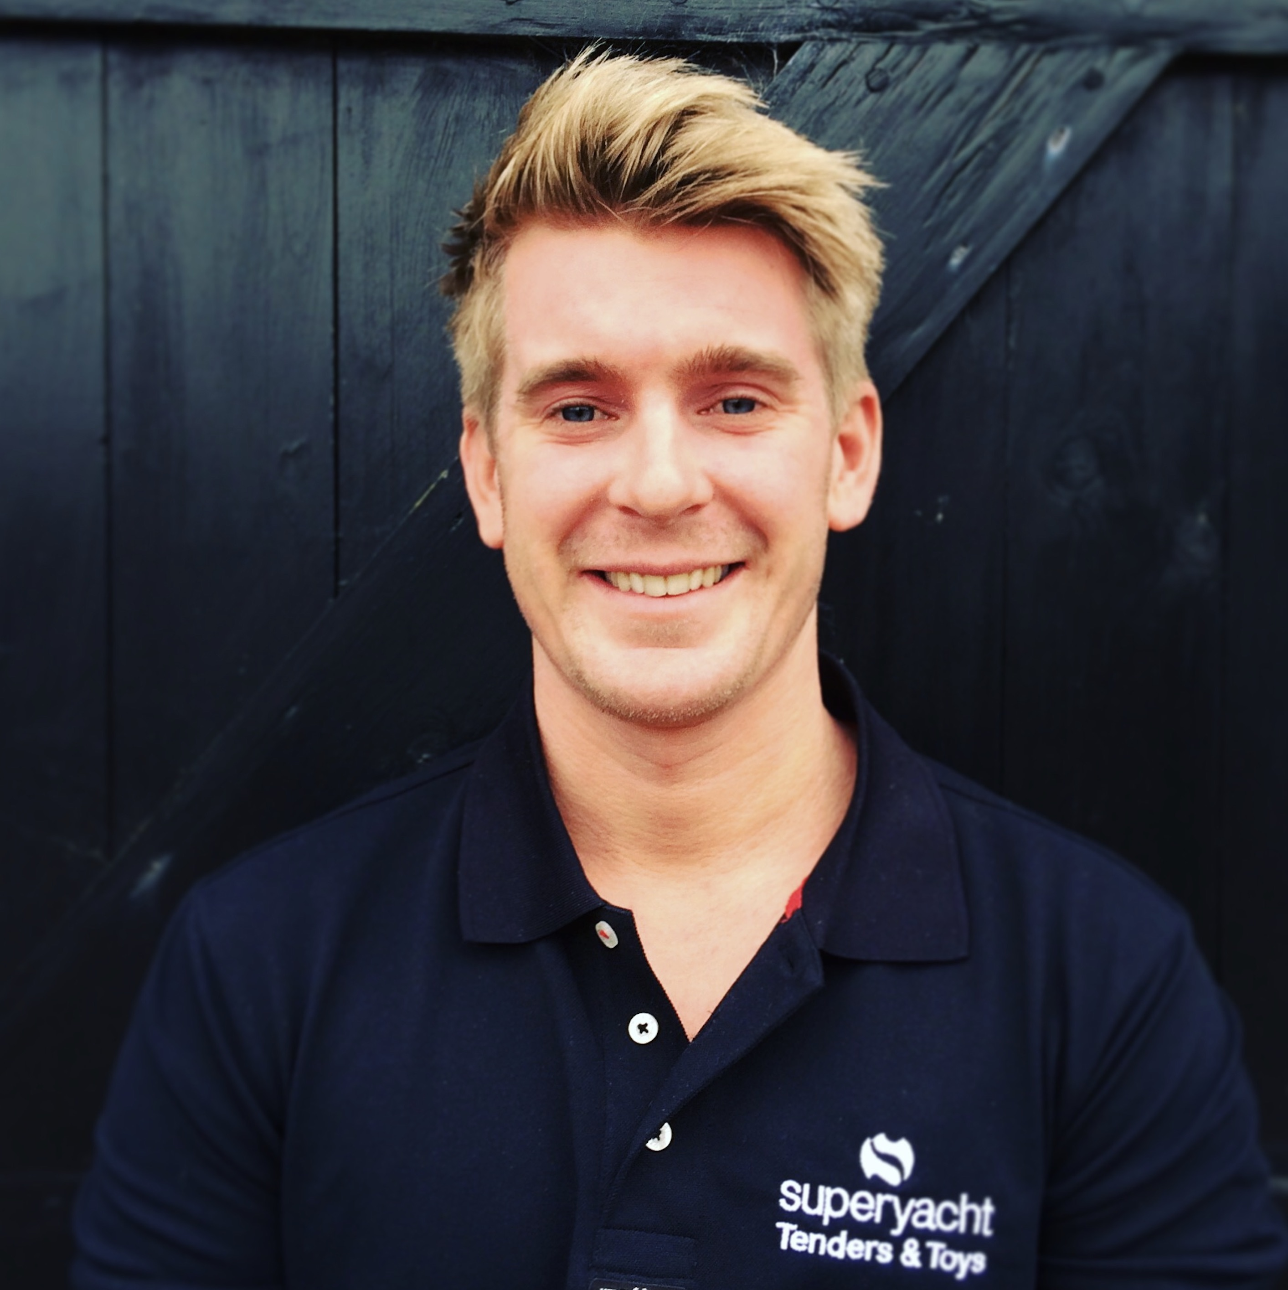
Superyacht Tenders and Toys, who recently won the Queens Award for International Trade 2017, continues to show strong growth and has welcomed Angus Gilmour as a new Project Assistant.
Angus has joined SYTT to assist the team and focus mainly on the management of custom tender projects. SYTT have noticed a large rise in the number of requests for project management due to increasingly large yachts being launched which have space for multiple tenders. An additional dedicated team member focusing on this will give the team more capacity for new projects.
Josh Richardson, Director, says “We are very excited to welcome Angus to the team. He has a wealth of ‘hands on’ superyacht experience having worked on a number of significant superyachts as deck crew. He lives and breathes anything Tender or Toy related and has great first hand knowledge. The growth of the company and expanding order book led us to look for an addition to our team who will fit in with our ethos of innovation and exceptional customer service. We were fortunate that we were able to find someone of Angus’s caliber to fulfill this role. I’m confident that he will play a key role in providing and implementing high quality solutions for our clients.”
To learn more about Superyacht Tenders and Toys, visit
www.superyachttendersandtoys.com
ENDS
Accompanying image link: http://marineadagency.com/gallery/superyacht-tenders-and-toys-expands-team-with-project-assistant/
Media enquiries via Marine Advertising Agency:
Alison Willis, alison@marineadagency.com
Jake Young, jake@marineadagency.com
T: 023 9252 2044
Or
Josh Richardson, Superyacht Tenders and Toys
T: UK +442380016363
T: France +33489733347
T: US +19643029066
E: info@sytt.co

Notes to Editors:
Superyacht Tenders and Toys is the leading independent consultancy and management company specialising in all superyacht tender and toy needs and provides practical solutions for the World’s finest yachts.

