N e w s R e l e a s e
17th August 2017

Swift Trawler 35 World Launch from Beneteau at TheYachtMarket.com Southampton Boat Show 2017

The world launch of the Beneteau Swift Trawler 35 will take place at the 2017
TheYachtMarket.com Southampton Boat Show (15th-24th September 2017).

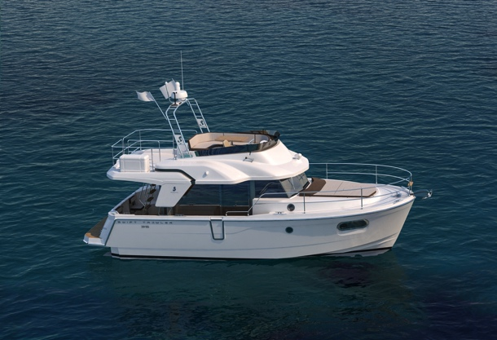
The Beneteau Swift Trawler 35 is taking over from the extremely successful Swift Trawler 34, which sold over 400 boats in her tenure. Not an easy task but this completely new boat with a redesigned hull takes on this challenge and not only succeeds but brings a trawler style boat bang up to date! Designed for comfortable cruising whether for long periods or short hops, the Swift Trawler 35 will certainly tick the boxes for owners and guests alike. Its harmonious lines and light-filled wheelhouse with 360º view will make this one for show visitors’ wish lists.
Swift Trawler 35

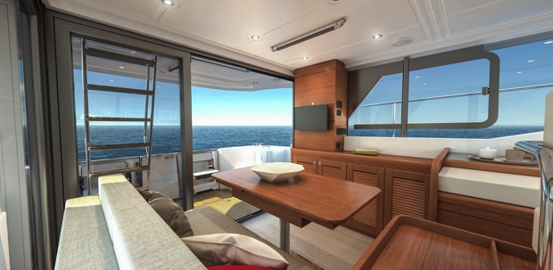
The Cummins 425hp engine and newly designed semi-planing hull work together to make this Swift Trawler 35 easy to manoeuvre and a pleasure to pilot. The design team have focussed on making the hull shape as efficient as possible to increase her cruising range, while tweaking the entry to make her comfortable at sea no matter what is thrown at you. The flybridge can either be protected by a bimini or soft top, and there is plenty of space to relax and enjoy the sea views. Broad walkways, lots of hand rails and high pushpits (higher than required by regulations) illustrate the importance attached to safety on board.
Swift Trawler 35 - interior

The spacious interior benefits from ingenious contemporary fittings. The owner’s cabin has a walkaround double berth bathed in light from the large hull windows and an en-suite shower room, while the second cabin is equipped with comfortable twin bunks. The U-shaped galley is fitted with a twin sink that converts to add additional worktop space, and also has an extra forward-facing seat. Seating in the saloon converts simply to add a comfortable double berth to the accommodation. Beneteau anticipates that the Swift Trawler 35, on its world launch, will be one of the must-see boats at TheYachtMarket.com Southampton Boat Show and with availability limited for 2018 you must snap yours up quickly!

Beneteau Power is also showcasing a new redesigned interior for the Swift Trawler 50 at the show. The entire Beneteau Power display will be on the water, giving easy access to all models and enabling visitors to see the boats afloat.

The full list of Beneteau Power models available to view at TheYachtMarket.com Southampton Boat Show is as follows:

Swift Trawler 35 WORLD LAUNCH
Swift Trawler 50 NEW INTERIOR
Swift Trawler 30
Gran Turismo 40
Gran Turismo 46

As the UK’s largest dealer for Beneteau Power, Ancasta will be presenting the models at TheYachtMarket.com Southampton Boat Show to UK buyers from 15th to 24th September 2017.

Contact Ancasta now to make an appointment to view any of the above, email enquiries@ancasta.com
or call +44 2380 450000.

For more information visit: http://www.ancasta.com

ENDS

Notes to editors

- Ancasta International Boat Sales has 14 offices worldwide
- Ancasta is the UK’s largest Prestige Luxury Motor Yachts dealer, the UK’s largest Beneteau Power and the UK’s largest Beneteau Sail dealer
- Ancasta is exclusive UK dealer for Lagoon Catamarans
- In addition Ancasta is a new boat dealer for CNB Yacht Builders and McConaghy Yachts
- The Ancasta Group incorporates Hamble Yacht Services Refit & Repair and Advanced Rigging and Hydraulics, both operating from Port Hamble.
- For more information on Ancasta visit www.ancasta.com

Media enquiries via Marine Advertising Agency:

Alison Willis - alison@marineadagency.com
Tel: 023 9252 2044

