News Release
For immediate release
20th September 2017

Marine industry charity 5-a-side tournament raises £1000 for Southampton hospital charities

On Tuesday the 19th of September 2017, teams from across the UK marine industry took part in the annual Marine Advertising Agency 5-a-side football tournament in order to help raise £1000 for the Paediatric Intensive Care Unit (PICU) and G4 Surgery at Southampton General Hospital.

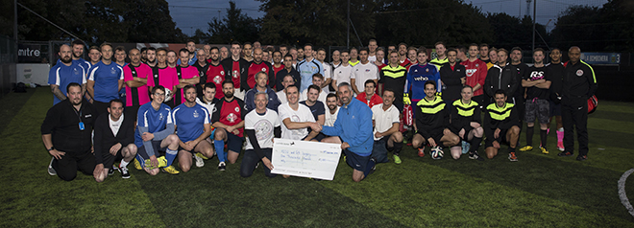

The tournament took place during this year’s TheYachtMarket.com Southampton Boat Show with 12 teams taking part. The 7th annual event saw three new teams participate: Gosport Borough Football Club U10's Dads, Moody Decking and Neuro Theatres UHS, one of three teams in the tournament from Southampton General Hospital, who competed alongside marine industry teams. For the second year running, tournament stalwarts, PSP Logistics, took home the silverware, winning the main Cup competition with a 3:1 victory over a team from Southampton FC’s corporate division.

The Plate competition was won by newcomers, Moody Decking, who beat MatchTech 4:3.

The tournament raised £1,000 for PICU and G4 Surgery ward at Southampton General Hospital. Mike Shepherd, Director of the Marine Advertising Agency (MAA), which organises the tournament said, “This year’s tournament was hotly contested! We’re delighted that so many of our marine industry colleagues take time out from what is a busy week, to enjoy a bit of friendly competition and raise funds for such an important local charity.” Mike’s daughter, Anna Shepherd, who has been supported by the units, and son, William Shepherd, both keen football players, were on hand to present the winners with their medals.

Southampton is the lead centre for paediatric intensive care in south central England with a catchment area that stretches from Dorset to Surrey to the Channel Islands. PICU provides first class
care and treatment to over 900 critically ill children every year. They care for children from birth right up to the age of 18, looking after those with both medical and surgical problems.

The MAA 5-a-side will take place again during next year’s TheYachtMarket.com Southampton Boat Show. Teams should get in touch with MAA to book their places.

ENDS//

Notes to editors
The Marine Advertising Agency was founded in 2009 by Mike Shepherd. MAA prides itself on providing no-nonsense solutions to marine companies’ advertising, PR and marketing needs. MAA’s current clients include Crewsaver, Ancasta, Wessex Resins & Adhesives Ltd, Navico, Superyacht Tenders and Toys, and British Marine Boat Shows, and the company is now providing services on a pan-European and international basis for its growing list of clients. For more information visit: http://www.marineadagency.com

TheYachtMarket.com Southampton Boat Show runs from 15-24th September 2017. For more information visit: http://www.southamptonboatshow.com

Media enquiries

Email: mike@marineadagency.com or alison@marineadagency.com

Tel: +44 (0) 23 9252 2044

Get high-resolution images of all the action from the tournament in the image gallery in our Media Centre:

http://marineadagency.com/gallery/maa-5-side-football-tournament-theyachtmarket-com-sbs-2017/

