For release: 19th October 2017
Crewsaver launches the #LifejacketSafe challenge as part of its lifejacket safety campaign

As part of its #LifejacketSafe campaign, Crewsaver has announced the launch of the #LifejacketSafe challenge, a quiz style challenge with thought-provoking questions highlighting lifejacket dos and don’ts. Not only could the advice learnt in the challenge save your life but also, by taking the challenge, you will be automatically entered into the prize draw to win the ultimate lifejacket package!
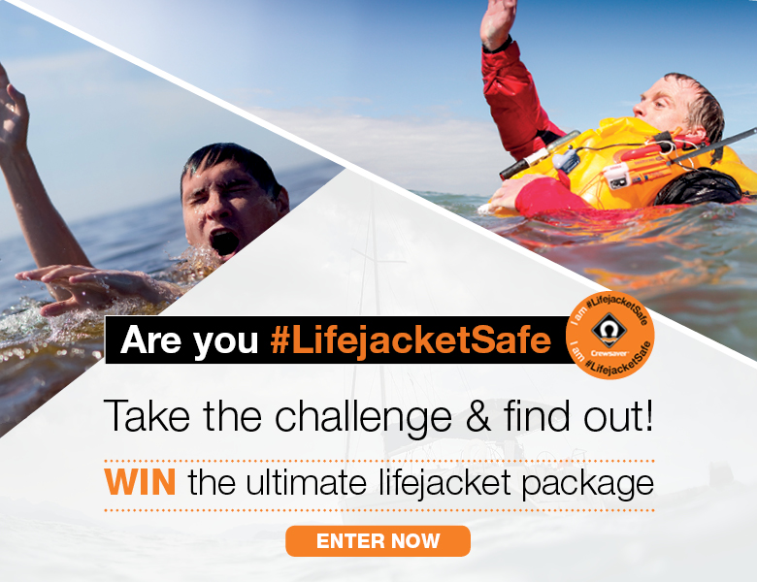
The #LifejacketSafe campaign aims to increase safety awareness by highlighting the importance of not only wearing a personal flotation device, but also making sure it is worn correctly and is well maintained. So, if the worst should happen, you are well equipped and can rest assured that your safety equipment is not going to let you down.
#LifejacketSafe challenge prize – Worth over £440 (483 Euros) *
- ErgoFit 290N EX lifejacket
- Lifejacket servicing voucher
- Rearming kit
- ErgoFit safety knife
- Safety line
So, do you think you know all there is to know about lifejackets? Do you know what a Newton is (not Isaac Newton, but he does play an important part!) and whether all lifejackets come with a light as standard? Prove you have what it takes to be #LifejacketSafe and enter the #LifejacketSafe challenge!

Accept the challenge here https://www.surveymonkey.co.uk/r/LifejacketSafe

Top advice for being #LifejacketSafe
- Wear a lifejacket and wear it correctly
- Get your lifejacket serviced annually
- Wear the right lifejacket for your activity
- Follow care and maintenance guidelines

*T&C’s apply. E&OE

T&C’s
The prize is non-transferable and no cash alternative will be offered.
The competition is open to all; however, the prize draw will exclude employees of Survitec Group Ltd and their immediate families and anyone else connected with the creation and administration of the promotion.
By entering the competition, entrants agree to be bound by the rules and by any other requirements set out in the promotional material.
The entry must be submitted through the highlighted platform. No responsibility will be accepted for entries lost, damaged or delayed.
The winner will be chosen at random.
The closing date for receipt of entries is 2359 on the 1st March 2018, and the winner will be informed by email as soon as possible thereafter and no later than the 9th March 2018.
One entry per person, no purchase necessary.
Entrants must be 16 years and over.
The judge’s decision is final, the winner is chosen (from the entrants who answer all questions correctly) using a random name picker software.
The winner may be required to take part in any publicity accompanying or resulting from this competition. The promoters are Survitec Group Ltd, Survitec House, Lederle Lane, Gosport, Hampshire, PO13 0FZ.
E&OE

//ENDS//

For media information, hi-res images or product tests please contact:
Crewsaver
Hazel Proudlock, Marketing Dept
T +44 (0) 1329 820406
E hazel.proudlock@survitecgroup.com

Alison Willis – Marine Advertising Agency Ltd
T +44 (0) 23 9252 2044
E Alison@marineadagency.com

Notes to Editors

Crewsaver is a world-leading manufacturer of marine safety equipment and clothing for the commercial and leisure marine industries. Based in Gosport, Hampshire, the company designs and manufactures bespoke safety equipment for several countries’ Special Forces, and the aviation and oil industries. Crewsaver is the only company to hold an exclusive contract to supply lifejackets to the UK government’s Environment Agency and the Royal National Lifeboat Institution (RNLI). They are part of the Survitec Group. www.crewsaver.com

Survitec Group is a global leader in survival and safety solutions to the marine, defence, aviation and offshore markets. Survitec has over 3,000 employees worldwide covering 8 manufacturing facilities, 15 offshore support centres and over 70 owned service stations. It is further supported by a network of over 500 3rd party service stations and distributors. Across its 160-year history, Survitec Group has remained at the forefront of innovation, design and application engineering and is the trusted name when it comes to critical safety and survival solutions. www.survitecgroup.com

