Press release
June 2017

Boating & Watersports Holiday Show’s second
attraction unveiled!

Get active at the Show’s very own beach resort –

on dry land or on the water, the options are limitless

For sheer exhilaration, nothing beats being out on the water. And when it comes to watersports, we’re certain to get visitors in the holiday spirit with the Show’s very own Beach Club & Activity Pool.
Designed to recreate the ultimate in a beach club environment, the attraction will offer visitors the chance to have a go at a new activity with one of the land-based interactive simulators or get wet having fun on the water. Visitors can book their upcoming watersports holiday or simply take the time to talk to those in the know who will share top tips and advice, whilst the kids play happily in the sand.

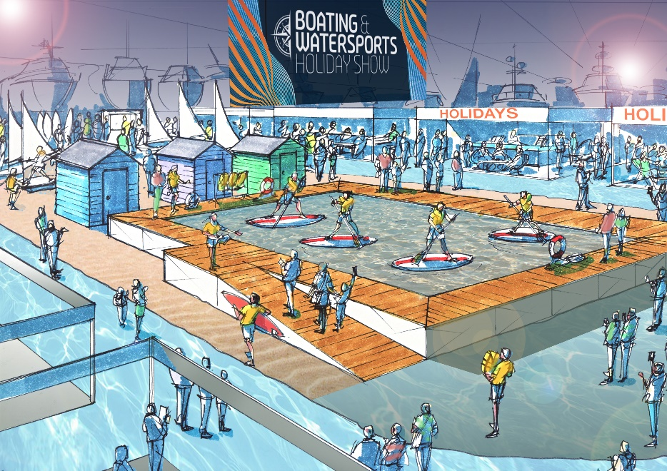
Artist impression

Surrounding the attraction will be a number of brands showcasing the best in family watersport holidays. Already committed for the 2018 Show are Dream Yacht Charter, Cosmos Yachting, Sailing Holidays and Sail Scotland.
This news follows the unveiling of the Show’s first attraction, a dedicated Lock & Waterside Pub area. Plenty more attractions are being developed and will be announced over the coming weeks.
ENDS

For more information, please contact Annabel Wildey on 01784 223811 or email awildey@britishmarine.co.uk.
Notes to editors:
About British Marine Boat Shows:
The London Boat Show at ExCeL London and TheYachtMarket.com Southampton Boat Show are organised by British Marine Boat Shows, a division of British Marine.
The 2018 London Boat Show will take place from 10-14 January 2018 at ExCeL London. For more information visit www.londonboatshow.com
TheYachtMarket.com Southampton Boat Show 2018 takes place from 14–23 September 2018, see www.southamptonboatshow.com for more details

